# Netty权威指南

# Java的I/O演进之路

## 1.1 I/O基础入门

jdk1.4之前，java I/O存在的问题：

1. 没有数据缓冲区，I/O性能存在问题；
2. 没有C或者C++中的Channel概念，智能输入和输出流
3. 同步阻塞式I/O通信(BIO)，通常会导致通信线程时间阻塞
4. 支持的字符集有限，引荐可移植性不好。

### 1.1.1 Linux网络I/O模型简介

5种IO模型：

1. 阻塞IO模型，
2. 非阻塞IO模型：
3. IO复用模型：
4. 信号驱动模型
5. 异步IO

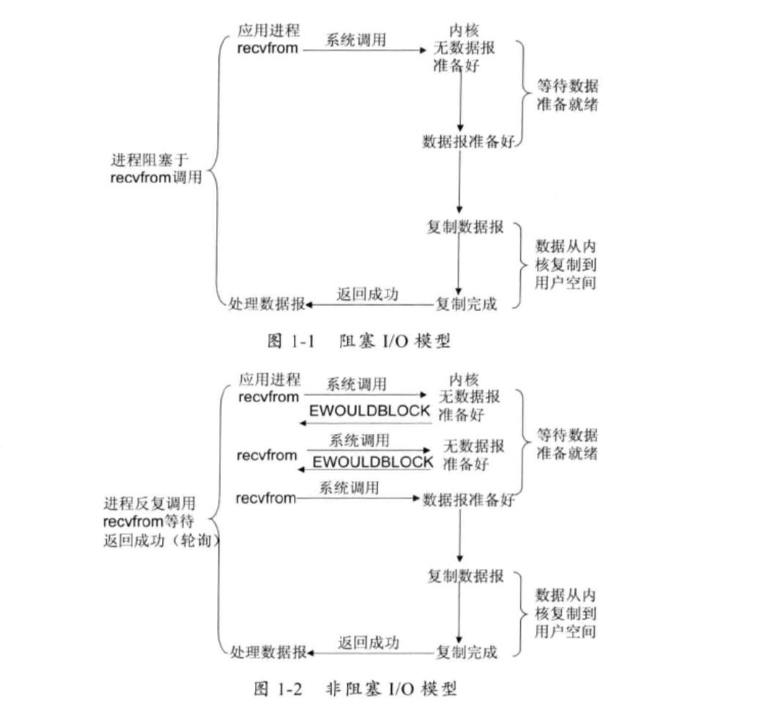

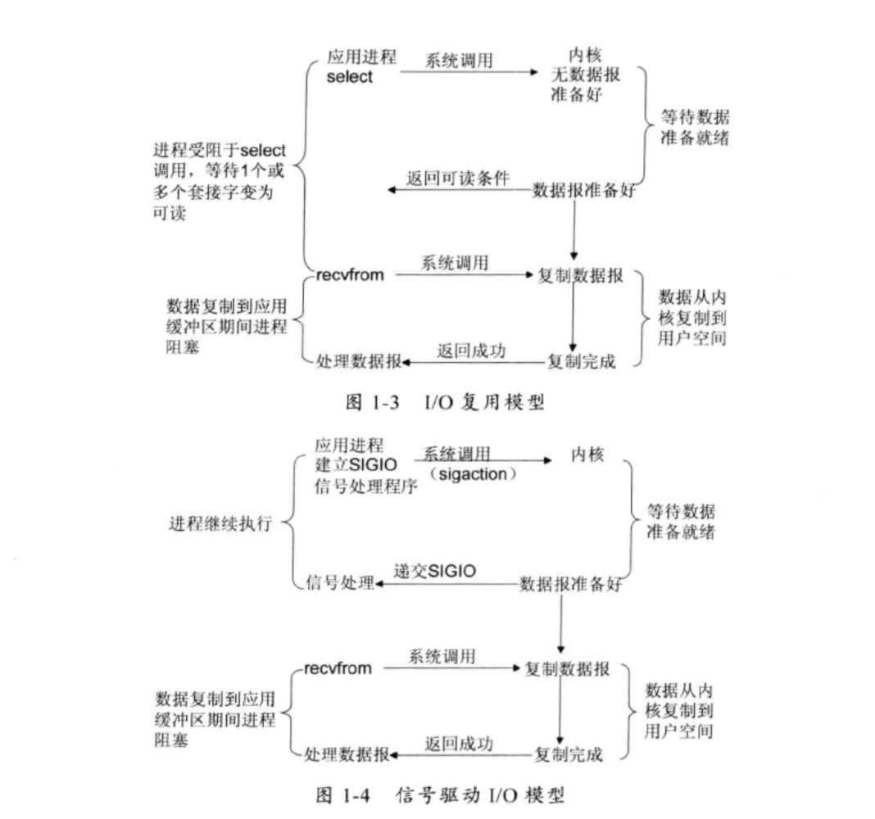

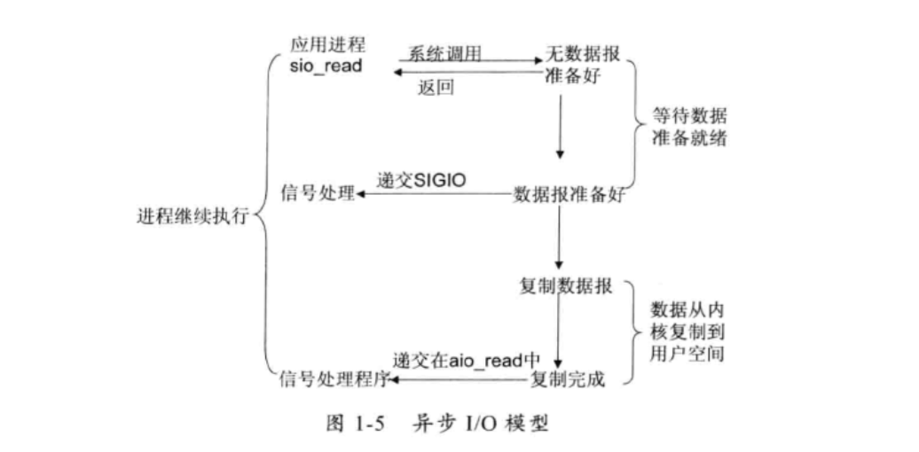

### 1.1.2 IO多路复用技术

IO多路复用主要应用场景：

1. 服务器同时处理多个处于监听状态或者多个连接状态的套接字
2. 服务器需要同时处理多种网络协议的套接字

# NIO入门

## 2.1 传统的BIO编程

### 2.1.1 BIO通信模型图

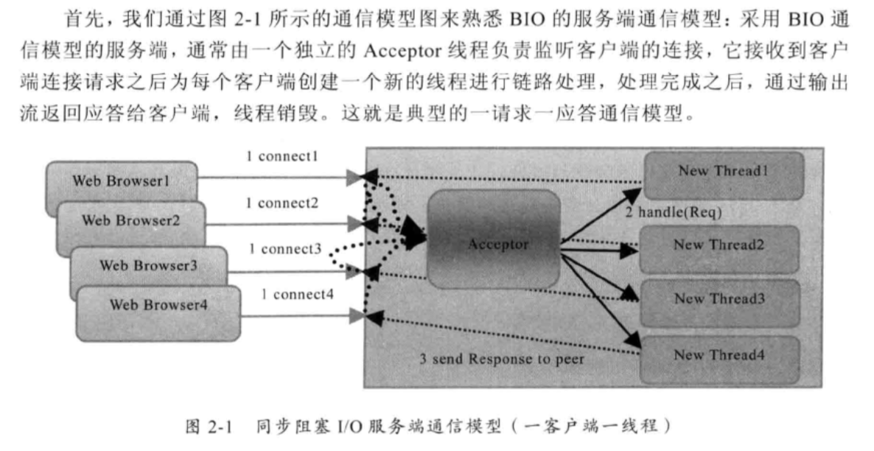

TimeServer

|  |
| --- |
| package com.netty.study.chapter02;  import java.io.IOException; import java.net.ServerSocket; import java.net.Socket;  public class TimeServer {  public static void main(String[] args) throws IOException {   int port = 8080;  if (args != null && args.length > 0) {  try {  port = Integer.*valueOf*(args[0]);  } catch (NumberFormatException e) {  }  }   ServerSocket server = null;   try {  server = new ServerSocket(port);  System.*out*.println("The time server is start in port :" + port);  Socket socket = null;  while (true){  socket = server.accept();  new Thread(new TimeServerHandler(socket)).start();  }   } finally {  if(server != null){  System.*out*.println("The time server close");  server.close();  server = null;  }  }   }  } |

TimeServerHandler

|  |
| --- |
| package com.netty.study.chapter02;  import java.io.BufferedReader; import java.io.IOException; import java.io.InputStreamReader; import java.io.PrintWriter; import java.net.Socket; import java.util.Date;  public class TimeServerHandler implements Runnable {   private Socket socket;   public TimeServerHandler(Socket socket) {  this.socket = socket;  }   public void run() {  BufferedReader in = null;  PrintWriter out = null;   try {  in = new BufferedReader(new InputStreamReader(this.socket.getInputStream()));  out = new PrintWriter(this.socket.getOutputStream(),true);  String currentTime = null;  String body = null;  while (true) {  body = in.readLine();  if (body == null) {  break;  }  System.*out*.println("The time server receive order : " + body);  currentTime = "QUERY TIME ORDER".equalsIgnoreCase(body) ? new Date(System.*currentTimeMillis*()).toString() : "BAD ORDER";  out.println(currentTime);  }  } catch (Exception e) {  if(in != null){  try {  in.close();  }catch (IOException e1){  e1.printStackTrace();  }  }   if(out != null){  out.close();  out = null;  }   if(this.socket != null){  try {  this.socket.close();  }catch (IOException e1){  e.printStackTrace();  }  this.socket = null;  }  }    } } |

TimeCLient

|  |
| --- |
| package com.netty.study.chapter02;  import java.io.BufferedReader; import java.io.IOException; import java.io.InputStreamReader; import java.io.PrintWriter; import java.net.Socket;  public class TimeClient {   public static void main(String[] args) {  int port = 8080;  if (args != null && args.length > 0) {  try {  port = Integer.*valueOf*(args[0]);  } catch (NumberFormatException e) {   }  }   Socket socket = null;  BufferedReader in = null;  PrintWriter out = null;   try {  socket = new Socket("127.0.0.1", port);  in = new BufferedReader(new InputStreamReader(socket.getInputStream()));   out = new PrintWriter(socket.getOutputStream(), true);  out.println("QUERY TIME ORDER");  System.*out*.println("Send order 2 server succeed");  String resp = in.readLine();  System.*out*.println("Now is: " + resp);   } catch (Exception e) {   } finally {  if (out != null){  out.close();  out = null;  }   if(in != null){  try {  in.close();  }catch (IOException e){  e.printStackTrace();  }   in = null;  }    if(socket != null){  try {  socket.close();  }catch (IOException e){  e.printStackTrace();  }  socket = null;  }   }  }  } |

## 2.2 伪异步IO编程

后端通过一个线程池来处理多个客户端的请求接入，形成客户端个数M：线程池最大线程数N的比例关系，其中M可以远远大于N。通过线程池可以灵活调配线程资源。

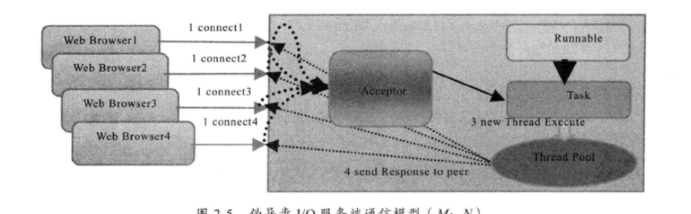

伪异步IO实际上进京对IO线程模型的简单优化，无法从根本上解决同步IO问题。

1. 服务端处理缓慢，返回应答消息耗费60s，平时只需要10ms
2. 采用伪异步IO的线程正在读取故障服务节点的响应，由于读取输入流是阻塞的，它将会被同步阻塞60s
3. 由于线程池采用阻塞对列实现，当对垒积满之后，后续入队列的操作将被阻塞。
4. 由于线程池采用阻塞对列实现，当对列积满之后，后续入队列的操作将被阻塞
5. 由于前端只有一个Accptor线程接收客户端接入，它被阻塞在线程池的同步阻塞对列之后，新的客户端请求消息将被拒绝，客户端会发生大量的连接超时
6. 由于几乎所有的连接都超时，调用者会认为系统已经崩溃，无法接收新的请求消息。

## 2.3 NIO编程

### 2.3.1 NIO类库介绍

**1 缓冲区Buffer**

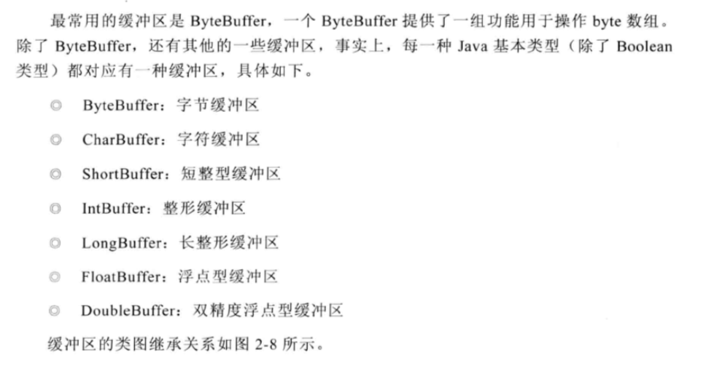

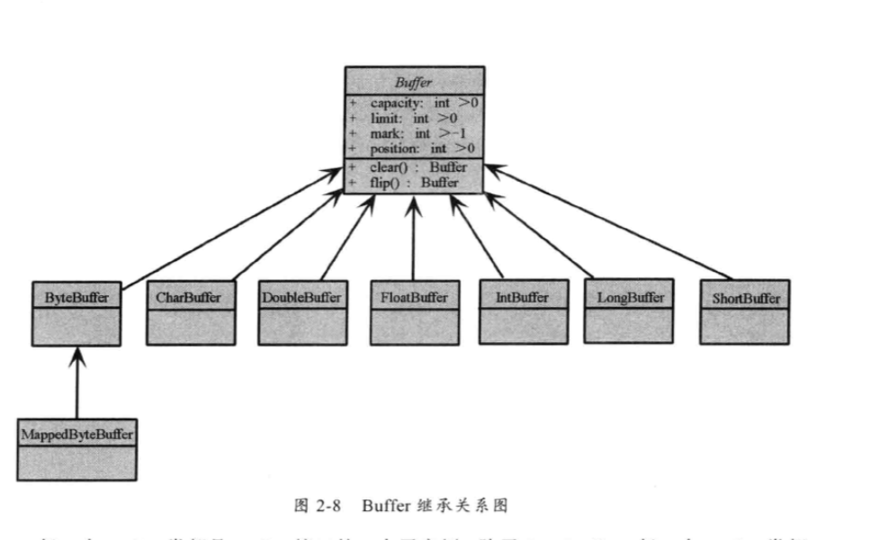

**2 通道Channel**

网络数据通过Channel读取和写入。通道与流的不同之处在于通道是双向的，流只是一个方向上移动，通道可以用于读、写或者二者同时进行。

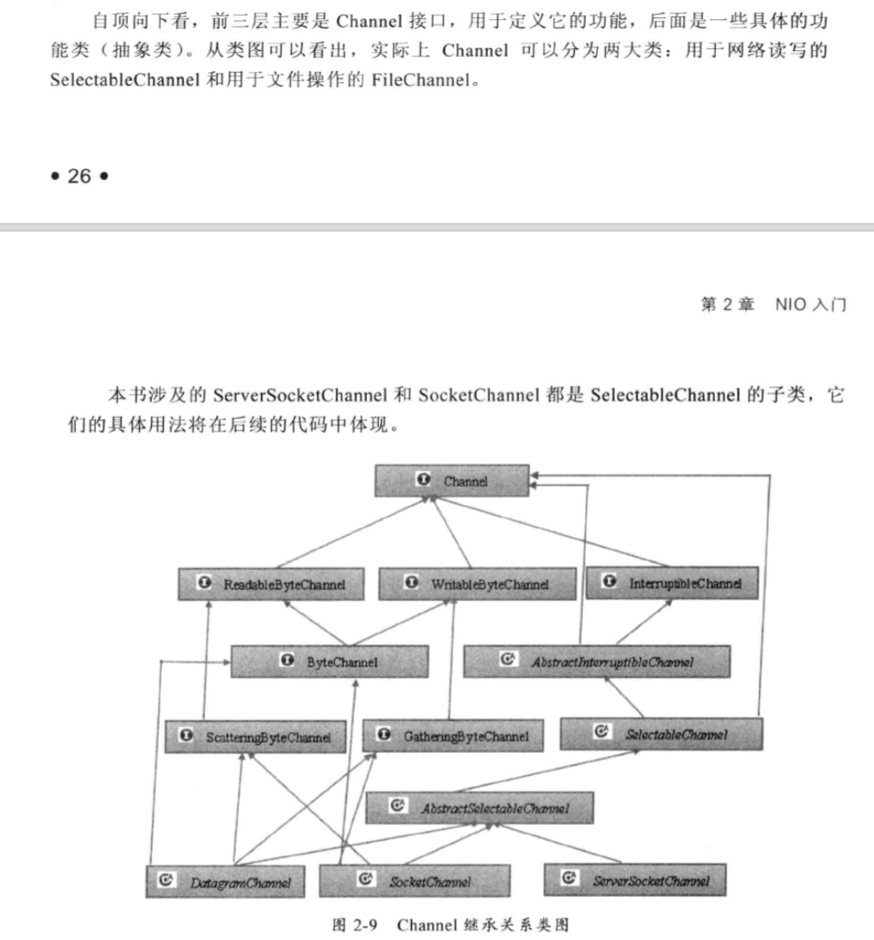

**3 多路复用器Selector**

Selector会不断地轮询注册在其上的Channel，如果Channel上面发生读或者写时间，这个Channel就处于就绪状态，会被Selector轮询出来，然后通过SelectionKey可以获取就绪Channel的集合，进行后续的IO操作。

### 2.3.2 NIO服务端序列图

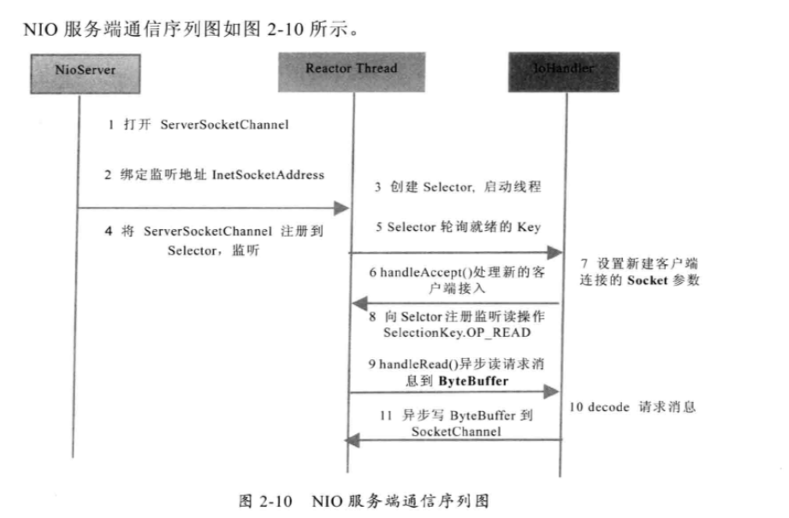

步骤一：打开ServerSocketChannel，用于监听客户端的连接，它是所有客户端连接的父管道，

ServerSocketChannel acceptorSvr = ServerSocketChannel.*open*();

步骤二：丙丁监听端口，设置连接为非主色模式，

acceptorSvr.socket().bind(new InetSocketAddress(InetAddress.*getByName*("IP"),port));  
acceptorSvr.configureBlocking(false);

步骤三：创建Reactor线程，创建多路复用器并启动线程。

Selector selector = Selector.*open*();  
new Thread(new ReactorTask()).start();

步骤四：将ServerSocketChannel注册到Reactor线程的多路复用器Selector上，监听Accept事件，

acceptorSvr.register(selector, SelectionKey.*OP_ACCEPT*,ioHandler);

步骤五：多路复用器在线程run方法的无限循环体内轮询准备就绪的Key，

int num = selector.select();  
Set<SelectionKey> selectionKeys = selector.selectedKeys();  
Iterator it = selectionKeys.iterator();  
while (it.hasNext()){  
 SelectionKey key = (SelectionKey) it.next();  
 // ... deal with I/O event ...  
}

步骤六：多路复用器监听到有新的客户端接入，处理新的接入请求，完成TCP三次握手，建立物理链路，实例代码如下：

SocketChannel channel = acceptorSvr.accept();

步骤七：设置客户端链路为非阻塞模式，

channel.configureBlocking(false);  
channel.socket().setReuseAddress(true);

步骤八：将新计入的客户端连接注册到Reactor线程的多路复用器上，监听读操作，读取客户端发送的网路消息，

SelectionKey key = channel.register(selector, SelectionKey.*OP_READ*, ioHandler);

步骤九：异步读取客户端请求消息到换从区，

int readNumber = channel.read(receivedBuffer);

步骤十：对ByteBuffer进行彪马，如果有半包消息指针reset，继续读取后续的报文，将解码成功的消息封装成Task，投递到业务线程中，进行业务逻辑编排，实例代码如下

Object message = null;  
while (byteBuffer.hasRemaining()) {  
 byteBuffer.mark();  
 message = *decode*(byteBuffer);  
 if (message == null) {  
 byteBuffer.reset();  
 break;  
 }  
 messageList.add(message);  
  
}  
  
if(!byteBuffer.hasRemaining()){  
 byteBuffer.clear();  
}else {  
 byteBuffer.compact();  
}  
  
if(messageList != null && !messageList.isEmpty()){  
 for (Object messageE : messageList) {  
 *handlerTask*(messageE);  
 }  
}

步骤十一：将POJO对象encode成ByteBuffer没调用SocketChannel的异步write接口将消息异步发送给客户端

channel.write(byteBuffer);

### 2.3.3 创建TimeServer2

TimeServer2

|  |
| --- |
| package com.netty.study.chapter02;  import java.io.IOException;  public class TimeServer2 {   public static void main(String[] args) throws IOException {   int port = 8080;  if (args != null && args.length > 0) {  try {  port = Integer.*valueOf*(args[0]);  } catch (NumberFormatException e) {  }  }   MultiplexerTimeServer timeServer = new MultiplexerTimeServer(port);   new Thread(timeServer,"NIO-MultiplexerTimeServer-001").start();  } } |

MultiplexerTimeServer

|  |
| --- |
| package com.netty.study.chapter02;  import java.io.IOException; import java.net.InetSocketAddress; import java.nio.ByteBuffer; import java.nio.channels.SelectionKey; import java.nio.channels.Selector; import java.nio.channels.ServerSocketChannel; import java.nio.channels.SocketChannel; import java.util.Date; import java.util.Iterator; import java.util.Set;  public class MultiplexerTimeServer implements Runnable {   private Selector selector;   private ServerSocketChannel servChannel;   private volatile boolean stop;   */**  * 初始化多路复用器，绑定监听端口  *  \** ***@param*** *port  */* public MultiplexerTimeServer(int port) {  try {  selector = Selector.*open*();  servChannel = ServerSocketChannel.*open*();  servChannel.configureBlocking(false);  servChannel.socket().bind(new InetSocketAddress(port), 1024);  servChannel.register(selector, SelectionKey.*OP_ACCEPT*);  System.*out*.println("The time server is start in port :" + port);   } catch (IOException e) {  e.printStackTrace();  System.*exit*(1);  }  }   public void stop() {  this.stop = true;  }    public void run() {  while (!stop) {  try {  selector.select(1000);  Set<SelectionKey> selectionKeys = selector.selectedKeys();  Iterator<SelectionKey> it = selectionKeys.iterator();   SelectionKey key = null;  while (it.hasNext()) {  key = it.next();  it.remove();  try {  handleInput(key);  } catch (Exception e) {  if (key != null) {  key.cancel();  if (key.channel() != null) {  key.channel().close();  }  }  }  }   } catch (Throwable t) {  t.printStackTrace();  }  }   // 多路复用器关闭后，所有注册在上面的Channel和Pipe等资源会被自动去注册并关闭，所以不需要重复释放资源  if (selector != null) {  try {  selector.close();  } catch (IOException e) {  e.printStackTrace();  }  }  }   private void handleInput(SelectionKey key) throws IOException {  if (key.isValid()) {  if (key.isAcceptable()) {  //处理新接入的请求信息  ServerSocketChannel ssc = (ServerSocketChannel) key.channel();  SocketChannel sc = ssc.accept();  sc.configureBlocking(false);   sc.register(selector, SelectionKey.*OP_READ*);  }  if (key.isReadable()) {  // Read the data  SocketChannel sc = (SocketChannel) key.channel();  ByteBuffer readBuffer = ByteBuffer.*allocate*(1024);  int readBytes = sc.read(readBuffer);   if (readBytes > 0) {  readBuffer.flip();  byte[] bytes = new byte[readBuffer.remaining()];  readBuffer.get(bytes);   String body = new String(bytes, "UTF-8");  System.*out*.println("The time server receive order: " + body);  String currentTime = "QUERY TIME ORDER".equalsIgnoreCase(body) ? new Date(System.*currentTimeMillis*()).toString() : "BAD ORDER";  doWrite(sc, currentTime);  } else if (readBytes < 0) {  // 对端链路关闭  key.cancel();  sc.close();  } else {  // 读到0字节，忽略  }  }  }    }   private void doWrite(SocketChannel channel, String response) throws IOException {  if (response != null && response.trim().length() > 0) {  byte[] bytes = response.getBytes();  ByteBuffer writeBuffer = ByteBuffer.*allocate*(bytes.length);  writeBuffer.put(bytes);  writeBuffer.flip();  channel.write(writeBuffer);  }  } } |

### 2.3.4 客户端序列图

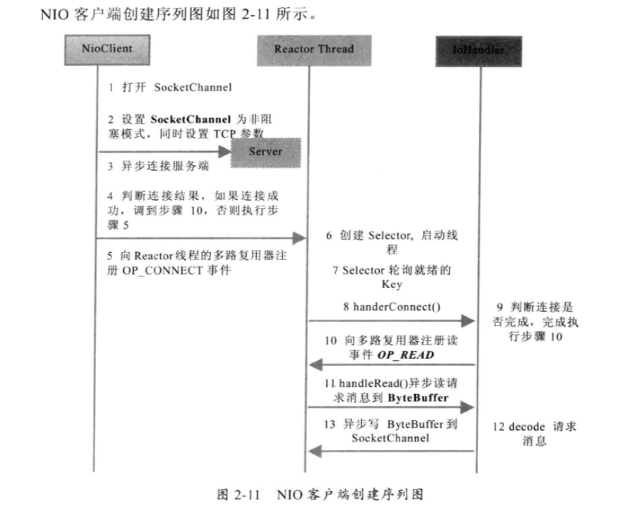

### 2.3.5 NIO创建TimeClient

TimeCilent

|  |
| --- |
| package com.netty.study.chapter02;  import java.io.BufferedReader; import java.io.IOException; import java.io.InputStreamReader; import java.io.PrintWriter; import java.net.Socket;  public class TimeClient2 {   public static void main(String[] args) {  int port = 8080;  if (args != null && args.length > 0) {  try {  port = Integer.*valueOf*(args[0]);  } catch (NumberFormatException e) {   }  }   new Thread(new TimeClientHandle("127.0.0.1",port),"TimeClient-001").start();   }  } |

TimeClientHandle

|  |
| --- |
| package com.netty.study.chapter02;  import java.io.IOException; import java.net.InetSocketAddress; import java.nio.ByteBuffer; import java.nio.channels.SelectionKey; import java.nio.channels.Selector; import java.nio.channels.SocketChannel; import java.util.Iterator; import java.util.Set;  public class TimeClientHandle implements Runnable {   private String host;  private int port;  private Selector selector;  private SocketChannel socketChannel;  private volatile boolean stop;    public TimeClientHandle(String host, int port) {  this.host = host == null ? "127.0.0.1" : host;  this.port = port;   try {  selector = Selector.*open*();  socketChannel = SocketChannel.*open*();  socketChannel.configureBlocking(false);  } catch (IOException e) {  e.printStackTrace();  System.*exit*(1);  }  }   public void run() {  try {  doConnect();  } catch (IOException e) {  e.printStackTrace();  System.*exit*(1);  }   while (!stop) {  try {  selector.select(1000);  Set<SelectionKey> selectionKeys = selector.selectedKeys();  Iterator<SelectionKey> it = selectionKeys.iterator();  SelectionKey key = null;   while (it.hasNext()) {  key = it.next();  it.remove();  try {  handleInput(key);  } catch (Exception e) {  if (key != null) {  key.cancel();  if (key.channel() != null) {  key.channel().close();  }  }  }   }  } catch (Exception e) {  e.printStackTrace();  System.*exit*(1);  }  }   // 多路复用器关闭后，所有注册在上面的Channel和Pipe等资源都会被自动去注册并关闭，所以不需要重复释放资源  if (selector != null) {  try {  selector.close();  } catch (IOException e) {  e.printStackTrace();  }  }    }   private void handleInput(SelectionKey key) throws IOException {  if (key.isValid()) {  // 判断是否连接成功  SocketChannel sc = (SocketChannel) key.channel();  if (key.isConnectable()) {  if (sc.finishConnect()) {  sc.register(selector, SelectionKey.*OP_READ*);  doWrite(sc);  } else {  // 连接失败，进程退出  System.*exit*(1);  }  }   if (key.isReadable()) {  ByteBuffer readBuffer = ByteBuffer.*allocate*(1024);  int readBytes = sc.read(readBuffer);  if (readBytes > 0) {  readBuffer.flip();  byte[] bytes = new byte[readBuffer.remaining()];  readBuffer.get(bytes);  String body = new String(bytes, "UTF-8");  System.*out*.println("Now is : " + body);  this.stop = true;  } else if (readBytes < 0) {  key.cancel();  sc.close();  } else {  // 读到0字节，忽略  }  }  }    }   private void doWrite(SocketChannel sc) throws IOException {  byte[] req = "QUERY TIME ORDER".getBytes();  ByteBuffer writeBuffer = ByteBuffer.*allocate*(req.length);  writeBuffer.put(req);  writeBuffer.flip();  sc.write(writeBuffer);  if (!writeBuffer.hasRemaining()) {  System.*out*.println("Send order 2 server succeed.");  }   }   private void doConnect() throws IOException {  if (socketChannel.connect(new InetSocketAddress(host, port))) {  socketChannel.register(selector, SelectionKey.*OP_READ*);  doWrite(socketChannel);  } else {  socketChannel.register(selector, SelectionKey.*OP_CONNECT*);  }  }   } |

## 2.4 AIO编程

|  |
| --- |
| package com.netty.study.chapter02;  import java.io.IOException;  public class TimeServer3 {   public static void main(String[] args) throws IOException {   int port = 8080;  if (args != null && args.length > 0) {  try {  port = Integer.*valueOf*(args[0]);  } catch (NumberFormatException e) {  }  }   AsyncTimeServerHandler timeServer = new AsyncTimeServerHandler(port);   new Thread(timeServer,"NIO-AsyncTimeServerHandler-001").start();  } }  package com.netty.study.chapter02;  import java.io.IOException; import java.net.InetSocketAddress; import java.nio.channels.AsynchronousServerSocketChannel; import java.util.concurrent.CountDownLatch;  public class AsyncTimeServerHandler implements Runnable {   private int port;  CountDownLatch latch;  AsynchronousServerSocketChannel asynchronousServerSocketChannel;   public AsyncTimeServerHandler(int port) {  this.port = port;   try {  asynchronousServerSocketChannel = AsynchronousServerSocketChannel.*open*();  asynchronousServerSocketChannel.bind(new InetSocketAddress(port));  System.*out*.println("The time server is start in port : " + port);   } catch (IOException e) {  e.printStackTrace();  }   }   public void run() {   latch = new CountDownLatch(1);  doAccept();  try {  latch.await();  }catch (InterruptedException e){  e.printStackTrace();  }   }   private void doAccept() {  asynchronousServerSocketChannel.accept(this,new AcceptCompletionHandler());  } }  package com.netty.study.chapter02;  import java.nio.ByteBuffer; import java.nio.channels.AsynchronousSocketChannel; import java.nio.channels.CompletionHandler;  public class AcceptCompletionHandler implements CompletionHandler<AsynchronousSocketChannel, AsyncTimeServerHandler> {   @Override  public void completed(AsynchronousSocketChannel result, AsyncTimeServerHandler attachment) {  attachment.asynchronousServerSocketChannel.accept(attachment, this);  ByteBuffer buffer = ByteBuffer.*allocate*(1024);  result.read(buffer, buffer, new ReadCompletionHandler(result));  }   @Override  public void failed(Throwable exc, AsyncTimeServerHandler attachment) {  exc.printStackTrace();  attachment.latch.countDown();  } }  package com.netty.study.chapter02;  import java.io.IOException; import java.io.UnsupportedEncodingException; import java.nio.ByteBuffer; import java.nio.channels.AsynchronousSocketChannel; import java.nio.channels.CompletionHandler; import java.util.Date;  public class ReadCompletionHandler implements CompletionHandler<Integer, ByteBuffer> {   private AsynchronousSocketChannel channel;   public ReadCompletionHandler(AsynchronousSocketChannel channel) {  if (this.channel == null) {  this.channel = channel;  }   }   @Override  public void completed(Integer result, ByteBuffer attachment) {  attachment.flip();  byte[] body = new byte[attachment.remaining()];  attachment.get(body);   try {  String req = new String(body, "UTF-8");  System.*out*.println("The time server receive order : " + req);  String currentTime = "QUERY TIME ORDER".equalsIgnoreCase(req) ? new Date(System.*currentTimeMillis*()).toString() : "BAD ORDER";  doWrite(currentTime);  } catch (UnsupportedEncodingException e) {  e.printStackTrace();  }  }   private void doWrite(String currentTime) {  if (currentTime != null && currentTime.trim().length() > 0) {  byte[] bytes = (currentTime).getBytes();  final ByteBuffer writeBuffer = ByteBuffer.*allocate*(bytes.length);  writeBuffer.put(bytes);  writeBuffer.flip();  channel.write(writeBuffer, writeBuffer, new CompletionHandler<Integer, ByteBuffer>() {  @Override  public void completed(Integer result, ByteBuffer buffer) {  // 如果没有发送完成，继续发送  if (buffer.hasRemaining()) {  channel.write(buffer, buffer, this);  }  }   @Override  public void failed(Throwable exc, ByteBuffer attachment) {  try {  channel.close();  } catch (IOException e) {  //ingnore on close  }  }  });  }  }   @Override  public void failed(Throwable exc, ByteBuffer attachment) {  try {  this.channel.close();  } catch (IOException e) {  e.printStackTrace();  }  } } |

客户端

|  |
| --- |
| package com.netty.study.chapter02;  public class TimeClient3 {   public static void main(String[] args) {  int port = 8080;  if (args != null && args.length > 0) {  try {  port = Integer.*valueOf*(args[0]);  } catch (NumberFormatException e) {   }  }  new Thread(new AsyncTimeClientHandler("127.0.0.1", port), "AsyncTimeClientHandler-001").start();  }  }  package com.netty.study.chapter02;  import java.io.IOException; import java.io.UnsupportedEncodingException; import java.net.InetSocketAddress; import java.nio.ByteBuffer; import java.nio.channels.AsynchronousSocketChannel; import java.nio.channels.CompletionHandler; import java.util.concurrent.CountDownLatch;  public class AsyncTimeClientHandler implements CompletionHandler<Void, AsyncTimeClientHandler>, Runnable {   private AsynchronousSocketChannel client;  private String host;  private int port;  private CountDownLatch latch;    public AsyncTimeClientHandler(String host, int port) {  this.host = host;  this.port = port;   try {  client = AsynchronousSocketChannel.*open*();  } catch (IOException e) {  e.printStackTrace();  }   }   @Override  public void run() {  latch = new CountDownLatch(1);  client.connect(new InetSocketAddress(host, port), this, this);   try {  latch.await();  } catch (InterruptedException e1) {  e1.printStackTrace();  }   try {  client.close();  } catch (IOException e) {  e.printStackTrace();  }   }   @Override  public void completed(Void result, AsyncTimeClientHandler attachment) {  byte[] req = "QUERY TIME ORDER".getBytes();  ByteBuffer writeBuffer = ByteBuffer.*allocate*(req.length);  writeBuffer.put(req);  writeBuffer.flip();   client.write(writeBuffer, writeBuffer, new CompletionHandler<Integer, ByteBuffer>() {  @Override  public void completed(Integer result, ByteBuffer buffer) {  if (buffer.hasRemaining()) {  client.write(buffer, buffer, this);  } else {  ByteBuffer readBuffer = ByteBuffer.*allocate*(1024);  client.read(readBuffer, readBuffer, new CompletionHandler<Integer, ByteBuffer>() {  @Override  public void completed(Integer result, ByteBuffer buffer) {  buffer.flip();  byte[] bytes = new byte[buffer.remaining()];  buffer.get(bytes);  String body;  try {  body = new String(bytes, "UTF-8");  System.*out*.println("Now is:" + body);  } catch (UnsupportedEncodingException e) {  e.printStackTrace();  }  }   @Override  public void failed(Throwable exc, ByteBuffer attachment) {  try {  client.close();  latch.countDown();  } catch (IOException e) {  e.printStackTrace();  // ingnore on close  }  }  });  }  }   @Override  public void failed(Throwable exc, ByteBuffer attachment) {  try {  client.close();  latch.countDown();  } catch (IOException e) {  e.printStackTrace();  }  }  });  }    @Override  public void failed(Throwable exc, AsyncTimeClientHandler attachment) {  try {  client.close();  latch.countDown();  } catch (IOException e) {  e.printStackTrace();  }  } } |

## 2.5 4中IO对比

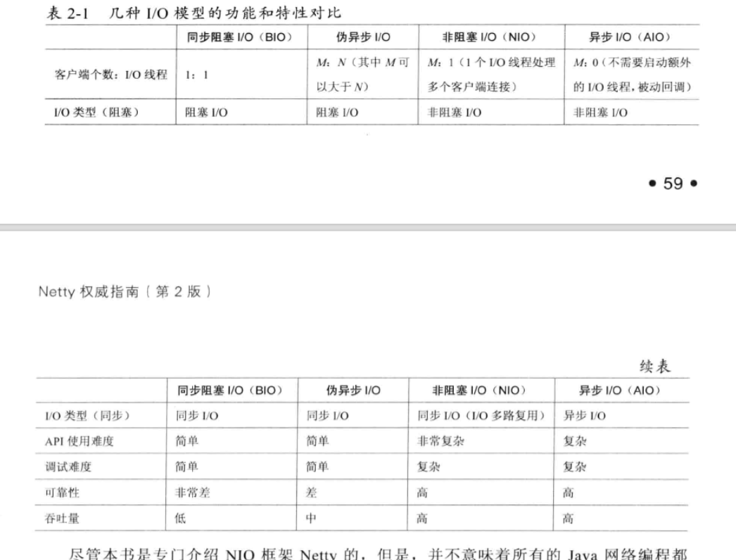

## 2.6 选择netty理由

# Netty入门的搭建

# TCP粘包/拆包问题解决

## 4.1 TCP粘包/拆包

### 4.1.1 TCP粘包/拆包问题说明

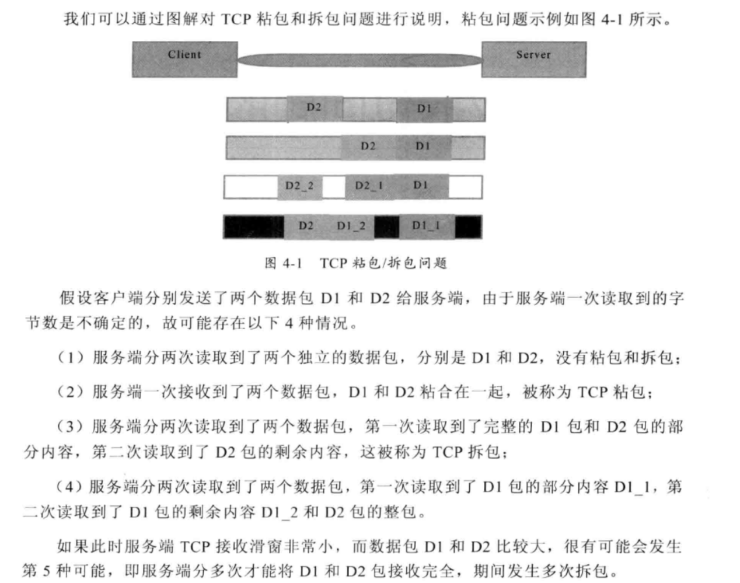

### 4.1.2 粘包/拆包发生的原因

1. 应用程序write写入的字节大小小于套接口发送缓存区大小；
2. 进行MSS大小的TCP分段；
3. 以太网帧的payload大于MTU进行IP分片

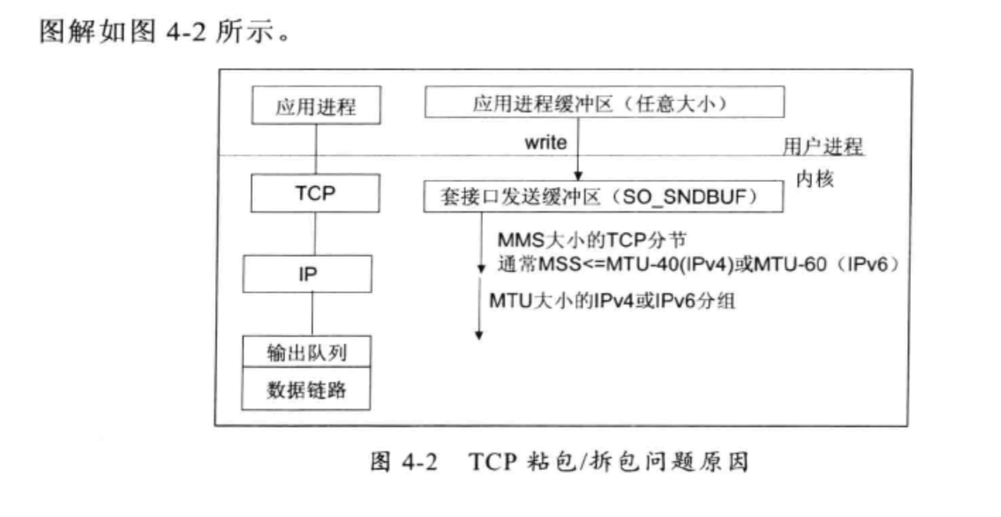

### 4.1.3 粘包问题的解决策略

1. 消息定长，例如每个报文的大小为固定长度200字节，如果不够，空位补空格
2. 在包尾增加回车换行符进行分割，例如FTP协议
3. 将消息分为消息头和消息体，消息头中包含表示消息总长度（或者消息体长度）的字段，通常
4. 更为复杂的应用层协议

## 4.2 未考虑TCP粘包/拆包导致功能异常案例

Server端

|  |
| --- |
| package com.netty.study.chapter04;  import io.netty.bootstrap.ServerBootstrap; import io.netty.channel.ChannelFuture; import io.netty.channel.ChannelInitializer; import io.netty.channel.ChannelOption; import io.netty.channel.nio.NioEventLoopGroup; import io.netty.channel.socket.SocketChannel; import io.netty.channel.socket.nio.NioServerSocketChannel;  public class TimeServer {   public void bind(int port) throws Exception {  // 配置服务端的NIO线程组  NioEventLoopGroup bossGroup = new NioEventLoopGroup();  NioEventLoopGroup workerGroup = new NioEventLoopGroup();   try {  ServerBootstrap b = new ServerBootstrap();  b.group(bossGroup, workerGroup)  .channel(NioServerSocketChannel.class)  .option(ChannelOption.*SO_BACKLOG*, 1024)  .childHandler(new TimeServer.ChildChannelHandler());  // 绑定端口，同步等待成功  ChannelFuture f = b.bind(port).sync();   // 等待服务端监听端口关闭  f.channel().closeFuture().sync();   } finally {  // 优雅退出，释放线程池资源  bossGroup.shutdownGracefully();  workerGroup.shutdownGracefully();  }  }      private class ChildChannelHandler extends ChannelInitializer<SocketChannel> {   @Override  protected void initChannel(SocketChannel socketChannel) throws Exception {  socketChannel.pipeline().addLast(new TimeServerHandler());  }  }    public static void main(String[] args) throws Exception {  new com.netty.study.chapter03.TimeServer().bind(8080);  }    }  package com.netty.study.chapter04;  import io.netty.buffer.ByteBuf; import io.netty.buffer.Unpooled; import io.netty.channel.ChannelHandlerAdapter; import io.netty.channel.ChannelHandlerContext;  import java.util.Date;  public class TimeServerHandler extends ChannelHandlerAdapter {   private int counter;   @Override  public void channelRead(ChannelHandlerContext ctx, Object msg) throws Exception {  ByteBuf buf = (ByteBuf) msg;  byte[] req = new byte[buf.readableBytes()];  buf.readBytes(req);   String body = new String(req, "UTF-8").substring(0, req.length - System.*getProperty*("line.separator").length());  System.*out*.println("The time server receive order : " + body + " ; the counter is : " + ++counter);  String currentTime = "QUERY TIME ORDER".equalsIgnoreCase(body) ? new Date(System.*currentTimeMillis*()).toString() : "BAD ORDER";  currentTime = currentTime + System.*getProperty*("line.separator");   ByteBuf resp = Unpooled.*copiedBuffer*(currentTime.getBytes());  ctx.writeAndFlush(resp);   }    @Override  public void channelReadComplete(ChannelHandlerContext ctx) throws Exception {  ctx.flush();  }   @Override  public void exceptionCaught(ChannelHandlerContext ctx, Throwable cause) throws Exception {  ctx.close();  } } |

client端

|  |
| --- |
| package com.netty.study.chapter04;  import io.netty.bootstrap.Bootstrap; import io.netty.channel.ChannelFuture; import io.netty.channel.ChannelInitializer; import io.netty.channel.ChannelOption; import io.netty.channel.EventLoopGroup; import io.netty.channel.nio.NioEventLoopGroup; import io.netty.channel.socket.SocketChannel; import io.netty.channel.socket.nio.NioSocketChannel;  public class TimeClient {   public void connect(int port, String host) throws Exception {  // 配置客户端NIO线程组  EventLoopGroup group = new NioEventLoopGroup();   try {  Bootstrap b = new Bootstrap();  b.group(group).channel(NioSocketChannel.class)  .option(ChannelOption.*TCP_NODELAY*, true)  .handler(new ChannelInitializer<SocketChannel>() {  @Override  protected void initChannel(SocketChannel socketChannel) throws Exception {  socketChannel.pipeline().addLast(new TimeClietHandler());  }  });  // 发起异步连接操作  ChannelFuture f = b.connect(host, port).sync();  // 等待客户独断链路操作  f.channel().closeFuture().sync();  } finally {  group.shutdownGracefully();  }  }   public static void main(String[] args) throws Exception {  new TimeClient().connect(8080,"127.0.0.1");  }  }  package com.netty.study.chapter04;  import io.netty.buffer.ByteBuf; import io.netty.buffer.Unpooled; import io.netty.channel.ChannelHandlerAdapter; import io.netty.channel.ChannelHandlerContext;  public class TimeClientHandler extends ChannelHandlerAdapter {    private int counter;   private byte[] req;    public TimeClientHandler() {  req = ("QUERY TIME ORDER" + System.*getProperty*("line.separator")).getBytes();   }    @Override  public void channelActive(ChannelHandlerContext ctx) throws Exception {  ByteBuf message = null;  // 客户端跟服务端链路建立成功之后，循环发送100条消息，没发送一条就刷新一次，  // 保证每条消息都会被写入Channel中  for (int i = 0; i < 100; i++) {  message = Unpooled.*buffer*(req.length);  message.writeBytes(req);  ctx.writeAndFlush(message);  }  }   @Override  public void channelRead(ChannelHandlerContext ctx, Object msg) throws Exception {  // 客户端每接收服务端一条消息应答之后，就打印一次计数器。  ByteBuf buf = (ByteBuf) msg;  byte[] req = new byte[buf.readableBytes()];  buf.readBytes(req);  String body = new String(req, "UTF-8");  System.*out*.println("Now is : " + body + " ; the counter is : " + (++counter));  }   @Override  public void exceptionCaught(ChannelHandlerContext ctx, Throwable cause) throws Exception {  // 释放资源  System.*out*.println("Unexpected exception from downstream : " + cause.getMessage());  ctx.close();  } } |

运行结果是：服务端接收两条消息，客户端接收一条消息

客户端，接收到含有2个 BAD ORDER的一条消息

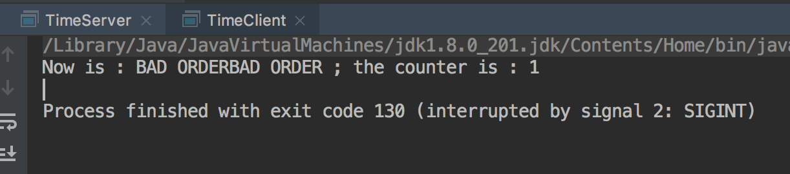

服务端接收2条消息：第二条和第一条 消息 发生了部分粘包，消息 被分开

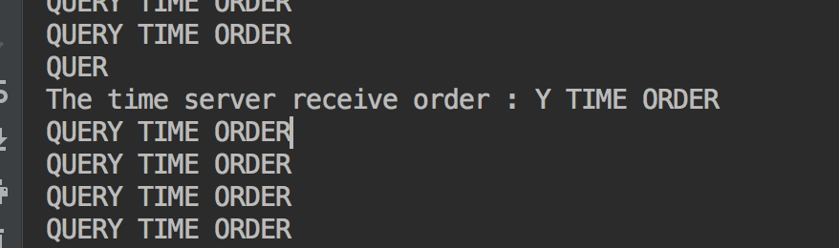

## 4.3 利用LineBasedFrameDecoder解决粘包问题

Server端

|  |
| --- |
| package com.netty.study.chapter04;  import io.netty.bootstrap.ServerBootstrap; import io.netty.channel.ChannelFuture; import io.netty.channel.ChannelInitializer; import io.netty.channel.ChannelOption; import io.netty.channel.nio.NioEventLoopGroup; import io.netty.channel.socket.SocketChannel; import io.netty.channel.socket.nio.NioServerSocketChannel; import io.netty.handler.codec.LineBasedFrameDecoder; import io.netty.handler.codec.string.StringDecoder;  public class TimeServer2 {   public void bind(int port) throws Exception {  // 配置服务端的NIO线程组  NioEventLoopGroup bossGroup = new NioEventLoopGroup();  NioEventLoopGroup workerGroup = new NioEventLoopGroup();   try {  ServerBootstrap b = new ServerBootstrap();  b.group(bossGroup, workerGroup)  .channel(NioServerSocketChannel.class)  .option(ChannelOption.*SO_BACKLOG*, 1024)  .childHandler(new ChildChannelHandler());  // 绑定端口，同步等待成功  ChannelFuture f = b.bind(port).sync();   // 等待服务端监听端口关闭  f.channel().closeFuture().sync();   } finally {  // 优雅退出，释放线程池资源  bossGroup.shutdownGracefully();  workerGroup.shutdownGracefully();  }  }    private class ChildChannelHandler extends ChannelInitializer<SocketChannel> {   @Override  protected void initChannel(SocketChannel socketChannel) throws Exception {  socketChannel.pipeline().addLast(new LineBasedFrameDecoder(1024));  socketChannel.pipeline().addLast(new StringDecoder());  socketChannel.pipeline().addLast(new TimeServerHandler2());  }  }    public static void main(String[] args) throws Exception {  new TimeServer2().bind(8080);  }   }  package com.netty.study.chapter04;  import io.netty.buffer.ByteBuf; import io.netty.buffer.Unpooled; import io.netty.channel.ChannelHandlerAdapter; import io.netty.channel.ChannelHandlerContext;  import java.util.Date;  public class TimeServerHandler2 extends ChannelHandlerAdapter {   private int counter;   @Override  public void channelRead(ChannelHandlerContext ctx, Object msg) throws Exception {   String body = (String) msg;  System.*out*.println("The time server receive order : " + body + " ; the counter is : " + ++counter);  String currentTime = "QUERY TIME ORDER".equalsIgnoreCase(body) ? new Date(System.*currentTimeMillis*()).toString() : "BAD ORDER";  currentTime = currentTime + System.*getProperty*("line.separator");   ByteBuf resp = Unpooled.*copiedBuffer*(currentTime.getBytes());  ctx.writeAndFlush(resp);   }   // @Override // public void channelReadComplete(ChannelHandlerContext ctx) throws Exception { // ctx.flush(); // }   @Override  public void exceptionCaught(ChannelHandlerContext ctx, Throwable cause) throws Exception {  ctx.close();  } } |

client

|  |
| --- |
| package com.netty.study.chapter04;  import io.netty.bootstrap.Bootstrap; import io.netty.channel.ChannelFuture; import io.netty.channel.ChannelInitializer; import io.netty.channel.ChannelOption; import io.netty.channel.EventLoopGroup; import io.netty.channel.nio.NioEventLoopGroup; import io.netty.channel.socket.SocketChannel; import io.netty.channel.socket.nio.NioSocketChannel; import io.netty.handler.codec.LineBasedFrameDecoder; import io.netty.handler.codec.string.StringDecoder;  public class TimeClient2 {   public void connect(int port, String host) throws Exception {  // 配置客户端NIO线程组  EventLoopGroup group = new NioEventLoopGroup();   try {  Bootstrap b = new Bootstrap();  b.group(group).channel(NioSocketChannel.class)  .option(ChannelOption.*TCP_NODELAY*, true)  .handler(new ChannelInitializer<SocketChannel>() {  @Override  protected void initChannel(SocketChannel socketChannel) throws Exception {  socketChannel.pipeline().addLast(new LineBasedFrameDecoder(1024));  socketChannel.pipeline().addLast(new StringDecoder());  socketChannel.pipeline().addLast(new TimeClientHandler2());   }  });  // 发起异步连接操作  ChannelFuture f = b.connect(host, port).sync();  // 等待客户独断链路操作  f.channel().closeFuture().sync();  } finally {  group.shutdownGracefully();  }  }   public static void main(String[] args) throws Exception {  new TimeClient2().connect(8080, "127.0.0.1");  }  }  package com.netty.study.chapter04;  import io.netty.buffer.ByteBuf; import io.netty.buffer.Unpooled; import io.netty.channel.ChannelHandlerAdapter; import io.netty.channel.ChannelHandlerContext;  public class TimeClientHandler2 extends ChannelHandlerAdapter {    private int counter;   private byte[] req;    public TimeClientHandler2() {  req = ("QUERY TIME ORDER" + System.*getProperty*("line.separator")).getBytes();   }    @Override  public void channelActive(ChannelHandlerContext ctx) throws Exception {  ByteBuf message = null;  // 客户端跟服务端链路建立成功之后，循环发送100条消息，没发送一条就刷新一次，  // 保证每条消息都会被写入Channel中  for (int i = 0; i < 100; i++) {  message = Unpooled.*buffer*(req.length);  message.writeBytes(req);  ctx.writeAndFlush(message);  }  }   @Override  public void channelRead(ChannelHandlerContext ctx, Object msg) throws Exception {  // 客户端每接收服务端一条消息应答之后，就打印一次计数器。  String body = (String) msg;  System.*out*.println("Now is : " + body + " ; the counter is : " + (++counter));  }   @Override  public void exceptionCaught(ChannelHandlerContext ctx, Throwable cause) throws Exception {  // 释放资源  System.*out*.println("Unexpected exception from downstream : " + cause.getMessage());  ctx.close();  } } |

server端输出：

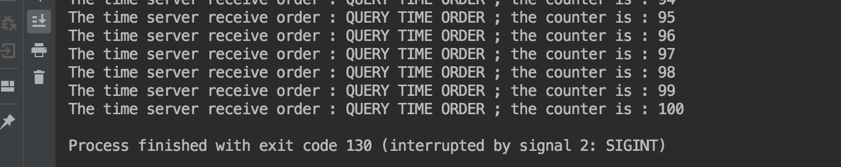

client输出：

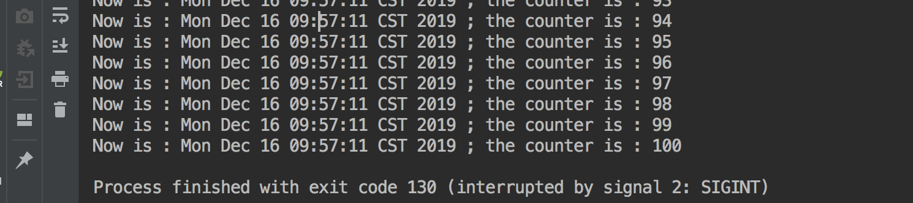

### 4.3.4 LineBasedFrameDecoder和StringDecoder的原理

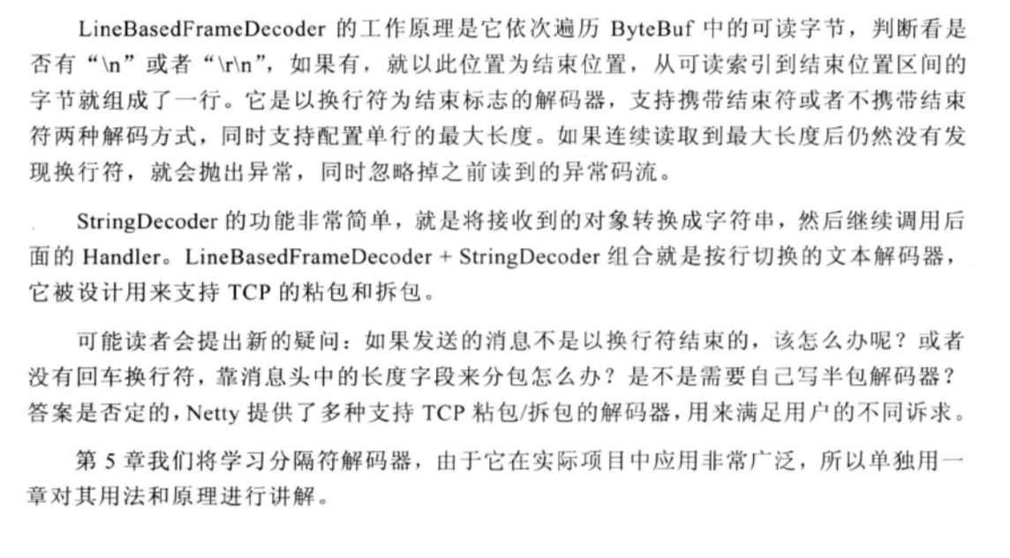

# 分隔符和定长解码器的应用

上层的应用协议为了对消息进行区分，往往采用如下4种方式。

1. 消息长度固定，累计读取到长度总和为定长LEN的报文后，就认为读取到了一个完整的消息；将计数器置位，重新开始读取下一个数据报。
2. 将回车换行符作为消息结束符，例如FTP协议，这种方式在文本协议中应用比较广泛
3. 将特殊的分隔符作为消息的结束标志，回车换行符就是一种特殊的结束分隔符
4. 通过在消息头中定义长度字段来表示消息的总长度。

## 5.1 DelimiterBasedFrameDecoder服务端和客户端

server

|  |
| --- |
| package com.netty.study.chapter05;  import io.netty.bootstrap.ServerBootstrap; import io.netty.buffer.ByteBuf; import io.netty.buffer.Unpooled; import io.netty.channel.ChannelFuture; import io.netty.channel.ChannelInitializer; import io.netty.channel.ChannelOption; import io.netty.channel.EventLoopGroup; import io.netty.channel.nio.NioEventLoopGroup; import io.netty.channel.socket.SocketChannel; import io.netty.channel.socket.nio.NioServerSocketChannel; import io.netty.handler.codec.DelimiterBasedFrameDecoder; import io.netty.handler.codec.string.StringDecoder; import io.netty.handler.logging.LogLevel; import io.netty.handler.logging.LoggingHandler;  public class EchoServer {   public void bind(int port) throws Exception {  // 配置服务端的NIO线程组  EventLoopGroup bossGroup = new NioEventLoopGroup();  EventLoopGroup workerGroup = new NioEventLoopGroup();   try {  ServerBootstrap b = new ServerBootstrap();  b.group(bossGroup, workerGroup)  .channel(NioServerSocketChannel.class)  .option(ChannelOption.*SO_BACKLOG*, 100)  .handler(new LoggingHandler(LogLevel.*INFO*))  .childHandler(new ChannelInitializer<SocketChannel>() {  @Override  protected void initChannel(SocketChannel socketChannel) throws Exception {  ByteBuf delimiter = Unpooled.*copiedBuffer*("$_".getBytes());  socketChannel.pipeline().addLast(new DelimiterBasedFrameDecoder(1024, delimiter));  socketChannel.pipeline().addLast(new StringDecoder());  socketChannel.pipeline().addLast(new EchoServerHandler());  }  });  // 绑定端口，同步等待成功  ChannelFuture f = b.bind(port).sync();   // 等待服务端监听端口关闭  f.channel().closeFuture().sync();  } finally {  bossGroup.shutdownGracefully();  workerGroup.shutdownGracefully();  }  }   public static void main(String[] args) throws Exception {  new EchoServer().bind(8080);  }   }  package com.netty.study.chapter05;  import io.netty.buffer.ByteBuf; import io.netty.buffer.Unpooled; import io.netty.channel.ChannelHandler; import io.netty.channel.ChannelHandlerAdapter; import io.netty.channel.ChannelHandlerContext; import io.netty.channel.ChannelHandlerInvoker; import io.netty.util.concurrent.EventExecutorGroup;  public class EchoServerHandler extends ChannelHandlerAdapter {   int counter = 0;   @Override  public void channelRead(ChannelHandlerContext ctx, Object msg) throws Exception {  String body = (String) msg;  System.*out*.println("This is " + (++counter) + " times receive client: [" + body + "]");  body += "$_";  ByteBuf echo = Unpooled.*copiedBuffer*(body.getBytes());  ctx.writeAndFlush(echo);  }   @Override  public void exceptionCaught(ChannelHandlerContext ctx, Throwable cause) throws Exception {  cause.printStackTrace();  ctx.close();// 发生异常，关闭链路  } } |

client

|  |
| --- |
| package com.netty.study.chapter05;  import io.netty.bootstrap.Bootstrap; import io.netty.buffer.ByteBuf; import io.netty.buffer.Unpooled; import io.netty.channel.ChannelFuture; import io.netty.channel.ChannelInitializer; import io.netty.channel.ChannelOption; import io.netty.channel.EventLoopGroup; import io.netty.channel.nio.NioEventLoopGroup; import io.netty.channel.socket.SocketChannel; import io.netty.channel.socket.nio.NioSocketChannel; import io.netty.handler.codec.DelimiterBasedFrameDecoder; import io.netty.handler.codec.string.StringDecoder;  public class EchoClient {    public void connect(int port, String host) throws Exception {  // 配置客户端NIO线程组  EventLoopGroup group = new NioEventLoopGroup();  try {  Bootstrap b = new Bootstrap();  b.group(group).channel(NioSocketChannel.class)  .option(ChannelOption.*TCP_NODELAY*,true)  .handler(new ChannelInitializer<SocketChannel>() {  @Override  protected void initChannel(SocketChannel socketChannel) throws Exception {  ByteBuf delimiter = Unpooled.*copiedBuffer*("$_".getBytes());  socketChannel.pipeline().addLast(new DelimiterBasedFrameDecoder(1024,delimiter));  socketChannel.pipeline().addLast(new StringDecoder());  socketChannel.pipeline().addLast(new EchoClientHandler());  }  });  // 发起异步连接操作  ChannelFuture f = b.connect(host,port).sync();   // 等待客户端链路关闭  f.channel().closeFuture().sync();  }finally {  // 优雅突出，释放NIO线程组  group.shutdownGracefully();  }  }   public static void main(String[] args) throws Exception {  new EchoClient().connect(8080,"127.0.0.1");  }  }  package com.netty.study.chapter05;  import io.netty.buffer.Unpooled; import io.netty.channel.ChannelHandlerAdapter; import io.netty.channel.ChannelHandlerContext;  public class EchoClientHandler extends ChannelHandlerAdapter {   private int counter;   static final String *ECHO_REQ* = "Hi,Lilinfeng. Welcome to Netty.$_";   public EchoClientHandler() {  }   @Override  public void channelActive(ChannelHandlerContext ctx) throws Exception {  for (int i = 0; i < 10; i++) {  ctx.writeAndFlush(Unpooled.*copiedBuffer*(*ECHO_REQ*.getBytes()));  }  }   @Override  public void channelRead(ChannelHandlerContext ctx, Object msg) throws Exception {  System.*out*.println("This is " + (++counter) + " times receive server : " + msg);  }   @Override  public void channelReadComplete(ChannelHandlerContext ctx) throws Exception {  ctx.flush();  }   @Override  public void exceptionCaught(ChannelHandlerContext ctx, Throwable cause) throws Exception {  cause.printStackTrace();  ctx.close();  } } |

## 5.2 FixedLengthFrameDecoder应用开发

server

|  |
| --- |
| package com.netty.study.chapter05;  import io.netty.bootstrap.ServerBootstrap; import io.netty.buffer.ByteBuf; import io.netty.buffer.Unpooled; import io.netty.channel.ChannelFuture; import io.netty.channel.ChannelInitializer; import io.netty.channel.ChannelOption; import io.netty.channel.EventLoopGroup; import io.netty.channel.nio.NioEventLoopGroup; import io.netty.channel.socket.SocketChannel; import io.netty.channel.socket.nio.NioServerSocketChannel; import io.netty.handler.codec.DelimiterBasedFrameDecoder; import io.netty.handler.codec.FixedLengthFrameDecoder; import io.netty.handler.codec.string.StringDecoder; import io.netty.handler.logging.LogLevel; import io.netty.handler.logging.LoggingHandler;  public class EchoServer2 {   public void bind(int port) throws Exception {  // 配置服务端的NIO线程组  EventLoopGroup bossGroup = new NioEventLoopGroup();  EventLoopGroup workerGroup = new NioEventLoopGroup();   try {  ServerBootstrap b = new ServerBootstrap();  b.group(bossGroup, workerGroup)  .channel(NioServerSocketChannel.class)  .option(ChannelOption.*SO_BACKLOG*, 100)  .handler(new LoggingHandler(LogLevel.*INFO*))  .childHandler(new ChannelInitializer<SocketChannel>() {  @Override  protected void initChannel(SocketChannel socketChannel) throws Exception {  socketChannel.pipeline().addLast(new FixedLengthFrameDecoder(20));  socketChannel.pipeline().addLast(new StringDecoder());  socketChannel.pipeline().addLast(new EchoServerHandler2());  }  });  // 绑定端口，同步等待成功  ChannelFuture f = b.bind(port).sync();   // 等待服务端监听端口关闭  f.channel().closeFuture().sync();  } finally {  bossGroup.shutdownGracefully();  workerGroup.shutdownGracefully();  }  }   public static void main(String[] args) throws Exception {  new EchoServer2().bind(8080);  }   }  package com.netty.study.chapter05;  import io.netty.buffer.ByteBuf; import io.netty.buffer.Unpooled; import io.netty.channel.ChannelHandlerAdapter; import io.netty.channel.ChannelHandlerContext;  public class EchoServerHandler2 extends ChannelHandlerAdapter {   int counter = 0;   @Override  public void channelRead(ChannelHandlerContext ctx, Object msg) throws Exception {  System.*out*.println("Receive client : [" + msg + "]");  }   @Override  public void exceptionCaught(ChannelHandlerContext ctx, Throwable cause) throws Exception {  cause.printStackTrace();  ctx.close();// 发生异常，关闭链路  } } |

# 编码技术

# MessagePack

# Protobuf

# JBoss

# Http协议开发应用

## 10.1 Http协议介绍

## 10.2 Netty Http服务器

文件服务器

|  |
| --- |
| package com.netty.study.chapter10;  import io.netty.bootstrap.ServerBootstrap; import io.netty.channel.ChannelFuture; import io.netty.channel.ChannelInitializer; import io.netty.channel.EventLoopGroup; import io.netty.channel.nio.NioEventLoopGroup; import io.netty.channel.socket.SocketChannel; import io.netty.channel.socket.nio.NioServerSocketChannel; import io.netty.handler.codec.http.HttpObjectAggregator; import io.netty.handler.codec.http.HttpRequestDecoder; import io.netty.handler.codec.http.HttpResponseEncoder; import io.netty.handler.stream.ChunkedWriteHandler;  public class HttpFileServer {   private static final String *DEFAULT_URL* = "/src/main/java/com/netty/study/";   public void run(final int port, final String url) throws Exception {  EventLoopGroup bossGroup = new NioEventLoopGroup();  EventLoopGroup workerGroup = new NioEventLoopGroup();   try {  ServerBootstrap b = new ServerBootstrap();  b.group(bossGroup, workerGroup)  .channel(NioServerSocketChannel.class)  .childHandler(new ChannelInitializer<SocketChannel>() {  @Override  protected void initChannel(SocketChannel ch) throws Exception {  ch.pipeline().addLast("http-decoder",  new HttpRequestDecoder()); // 请求消息解码器  ch.pipeline().addLast("http-aggregator",  new HttpObjectAggregator(65536));// 目的是将多个消息转换为单一的request或者response对象  ch.pipeline().addLast("http-encoder",  new HttpResponseEncoder());//响应解码器  ch.pipeline().addLast("http-chunked",  new ChunkedWriteHandler());//目的是支持异步大文件传输（）  ch.pipeline().addLast("fileServerHandler",  new HttpFileServerHandler(url));// 业务逻辑  }  });  ChannelFuture future = b.bind("150.223.208.248", port).sync();  System.*out*.println("Http 文件目录服务器启动，网址是： http://150.223.208.248:" + port + url);   future.channel().closeFuture().sync();  } finally {  bossGroup.shutdownGracefully();  workerGroup.shutdownGracefully();  }  }   public static void main(String[] args) throws Exception {  int port = 8080;   new HttpFileServer().run(port, *DEFAULT_URL*);    }  }  package com.netty.study.chapter10;  import io.netty.buffer.ByteBuf; import io.netty.buffer.Unpooled; import io.netty.channel.*; import io.netty.handler.codec.http.*; import io.netty.handler.stream.ChunkedFile; import io.netty.util.CharsetUtil;  import javax.activation.MimetypesFileTypeMap; import java.io.File; import java.io.FileNotFoundException; import java.io.RandomAccessFile; import java.io.UnsupportedEncodingException; import java.net.URLDecoder; import java.util.regex.Pattern;  import static io.netty.handler.codec.http.HttpVersion.*HTTP_1_1*;  public class HttpFileServerHandler extends SimpleChannelInboundHandler<FullHttpRequest> {    private String url;  private static final Pattern *INSECURE_URI* = Pattern.*compile*(".*[<>&\"].*");   private static final Pattern *ALLOWED_FILE_NAME* = Pattern  .*compile*("[A-Za-z0-9][-_A-Za-z0-9\\.]*");   public HttpFileServerHandler(String url) {  this.url = url;  }   @Override  protected void messageReceived(ChannelHandlerContext ctx, FullHttpRequest fullHttpRequest) throws Exception {  if (!fullHttpRequest.getDecoderResult().isSuccess()) {  sendError(ctx, HttpResponseStatus.*BAD_REQUEST*);  return;  }   if (fullHttpRequest.getMethod() != HttpMethod.*GET*) {  sendError(ctx, HttpResponseStatus.*METHOD_NOT_ALLOWED*);  return;  }   final String uri = fullHttpRequest.getUri();  final String path = sanitizeUri(uri);    if (path == null) {  sendError(ctx, HttpResponseStatus.*FORBIDDEN*);  return;  }   File file = new File(path);  if (file.isHidden() || !file.exists()) {  sendError(ctx, HttpResponseStatus.*NOT_FOUND*);  }   if (file.isDirectory()) {  if (uri.endsWith("/")) {  sendListing(ctx, file);  } else {  sendRedirect(ctx, uri + '/');  }  return;  }  if (!file.isFile()) {  sendError(ctx, HttpResponseStatus.*FORBIDDEN*);  return;  }    RandomAccessFile randomAccessFile = null;  try {  randomAccessFile = new RandomAccessFile(file, "r");// 以只读的方式打开文件  } catch (FileNotFoundException e) {  sendError(ctx, HttpResponseStatus.*NOT_FOUND*);  return;  }   long fileLength = randomAccessFile.length();   DefaultHttpResponse response = new DefaultHttpResponse(*HTTP_1_1*, HttpResponseStatus.*OK*);  HttpHeaders.*setContentLength*(response, fileLength);  setContentTypeHeader(response, file);    if (HttpHeaders.*isKeepAlive*(fullHttpRequest)) {  response.headers().set(HttpHeaders.Names.*CONNECTION*, HttpHeaders.Values.*KEEP_ALIVE*);  }   ctx.write(response);  ChannelFuture sendFileFuture;  sendFileFuture = ctx.write(new ChunkedFile(randomAccessFile, 0, fileLength, 8192), ctx.newProgressivePromise());   sendFileFuture.addListener(new ChannelProgressiveFutureListener() {  @Override  public void operationProgressed(ChannelProgressiveFuture future, long progress, long total) throws Exception {  if (total < 0) {  System.*out*.println("Transfer progress : " + progress);  } else {  System.*out*.println("Transfer progerss : " + progress + "/" + total);  }  }   @Override  public void operationComplete(ChannelProgressiveFuture future) throws Exception {  System.*out*.println("Transfer complete.");  }  });    ChannelFuture lastContentFuture = ctx.writeAndFlush(LastHttpContent.*EMPTY_LAST_CONTENT*);  if (!HttpHeaders.*isKeepAlive*(fullHttpRequest)) {  lastContentFuture.addListener(ChannelFutureListener.*CLOSE*);  }   }   private void sendRedirect(ChannelHandlerContext ctx, String newUri) {  FullHttpResponse response = new DefaultFullHttpResponse(*HTTP_1_1*, HttpResponseStatus.*FOUND*);  response.headers().set(HttpHeaders.Names.*LOCATION*, newUri);  ctx.writeAndFlush(response).addListener(ChannelFutureListener.*CLOSE*);  }   private void sendListing(ChannelHandlerContext ctx, File dir) {  FullHttpResponse response = new DefaultFullHttpResponse(*HTTP_1_1*, HttpResponseStatus.*OK*);  response.headers().set(HttpHeaders.Names.*CONTENT_TYPE*, "text/html; charset=UTF-8");  StringBuilder buf = new StringBuilder();  String dirPath = dir.getPath();  buf.append("<!DOCTYPE html>\r\n");  buf.append("<html><head><title>");  buf.append(dirPath);  buf.append(" 目录：");  buf.append("</title></head><body>\r\n");  buf.append("<h3>");  buf.append(dirPath).append(" 目录：");  buf.append("</h3>\r\n");  buf.append("<ul>");  buf.append("<li>链接：<a href=\"../\">..</a></li>\r\n");  for (File f : dir.listFiles()) {  if (f.isHidden() || !f.canRead()) {  continue;  }  String name = f.getName();  if (!*ALLOWED_FILE_NAME*.matcher(name).matches()) {  continue;  }  buf.append("<li>链接：<a href=\"");  buf.append(name);  buf.append("\">");  buf.append(name);  buf.append("</a></li>\r\n");  }  buf.append("</ul></body></html>\r\n");  ByteBuf buffer = Unpooled.*copiedBuffer*(buf, CharsetUtil.*UTF_8*);  response.content().writeBytes(buffer);  buffer.release();  ctx.writeAndFlush(response).addListener(ChannelFutureListener.*CLOSE*);  }   @Override  public void exceptionCaught(ChannelHandlerContext ctx, Throwable cause) throws Exception {  cause.printStackTrace();  if (ctx.channel().isActive()) {  sendError(ctx, HttpResponseStatus.*INTERNAL_SERVER_ERROR*);  }  }   private String sanitizeUri(String uri) {  try {  URLDecoder.*decode*(uri, "UTF-8");  } catch (UnsupportedEncodingException e) {  e.printStackTrace();  try {  uri = URLDecoder.*decode*(uri, "ISO-8859-1");  } catch (UnsupportedEncodingException ex) {  ex.printStackTrace();  throw new Error();  }  }   if (!uri.startsWith(url)) {  return null;  }   if (!uri.startsWith("/")) {  return null;  }   uri = uri.replace('/', File.*separatorChar*);   if (uri.contains(File.*separator* + ".") || uri.contains('.' + File.*separator*) || uri.startsWith(".") ||  uri.endsWith(".") || *INSECURE_URI*.matcher(uri).matches()) {  return null;  }   return System.*getProperty*("user.dir") + File.*separator* + uri;  }    private void setContentTypeHeader(DefaultHttpResponse response, File file) {  MimetypesFileTypeMap mimeTypesMap = new MimetypesFileTypeMap();  response.headers().set(HttpHeaders.Names.*CONTENT_TYPE*,  mimeTypesMap.getContentType(file.getPath()));   }    private void sendError(ChannelHandlerContext ctx, HttpResponseStatus status) {  FullHttpResponse response = new DefaultFullHttpResponse(*HTTP_1_1*,  status, Unpooled.*copiedBuffer*("Failure: " + status.toString()  + "\r\n", CharsetUtil.*UTF_8*));  response.headers().set(HttpHeaders.Names.*CONTENT_TYPE*, "text/plain; charset=UTF-8");  ctx.writeAndFlush(response).addListener(ChannelFutureListener.*CLOSE*);  } } |

# WebSocket协议开发

## 11.1 HTTP协议的弊端

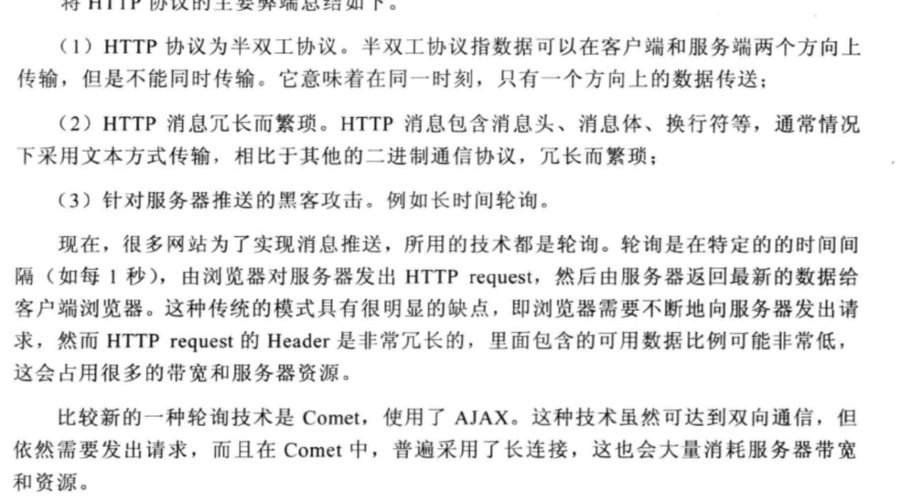

## 11.2 WebSocket入门

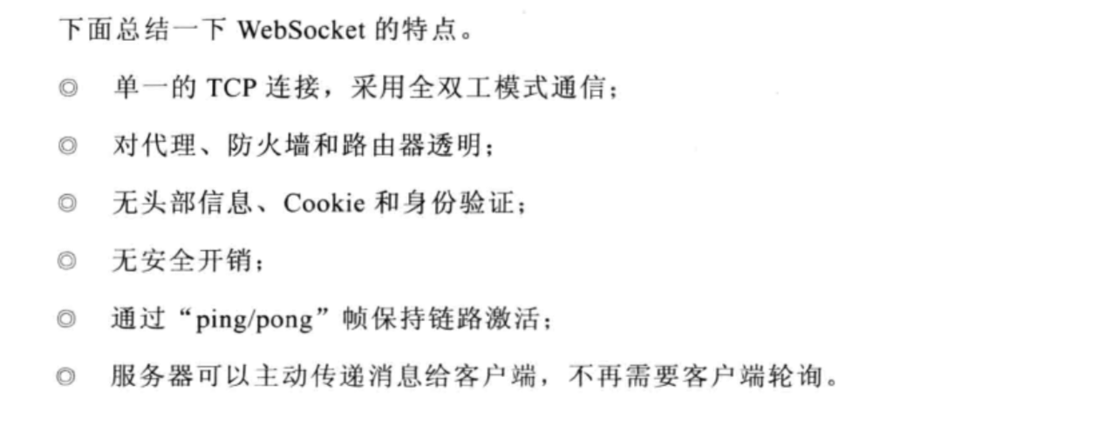

## 11.3 Netty WebSocket协议开发

服务端

|  |
| --- |
| package com.netty.study.chapter11;  import io.netty.bootstrap.ServerBootstrap; import io.netty.channel.Channel; import io.netty.channel.ChannelInitializer; import io.netty.channel.ChannelPipeline; import io.netty.channel.EventLoopGroup; import io.netty.channel.nio.NioEventLoopGroup; import io.netty.channel.socket.SocketChannel; import io.netty.channel.socket.nio.NioServerSocketChannel; import io.netty.handler.codec.http.HttpObjectAggregator; import io.netty.handler.codec.http.HttpServerCodec; import io.netty.handler.stream.ChunkedWriteHandler;  public class WebSocketServer {    public void run(int port) throws Exception {  EventLoopGroup bossGroup = new NioEventLoopGroup();  EventLoopGroup workerGroup = new NioEventLoopGroup();   try {  ServerBootstrap b = new ServerBootstrap();  b.group(bossGroup, workerGroup)  .channel(NioServerSocketChannel.class)  .childHandler(new ChannelInitializer<SocketChannel>() {  @Override  protected void initChannel(SocketChannel ch) throws Exception {  ChannelPipeline pipeline = ch.pipeline();  pipeline.addLast("http-codec", new HttpServerCodec());  pipeline.addLast("aggregator", new HttpObjectAggregator(65536));  pipeline.addLast("http-chunked", new ChunkedWriteHandler());  pipeline.addLast("handler", new WebSocketServerHandler());  }  });  Channel ch = b.bind(port).sync().channel();  System.*out*.println("Web socket server started at port " + port + ".");  System.*out*.println("Open your browser and navigate to http://localhost: " + port + "/");  ch.closeFuture().sync();  } finally {  bossGroup.shutdownGracefully();  workerGroup.shutdownGracefully();  }    }   public static void main(String[] args) throws Exception {  new WebSocketServer().run(8080);   }   }  package com.netty.study.chapter11;  import io.netty.buffer.ByteBuf; import io.netty.buffer.Unpooled; import io.netty.channel.ChannelFuture; import io.netty.channel.ChannelFutureListener; import io.netty.channel.ChannelHandlerContext; import io.netty.channel.SimpleChannelInboundHandler; import io.netty.handler.codec.http.*; import io.netty.handler.codec.http.websocketx.*; import io.netty.util.CharsetUtil;  import java.util.Date;  public class WebSocketServerHandler extends SimpleChannelInboundHandler<Object> {   private WebSocketServerHandshaker handshaker;    protected void messageReceived(ChannelHandlerContext ctx, Object msg) throws Exception {  // 传通的HTTP接入  if (msg instanceof FullHttpRequest) {  handleHttpRequest(ctx, (FullHttpRequest) msg);  }  // WebSocket 接入  else if (msg instanceof WebSocketFrame) {  handleWebSocketFrame(ctx, (WebSocketFrame) msg);  }  }    @Override  public void channelReadComplete(ChannelHandlerContext ctx) throws Exception {  ctx.flush();  }   @Override  public void exceptionCaught(ChannelHandlerContext ctx, Throwable cause) throws Exception {  cause.printStackTrace();  ctx.close();  }   private void handleWebSocketFrame(ChannelHandlerContext ctx, WebSocketFrame frame) {  // 判断是否关闭链路的指令  if (frame instanceof CloseWebSocketFrame) {  handshaker.close(ctx.channel(), (CloseWebSocketFrame) frame.retain());  return;  }   // 判断是否是Ping消息  if (frame instanceof PingWebSocketFrame) {  ctx.channel().write(new PongWebSocketFrame(frame.content().retain()));  return;  }   // 本例程仅支持文本消息，不支持二进制消息  if (!(frame instanceof TextWebSocketFrame)) {  throw new UnsupportedOperationException(String.*format*("%s frame types not supported", frame.getClass().getName()));  }   // 返回应答消息  String request = ((TextWebSocketFrame) frame).text();   ctx.channel().write(new TextWebSocketFrame(request + ",欢迎使用Netty WebSocket服务，现在时刻：" + new Date().toString()));   }   private void handleHttpRequest(ChannelHandlerContext ctx, FullHttpRequest req) {  if (!req.getDecoderResult().isSuccess() || (!"websocket".equals(req.headers().get("Upgrade")))) {  sendHttpResponse(ctx, req, new DefaultFullHttpResponse(HttpVersion.*HTTP_1_1*, HttpResponseStatus.*BAD_REQUEST*));  return;  }   // 构造握手响应返回，本机测试  WebSocketServerHandshakerFactory wsFactory = new WebSocketServerHandshakerFactory("ws://localhost:8080/websocket", null, false);  handshaker = wsFactory.newHandshaker(req);   if (handshaker == null) {  WebSocketServerHandshakerFactory.*sendUnsupportedWebSocketVersionResponse*(ctx.channel());  } else {  handshaker.handshake(ctx.channel(), req);  }    }   private void sendHttpResponse(ChannelHandlerContext ctx, FullHttpRequest req, FullHttpResponse res) {  // 返回应答客户端  if (res.getStatus().code() != 200) {  ByteBuf buf = Unpooled.*copiedBuffer*(res.getStatus().toString(), CharsetUtil.*UTF_8*);  res.content().writeBytes(buf);  buf.release();  HttpHeaders.*setContentLength*(res, res.content().readableBytes());  }   // 如果是非Keep-Alive，关闭连接  ChannelFuture f = ctx.channel().writeAndFlush(res);  if (!HttpHeaders.*isKeepAlive*(req) || res.getStatus().code() != 200) {  f.addListener(ChannelFutureListener.*CLOSE*);  }  } } |

客户端

|  |
| --- |
| <!DOCTYPE html>  <html>  <head>  <title>时间服务器</title>  </head>  <body>  <script type="text/javascript">    var socket;  if(!window.WebSocket){  window.WebSocket = window.MozWebSocket  }  if(window.WebSocket){  socket = new WebSocket("ws://localhost:8080/websocket");  socket.onmessage = function(event){  var ta = document.getElementById("responseText");  ta.value = "";  ta.value = event.data;  }  socket.onopen = function(event){  var ta = document.getElementById("responseText");  ta.value = "打开WebSocket服务器正常，浏览器支持WebSocket！";  }    socket.onclose = function(event){  var ta = document.getElementById("responseText");  ta.value = "";  ta.value = "WebSocket 关闭";  }  }else{  alert("抱歉，您的浏览器不支持WebSocket协议");  }  function send(message){  if(!window.WebSocket){  return;  }  if(socket.readyState == WebSocket.OPEN){  socket.send(message);  }else{  alert("WebSocket 连接没有建立成功！");  }  }  </script>  <form onsubmit="return false;">  <input type="text" name="message" value="Netty最佳实践">  <br>  <input type="button" value="发送WebSocket 请求消息" onclick="send(this.form.message.value)">  <hr color="blue"/>  <h3>服务端返回的应答消息</h3>  <textarea id="responseText" style="width: 500px;height: 300px;"></textarea>  </form>    </body>  </html> |

# 私有协议栈开发

## 12.2 Netty协议栈功能的设计

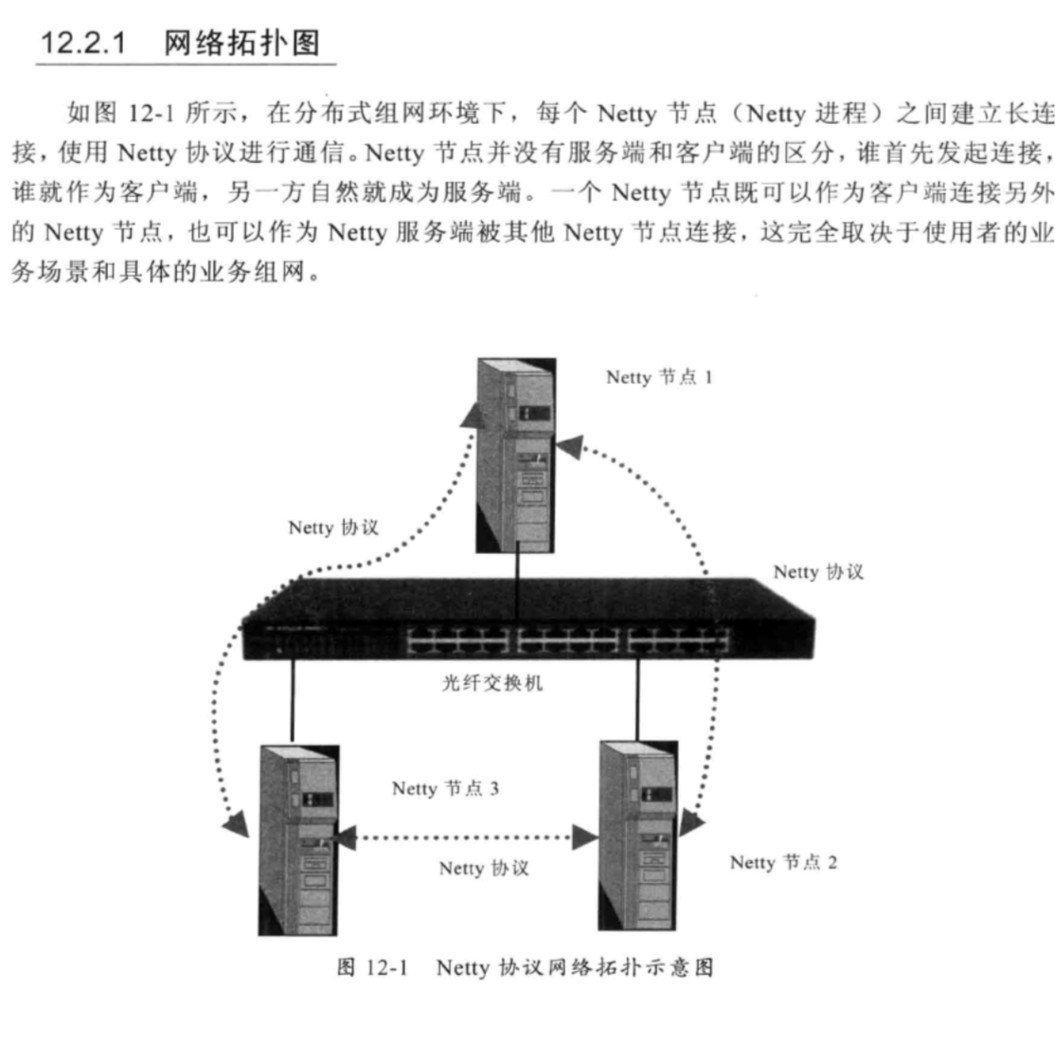

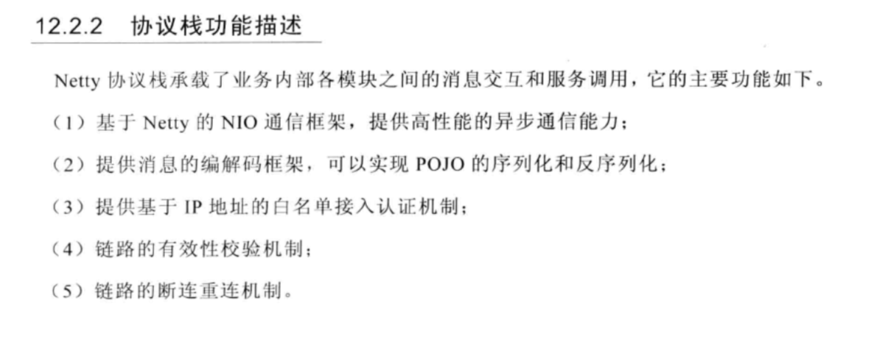

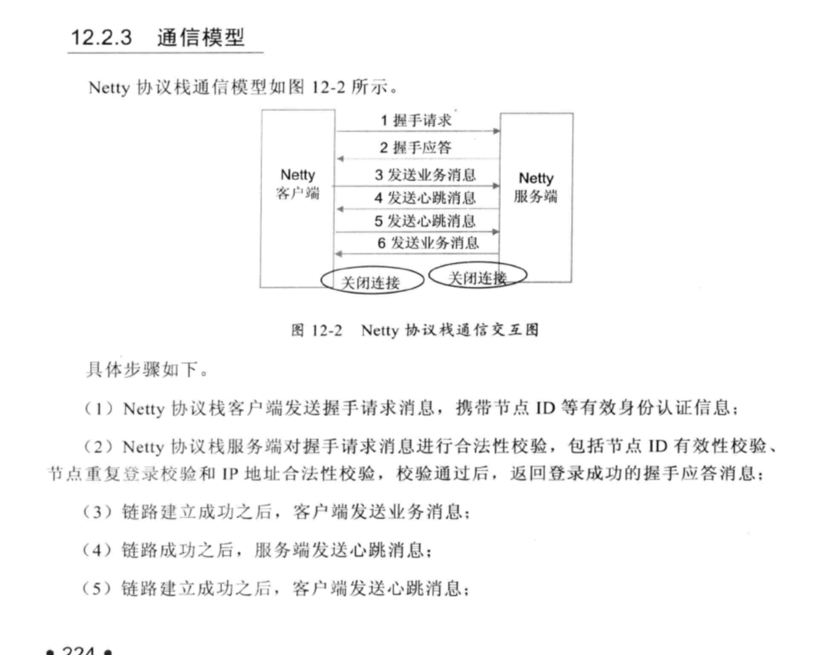

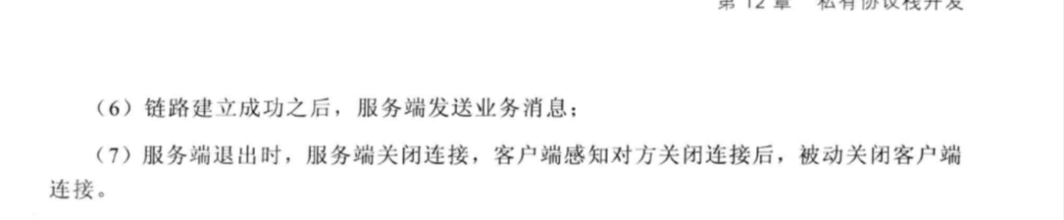

## 12.2.9 可靠性设计

1. 心跳机制

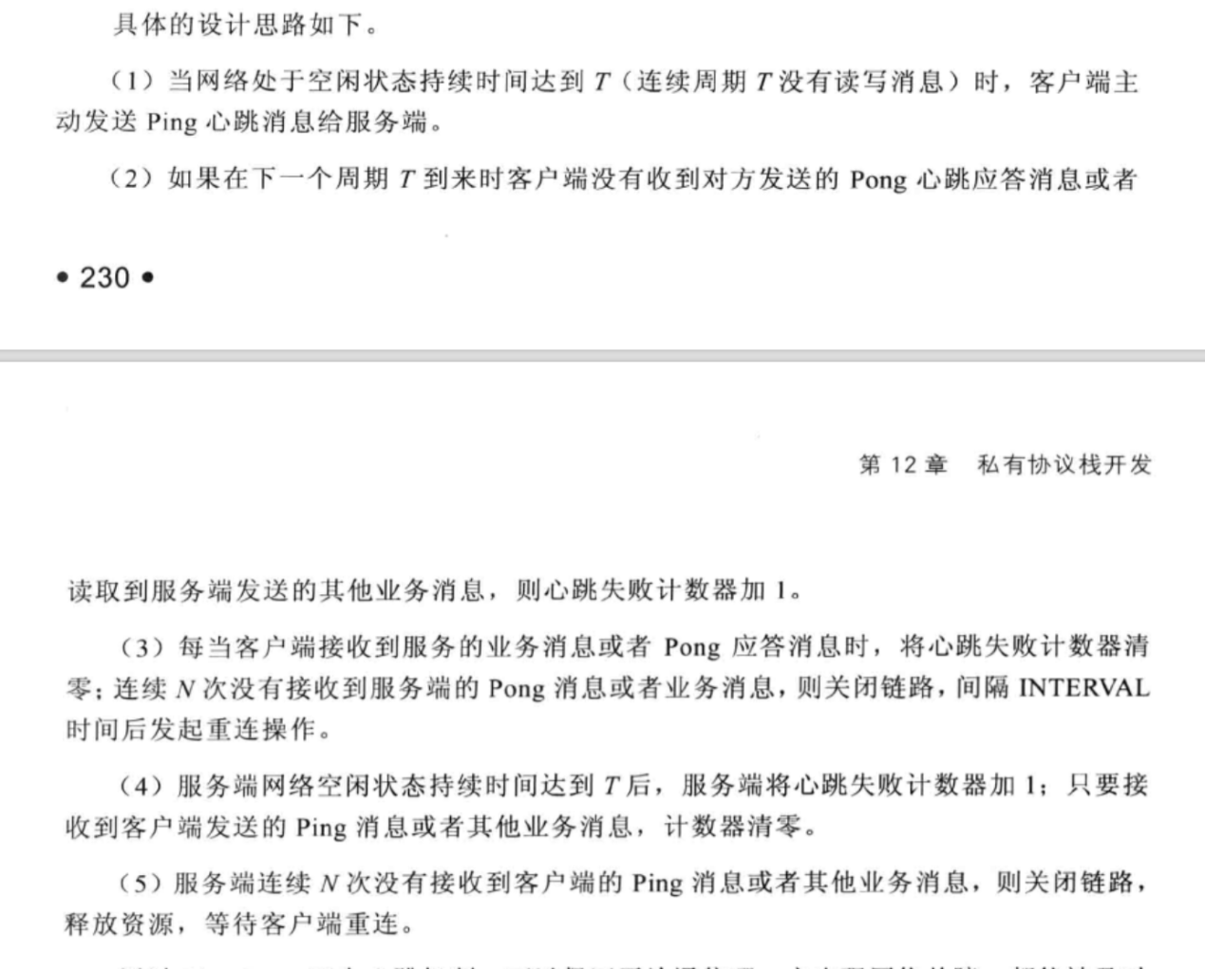

1. 重连机制
2. 重复登录保护
3. 消息缓存重发

## 12.2.10 安全性设计

## 12.2.11 可扩展性设计

## 12.2 Netty协议栈开发

# 服务端创建

### 13.2.1 Netty 服务端创建时序图

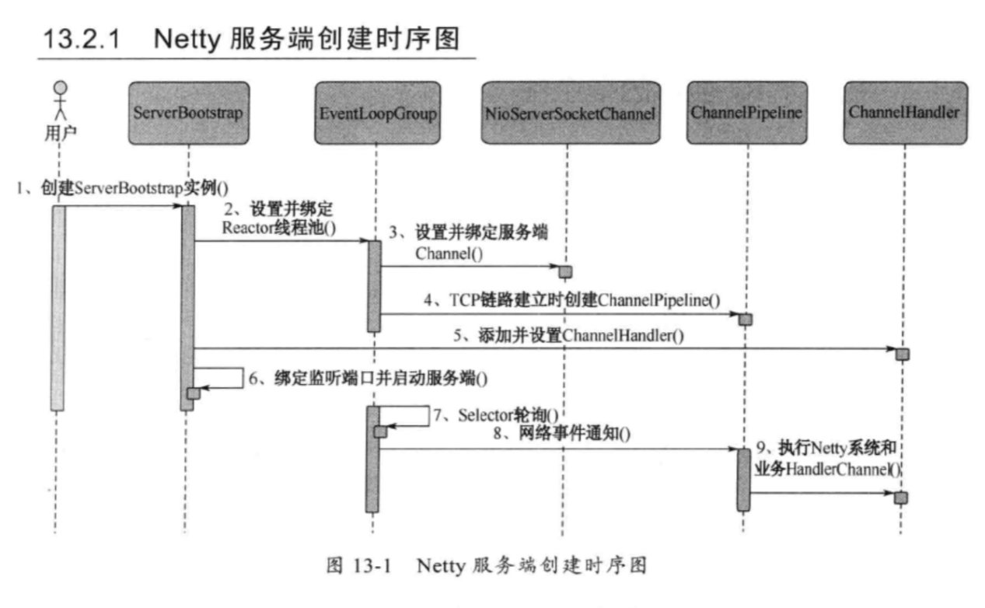

# 客户端创建

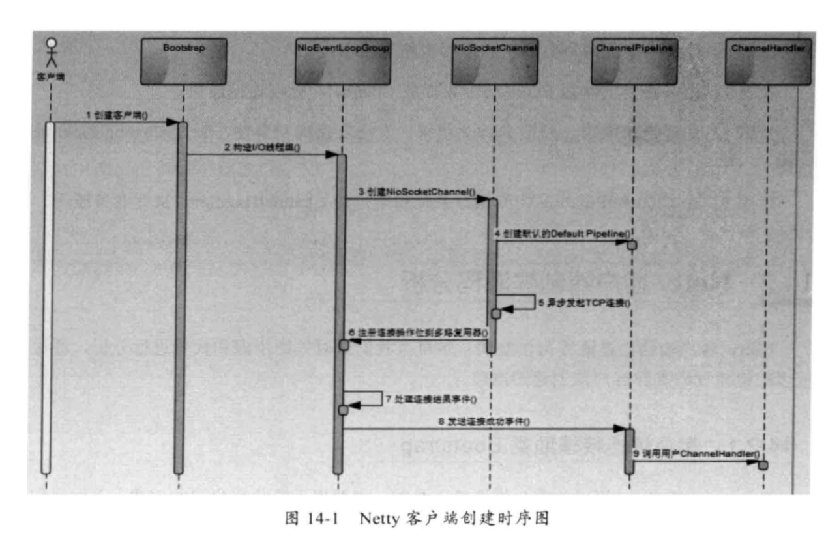

# ByteBuf和相关辅助类

## 15.1 ByteBuf功能说明

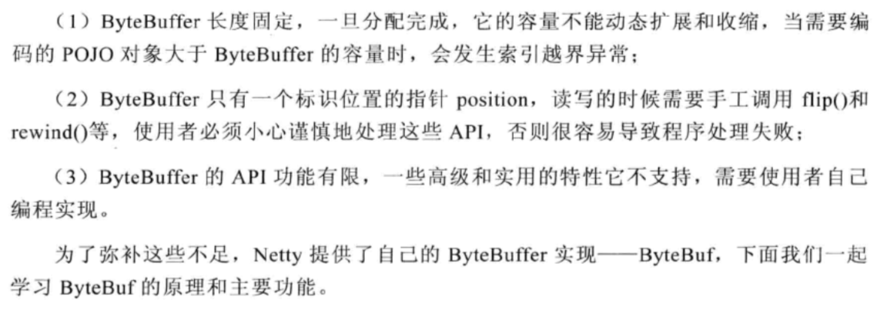

ByteBuf依然是个Byte数组的缓冲区，它的基本功能应该与JDK的ByteBuffer一致，提供一下积累基本功能：

1.7种Java基础类型、byte数组

1. 缓冲区自身的copy和slice等
2. 设置网络字节序
3. 构造缓冲实例
4. 操作位置指针等方法

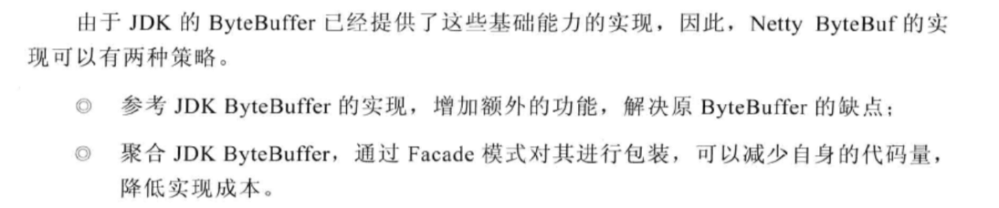

### 15.1.2 ByteBuf功能介绍

1. 顺序读操作（read）
2. 顺序写操作(write)
3. readerIndex和writerIndex

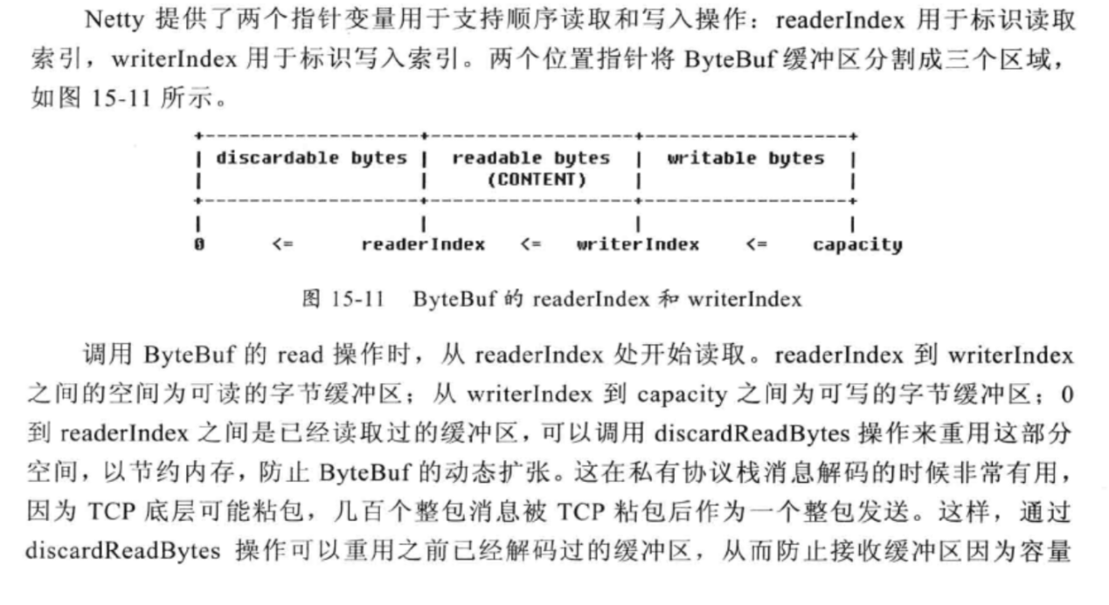

1. Discardable bytes

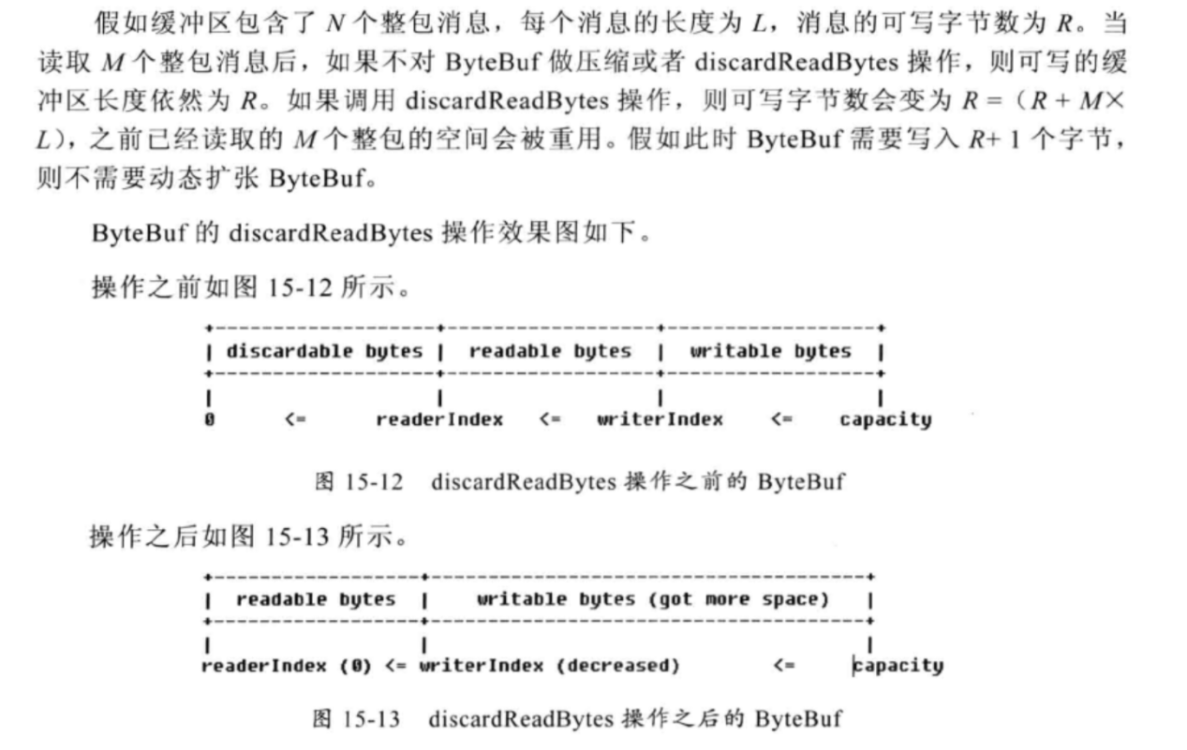

1. Readable bytes和Writable bytes
2. clear操作

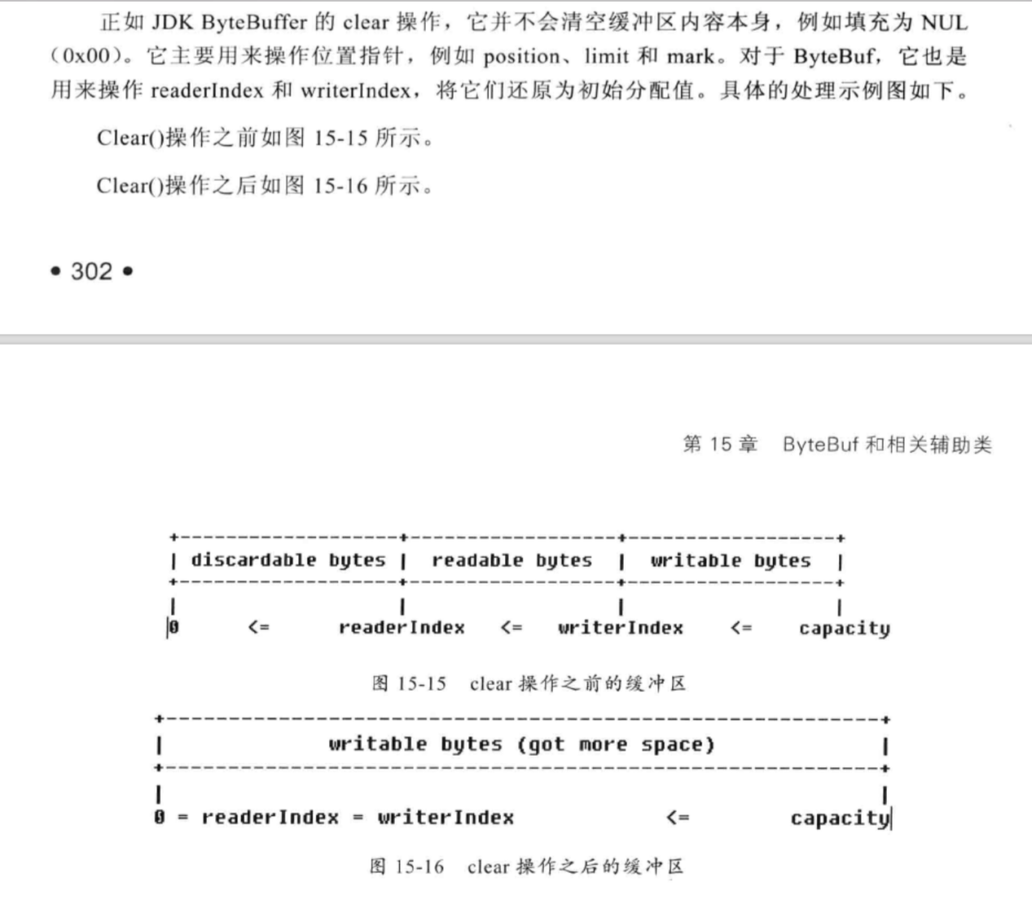

1. Mark和Rest

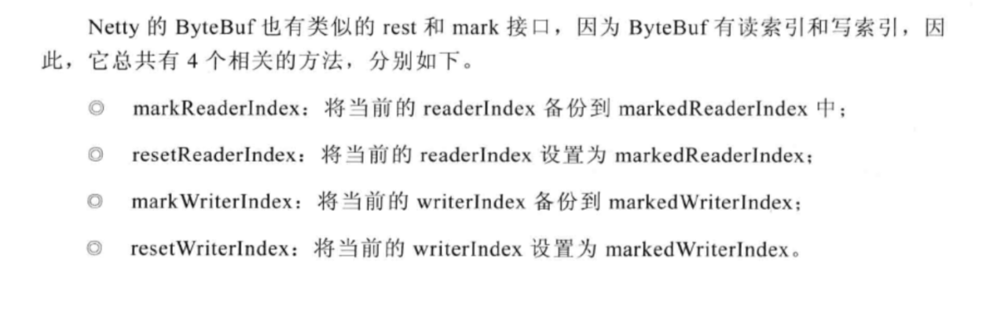

1. 查找操作
2. Derived buffers

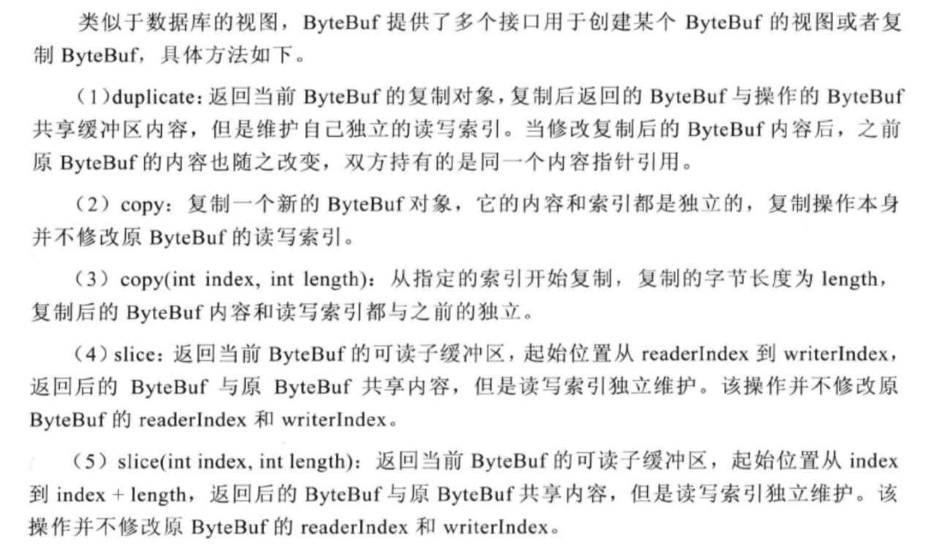

1. 转换成标准的ByteBuffer

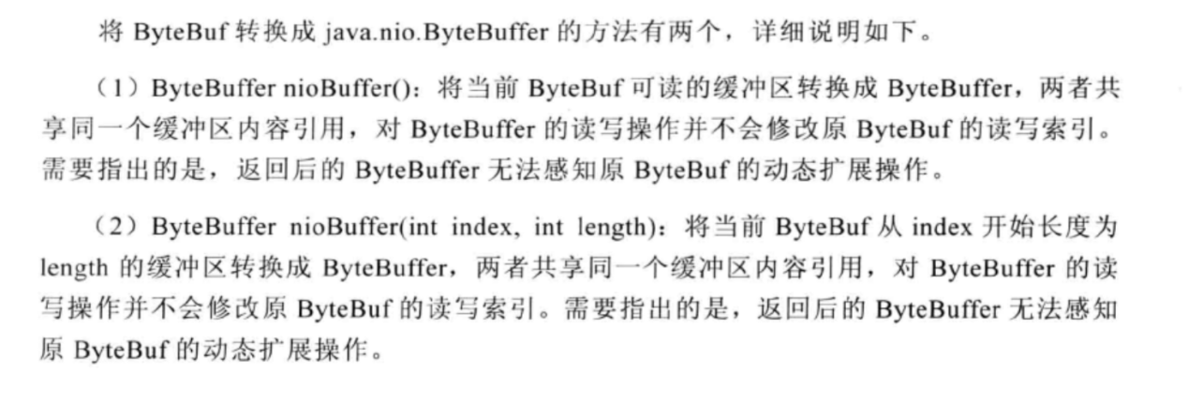

1. 随机读写(set和get)

## 15.2 ByteBuf源码分析

### 15.2.1 ByteBuf主要类继承关系

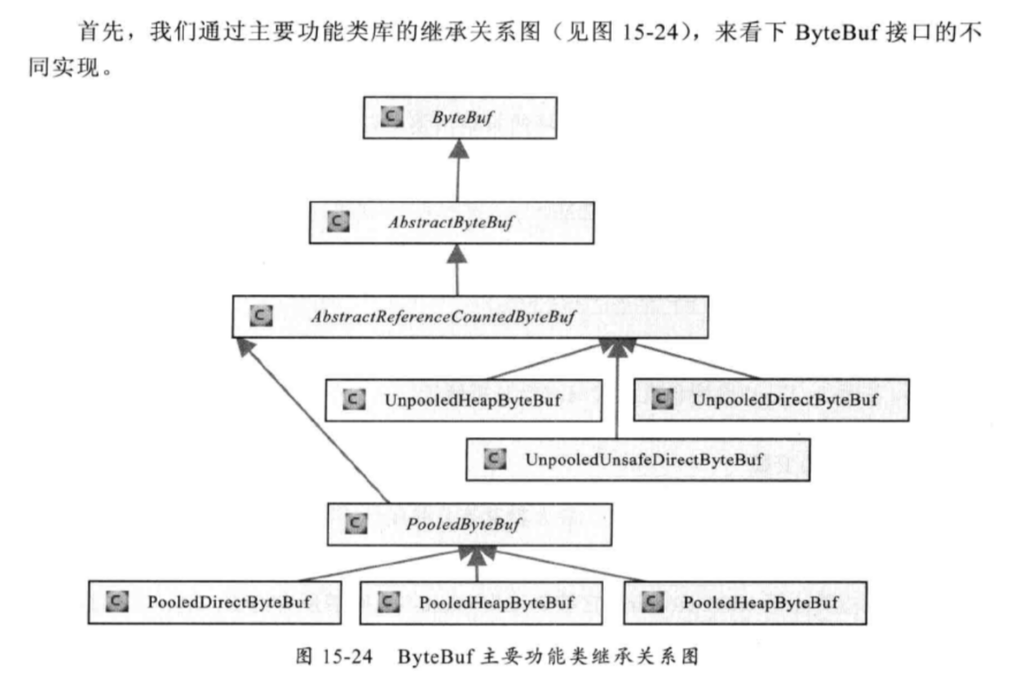

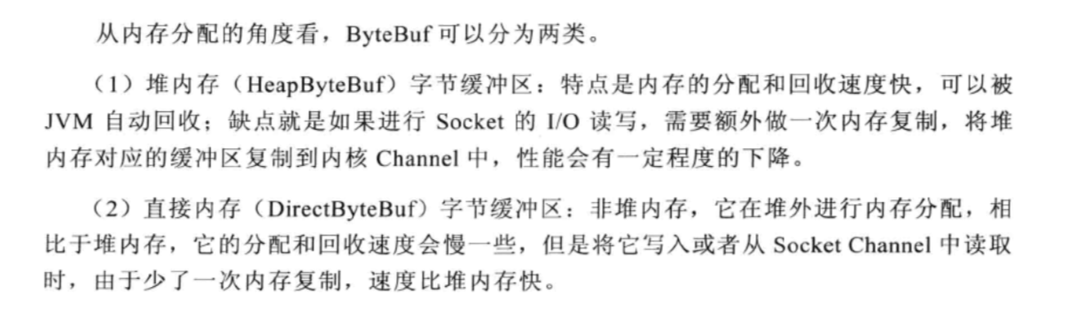

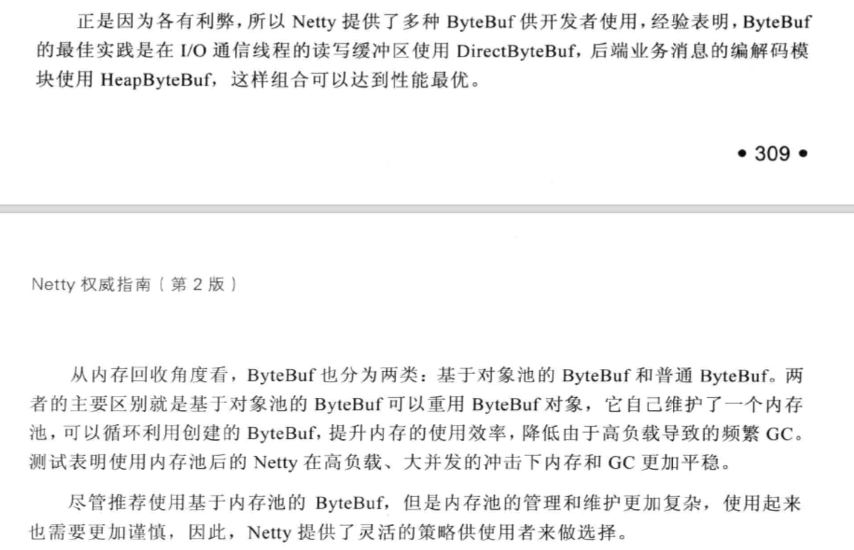

### 15.2.2 AbstractByteBuf源码分析

成员变量

|  |
| --- |
| static final ResourceLeakDetector<ByteBuf> *leakDetector* = new ResourceLeakDetector<ByteBuf>(ByteBuf.class);  int readerIndex; private int writerIndex; private int markedReaderIndex; private int markedWriterIndex;  private int maxCapacity;  leakDetector，用于检测对象是否泄漏 |

读操作

|  |
| --- |
| public ByteBuf readBytes(byte[] dst, int dstIndex, int length) {  // 校验是否可读  checkReadableBytes(length);  // 复制到目标数组中  getBytes(readerIndex, dst, dstIndex, length);  readerIndex += length;  return this; }  protected final void checkReadableBytes(int minimumReadableBytes) {  ensureAccessible();  if (minimumReadableBytes < 0) {  throw new IllegalArgumentException("minimumReadableBytes: " + minimumReadableBytes + " (expected: >= 0)");  }  if (readerIndex > writerIndex - minimumReadableBytes) {  throw new IndexOutOfBoundsException(String.*format*(  "readerIndex(%d) + length(%d) exceeds writerIndex(%d): %s",  readerIndex, minimumReadableBytes, writerIndex, this));  } }  // 由子类实现  public abstract ByteBuf getBytes(int index, byte[] dst, int dstIndex, int length); |

写操作

|  |
| --- |
| public ByteBuf writeBytes(byte[] src, int srcIndex, int length) {  ensureWritable(length);  setBytes(writerIndex, src, srcIndex, length);  writerIndex += length;  return this; }  // 确保可以写  public ByteBuf ensureWritable(int minWritableBytes) {  if (minWritableBytes < 0) {  throw new IllegalArgumentException(String.*format*(  "minWritableBytes: %d (expected: >= 0)", minWritableBytes));  }   if (minWritableBytes <= writableBytes()) {  return this;  }   if (minWritableBytes > maxCapacity - writerIndex) {  throw new IndexOutOfBoundsException(String.*format*(  "writerIndex(%d) + minWritableBytes(%d) exceeds maxCapacity(%d): %s",  writerIndex, minWritableBytes, maxCapacity, this));  }   // Normalize the current capacity to the power of 2.  // 计算东塔爱扩容的容量  int newCapacity = calculateNewCapacity(writerIndex + minWritableBytes);   // Adjust to the new capacity.  // 进行扩容  capacity(newCapacity);  return this; }    // 扩容操作，由子类实现  public abstract ByteBuf capacity(int newCapacity); |

1. 操作索引
2. 重置缓冲区

|  |
| --- |
| public ByteBuf discardReadBytes() {  ensureAccessible();  if (readerIndex == 0) {  return this;  }   if (readerIndex != writerIndex) {  // 将可读的的索引复制到缓冲区的初始位置  setBytes(0, this, readerIndex, writerIndex - readerIndex);  writerIndex -= readerIndex;  // 调整markedReaderIndex和markedWriterIndex  adjustMarkers(readerIndex);  readerIndex = 0;  } else {  adjustMarkers(readerIndex);  writerIndex = readerIndex = 0;  }  return this; }  protected final void adjustMarkers(int decrement) {  int markedReaderIndex = this.markedReaderIndex;  if (markedReaderIndex <= decrement) {  this.markedReaderIndex = 0;  int markedWriterIndex = this.markedWriterIndex;  if (markedWriterIndex <= decrement) {  this.markedWriterIndex = 0;  } else {  this.markedWriterIndex = markedWriterIndex - decrement;  }  } else {  this.markedReaderIndex = markedReaderIndex - decrement;  markedWriterIndex -= decrement;  } } |

1. skipBytes

|  |
| --- |
| public ByteBuf skipBytes(int length) {  checkReadableBytes(length);   int newReaderIndex = readerIndex + length;  if (newReaderIndex > writerIndex) {  throw new IndexOutOfBoundsException(String.*format*(  "length: %d (expected: readerIndex(%d) + length <= writerIndex(%d))",  length, readerIndex, writerIndex));  }  readerIndex = newReaderIndex;  return this; } |

### 15.2.3 AbstractReferenceCountedByteBuf源码分析

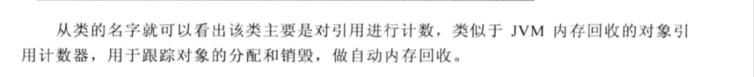

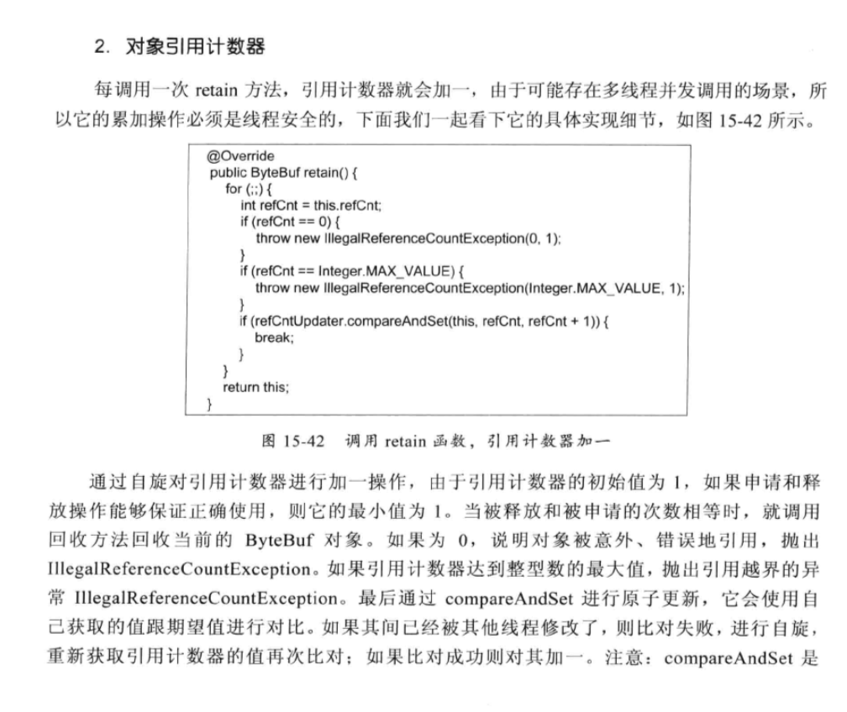

### 15.2.4 UnpooledHeapByteBuf源码分析

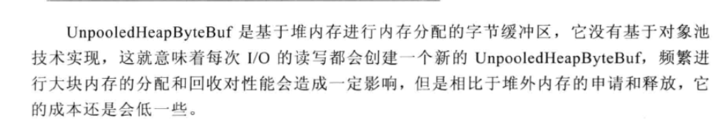

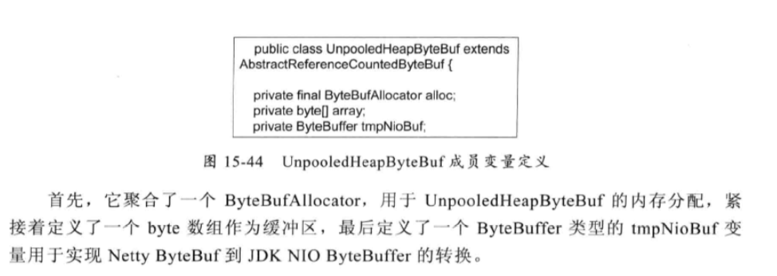

|  |
| --- |
| public ByteBuf capacity(int newCapacity) {  ensureAccessible();  if (newCapacity < 0 || newCapacity > maxCapacity()) {  throw new IllegalArgumentException("newCapacity: " + newCapacity);  }   int oldCapacity = array.length;  if (newCapacity > oldCapacity) {  byte[] newArray = new byte[newCapacity];  System.*arraycopy*(array, 0, newArray, 0, array.length);  setArray(newArray);  } else if (newCapacity < oldCapacity) {  byte[] newArray = new byte[newCapacity];  int readerIndex = readerIndex();  if (readerIndex < newCapacity) {  int writerIndex = writerIndex();  if (writerIndex > newCapacity) {  writerIndex(writerIndex = newCapacity);  }  System.*arraycopy*(array, readerIndex, newArray, readerIndex, writerIndex - readerIndex);  } else {  setIndex(newCapacity, newCapacity);  }  setArray(newArray);  }  return this; }  字节数组复制  public ByteBuf setBytes(int index, byte[] src, int srcIndex, int length) {  checkSrcIndex(index, length, srcIndex, src.length);  System.*arraycopy*(src, srcIndex, array, index, length);  return this; }  protected final void checkSrcIndex(int index, int length, int srcIndex, int srcCapacity) {  checkIndex(index, length);  if (srcIndex < 0 || srcIndex > srcCapacity - length) {  throw new IndexOutOfBoundsException(String.*format*(  "srcIndex: %d, length: %d (expected: range(0, %d))", srcIndex, length, srcCapacity));  } } |

装换为JDK ByteBuffer

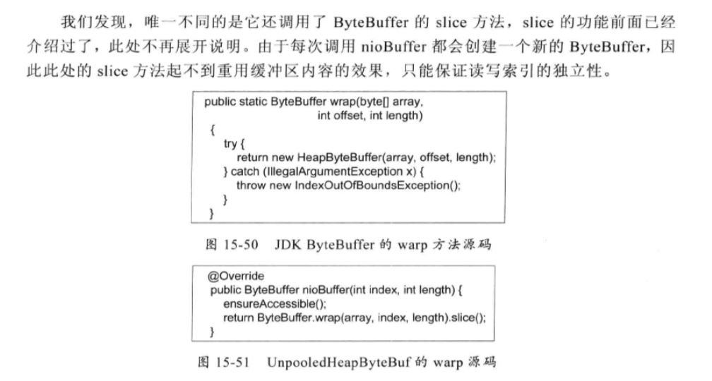

### 15.2.5 PooledByteBuf内存池原理分析

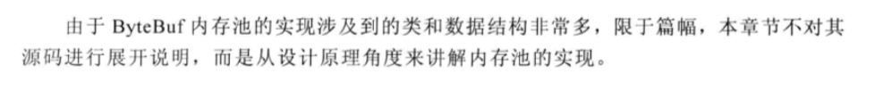

### 15.2.6 PooledDirectByteBuf源码分析

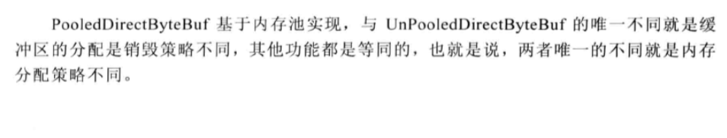

## 15.3 ByteBuf相关的辅助类功能介绍

### 15.3.1 ByteBufHolder

### 15.3.2 ByteBufAllcator

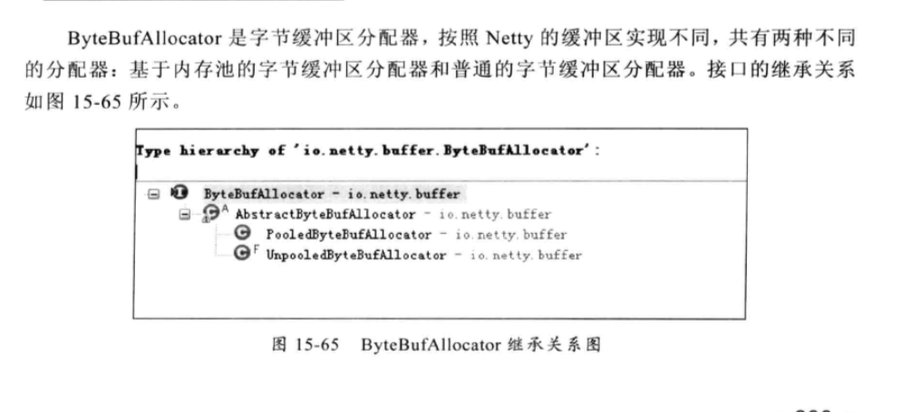

### 15.3.3 CompositeByteBuf

### 15.3.4 ByteBufUtil

# Channel和Unsafe

## 16.1 Channel功能说明

### 16.1.1 Channel 的工作原理

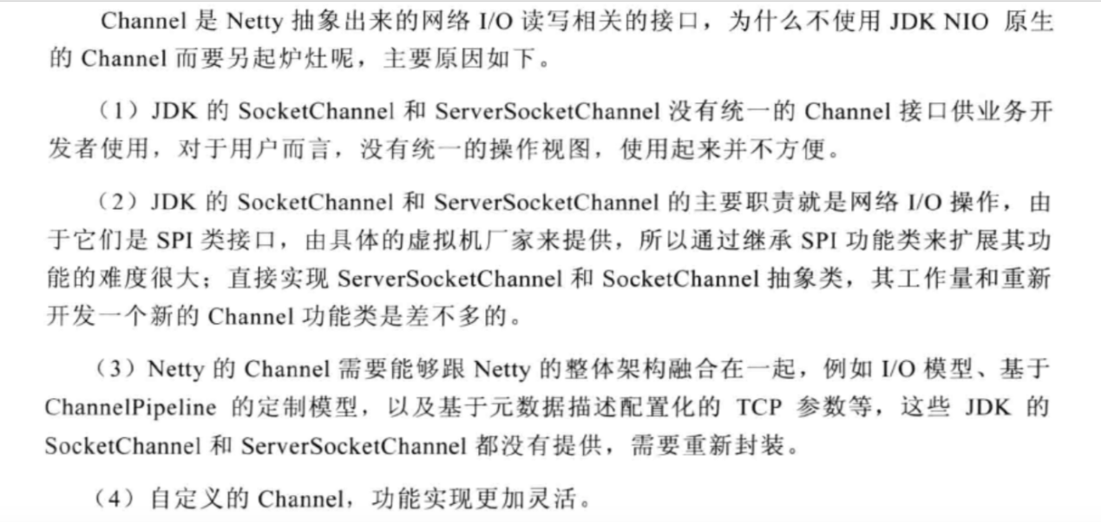

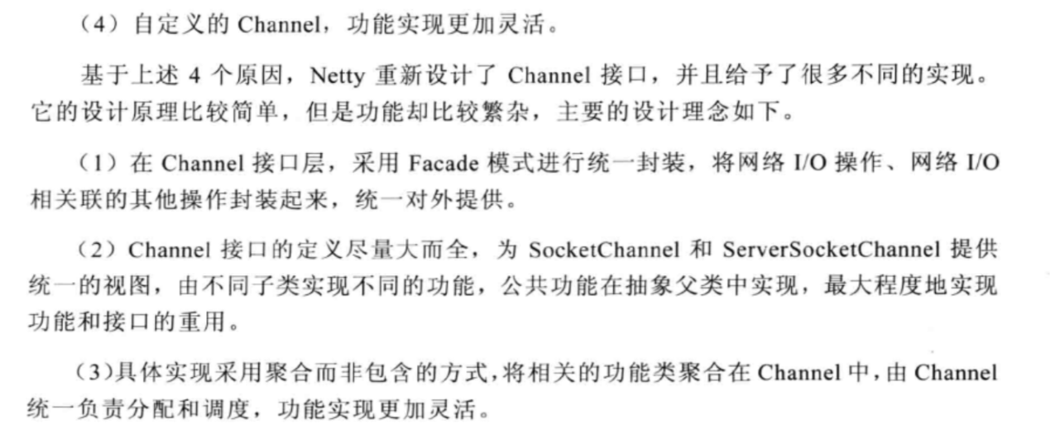

### 16.1.2 Channel的功能介绍

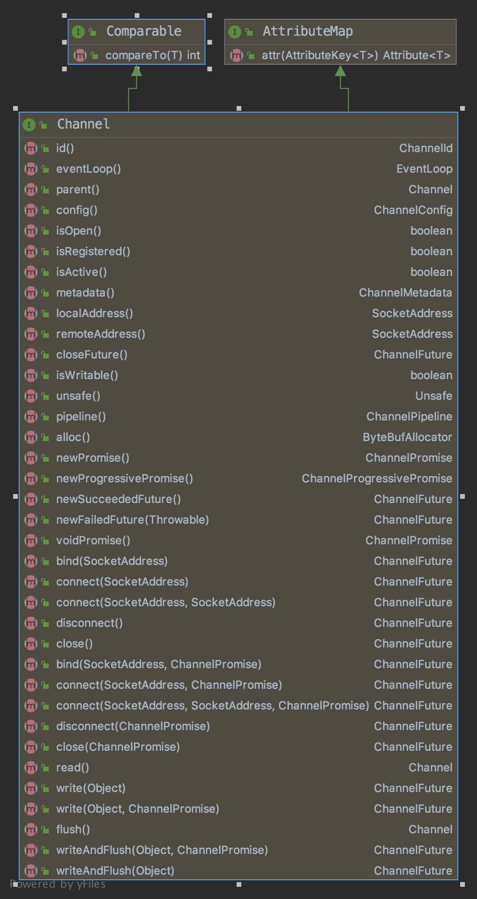

**网络IO操作**

1. Channel read():从当前的Channel中读取数据到第一个inbound缓冲区中，如果数据被成功读取，触发ChannelHandler.channelRead(ChannelHandlerContext,Object)事件。读取操作API调用完成之后，紧接着会触发ChannelHandler.channelReadComplete(ChannelHandlerContext)，这样业务的ChannelHandler可以决定是否需要继续读取数据。如果已经有读操作请求挂起，则后续的读操作会被忽略。
2. ChannelFuture write(Object msg):请求将当前msg通过ChannelPipeline写入到目标Channel中。write操作只是将消息存入到消息发送环形数组中。并没有真正发送，只有调用flush操作才会被写入到Channel中，发送给对方。
3. ChannelFuture write(Object msg,ChannelPromise promise)：功能与write(Object msg)相同，但是携带了ChannelPromise参数负责设置写入操作的结果。
4. ChannelFuture writeAndFlush(Object msg,ChannelPromise promise)：等价于write和flush操作组合
5. ChannelFuture writeAndFlush(Object msg)：功能等同于方法4
6. Channel flush():将之前写入到发送环形数组中的消息全部写入到目标Channel中，发送给通信对方。
7. ChannelFuture close(ChannelPromise promise)：主动关闭当前连接，通过Channel Promise设置操作结果并进行结果通知，无论操作是否成功，都可以通过ChannelPromise获取操作结果。该操作会级联触发ChannelPipeline中所有ChannelHandler的ChannelHandler。close(ChannelHandlerContext,ChannelPromise)事件
8. ChannelFuture disconnect(ChannelPromise promise):请求断开与远程通信对端连接并使用CHannelPromise来获取操作结果的通知消息。
9. ChannelFuture connect(SocketAddress remoteAddress)：客户端使用指定的服务端地址remoteAddress发起连接请求，如果连接因为应答超时而失败，ChannelFuture中的操作结果就是ConnectTimeoutException异常。
10. ChannelFuture connect(SocketAddress remoteAddress,SocketAddress localAddress):先绑定本地地址localAddress，然后再连接服务端。
11. ChannelFuture connect(SocketAddress remoteAddress,ChannelPromise promise)：
12. connect(SocketAddress remoteAddress,SocketAddreess localAddress,ChannelPromise promise):
13. ChannelFuture bind(SocketAddress localAddress)：绑定指定的本地Socket地址localAddress，该方法级联触发ChannelHandler.bind(ChannelHandlerContext SocketAddress,ChannelPromise)事件。
14. ChannelFuture bind(SocketAddress localAddress,ChannelPromise promise):
15. ChannelConfig config()：获取当前Channel的配置信息，例如CONNECT_TIMEOUT_MILLS。
16. boolean isOpen():判断当前Channel是否已经打开。
17. boolean isRegistered（）:判断当前Channel是否已经处于激活状态。
18. boolean isActive():判断当前Channel是否已经处于激活状态。
19. ChannelMetadata metadata():获取当前Channel的元数据描述信息，包括TCP参数配置等。
20. SocketAddress localAddress()：获取当前Channel的本地绑定地址。
21. SocketAddress remoteAddress():获取当前Channel通信的远程Socket地址。

**其他API**

## 16.2 Channel源码

### 16.2.1 Channel的主要继承关系类图

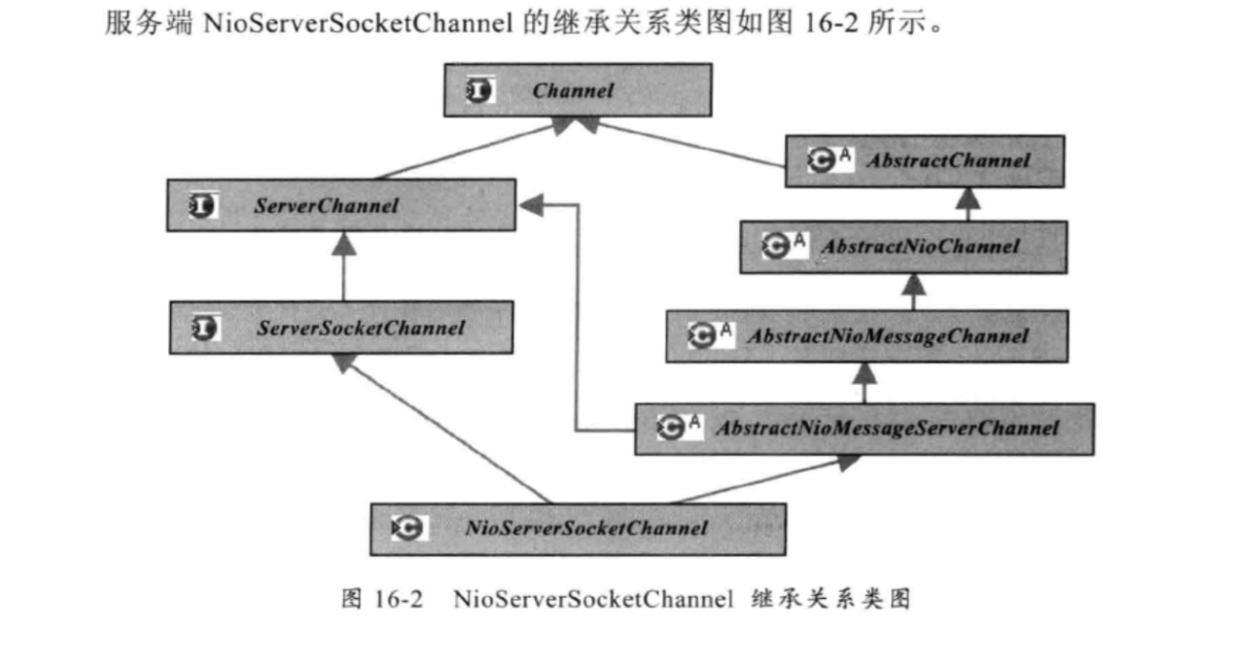

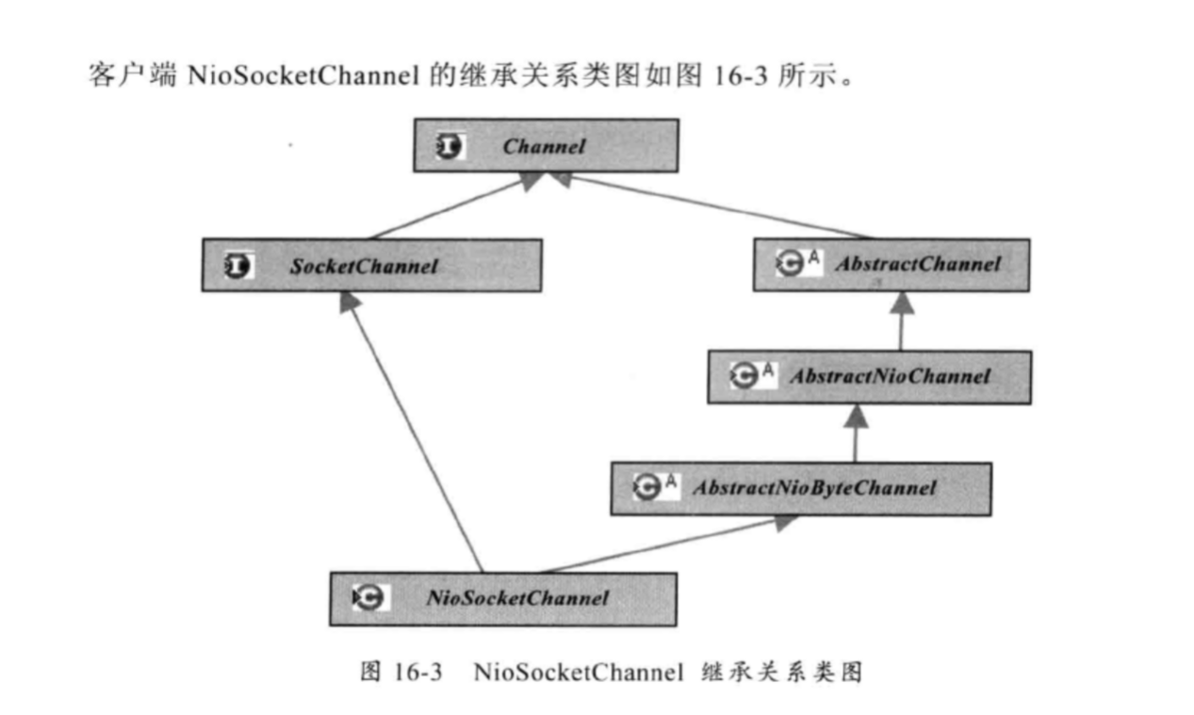

### 16.2.2 AbstractChannel

|  |
| --- |
| // 链路已经关闭已经异常  static final ClosedChannelException *CLOSED_CHANNEL_EXCEPTION* = new ClosedChannelException();  // 物理链路尚未建立异常 static final NotYetConnectedException *NOT_YET_CONNECTED_EXCEPTION* = new NotYetConnectedException();  static {  *CLOSED_CHANNEL_EXCEPTION*.setStackTrace(EmptyArrays.*EMPTY_STACK_TRACE*);  *NOT_YET_CONNECTED_EXCEPTION*.setStackTrace(EmptyArrays.*EMPTY_STACK_TRACE*); }  // 用于预测下一个报文的大小 private MessageSizeEstimator.Handle estimatorHandle; // 代表父类Channel private final Channel parent;  // 采用默认方式生成的全局唯一ID private final ChannelId id = DefaultChannelId.*newInstance*();  // Unsafe实例 private final Unsafe unsafe;  // 当前CHannel对应的DefaultChannelPipeline private final DefaultChannelPipeline pipeline;  private final ChannelFuture succeededFuture = new SucceededChannelFuture(this, null); private final VoidChannelPromise voidPromise = new VoidChannelPromise(this, true); private final VoidChannelPromise unsafeVoidPromise = new VoidChannelPromise(this, false); private final CloseFuture closeFuture = new CloseFuture(this);  private volatile SocketAddress localAddress; private volatile SocketAddress remoteAddress;  // 当前Channel注册的EventLoop private final EventLoop eventLoop; private volatile boolean registered;  */** Cache for the string representation of this channel */* private boolean strValActive; private String strVal; |

Netty基于事件驱动，当Channel进行IO操作时会产生对应的IO事件，然后驱动事件在ChannelPipeline中传播，由对应的ChannelHandler对时间进行拦截和处理。采用事件驱动的方式可以非常轻松地通过事件定义来划分事件拦截切面，相比AOP，器性能更高，但功能却基本等价。

网络IO直接调用DefaultChannelPipeline的相关方法，由DefaultChannelPipeline中对应的ChannelHandler进行具体的逻辑处理。

|  |
| --- |
| @Override public ChannelFuture connect(SocketAddress remoteAddress) {  return pipeline.connect(remoteAddress); }  @Override public ChannelFuture connect(SocketAddress remoteAddress, SocketAddress localAddress) {  return pipeline.connect(remoteAddress, localAddress); }  @Override public ChannelFuture disconnect() {  return pipeline.disconnect(); }  @Override public ChannelFuture close() {  return pipeline.close(); }  @Override public Channel flush() {  pipeline.flush();  return this; } |

|  |
| --- |
| @Override public SocketAddress remoteAddress() {  SocketAddress remoteAddress = this.remoteAddress;  if (remoteAddress == null) {  try {  this.remoteAddress = remoteAddress = unsafe().remoteAddress();  } catch (Throwable t) {  // Sometimes fails on a closed socket in Windows.  return null;  }  }  return remoteAddress; } |

### 16.2.3 AbstractNioChannel

|  |
| --- |
| private final SelectableChannel ch;  // 代表了JDK SelectionKey的OP_READ protected final int readInterestOp;  // 是Channel注册到EventLoop后返回的选择键。 private volatile SelectionKey selectionKey; private volatile boolean inputShutdown;  */**  * The future of the current connection attempt. If not null, subsequent  * connection attempts will fail.  */*  *// 代表连接操作结果的ChannelPromise以及连接超时定时器ScheduledFuture和请求的通信地址信息* private ChannelPromise connectPromise; private ScheduledFuture<?> connectTimeoutFuture; private SocketAddress requestedRemoteAddress; |

1. 核心源码

|  |
| --- |
| protected void doRegister() throws Exception {  boolean selected = false;  for (;;) {  try {  // 注册到EventLoop的多路复用器上  selectionKey = javaChannel().register(eventLoop().selector, 0, this);  return;  } catch (CancelledKeyException e) {  if (!selected) {  // Force the Selector to select now as the "canceled" SelectionKey may still be  // cached and not removed because no Select.select(..) operation was called yet.  eventLoop().selectNow();  selected = true;  } else {  // We forced a select operation on the selector before but the SelectionKey is still cached  // for whatever reason. JDK bug ?  throw e;  }  }  } } |

准备处理读操作之前需要设置网路操作位为读

|  |
| --- |
| protected void doBeginRead() throws Exception {  // 先判断Channel是否关闭  if (inputShutdown) {  return;  }  // 判断当前的SelectionKey是否可用  final SelectionKey selectionKey = this.selectionKey;  if (!selectionKey.isValid()) {  return;  }   final int interestOps = selectionKey.interestOps();  // 按位&判断，==0 说明没有设置读操作位  if ((interestOps & readInterestOp) == 0) {  // 设置读操作位  selectionKey.interestOps(interestOps | readInterestOp);  } } |

### 16.2.4 AbstractNioByteChannel

|  |
| --- |
| // 负责继续写半包消息  private Runnable flushTask; |

|  |
| --- |
| protected void doWrite(ChannelOutboundBuffer in) throws Exception {  int writeSpinCount = -1;   for (;;) {  // 环形数组ChannelOutboundBuffer 弹出一条消息  // 消息为空，说明消息都已经发送完成，清除半包标识，然后退出循环  Object msg = in.current(true);  if (msg == null) {  // Wrote all messages.  clearOpWrite();  break;  }   if (msg instanceof ByteBuf) {  ByteBuf buf = (ByteBuf) msg;  int readableBytes = buf.readableBytes();  if (readableBytes == 0) {  in.remove();  continue;  }  // 写半包标志，  boolean setOpWrite = false;  // 消息是否全部发送标识，  boolean done = false;  // 发送的总消息字节数  long flushedAmount = 0;  // 设置写半包最大循环次数的原因是当循环发送的时候，IO线程会一致尝  // 试进行写操作，此时IO线程无法处理其他的IO操作，例如读心的消息  // 或者执行定时任务和NioTask等，如果网络IO阻塞或者对方接收消息  // 太慢,可能会导致线程假死  if (writeSpinCount == -1) {  writeSpinCount = config().getWriteSpinCount();  }  for (int i = writeSpinCount - 1; i >= 0; i --) {  int localFlushedAmount = doWriteBytes(buf);  if (localFlushedAmount == 0) {  // 说明发送TCP缓冲区已满。需要退出循环  setOpWrite = true;  break;  }  // 消息总数累加  flushedAmount += localFlushedAmount;  if (!buf.isReadable()) {  done = true;  break;  }  }   in.progress(flushedAmount);   if (done) {  // 发送成功，将已经发送的消息从发送数组中删除；  in.remove();  } else {  // 设置写半包标识，启动刷新新线程继续发送之前没有发送完全的半  // 包消息  incompleteWrite(setOpWrite);  break;  }  } else if (msg instanceof FileRegion) {  FileRegion region = (FileRegion) msg;  boolean setOpWrite = false;  boolean done = false;  long flushedAmount = 0;  if (writeSpinCount == -1) {  writeSpinCount = config().getWriteSpinCount();  }  for (int i = writeSpinCount - 1; i >= 0; i --) {  long localFlushedAmount = doWriteFileRegion(region);  if (localFlushedAmount == 0) {  setOpWrite = true;  break;  }   flushedAmount += localFlushedAmount;  if (region.transfered() >= region.count()) {  done = true;  break;  }  }   in.progress(flushedAmount);   if (done) {  // 发送成功，将已经发送的消息从发送数组中删除；  in.remove();  } else {  // 设置写半包标识，启动刷新新线程继续发送之前没有发送完全的半  // 包消息  incompleteWrite(setOpWrite);  break;  }  } else {  throw new UnsupportedOperationException("unsupported message type: " + StringUtil.*simpleClassName*(msg));  }  } }  protected final void clearOpWrite() {  // 从当前SelectionKey中获取网络操作位，  final SelectionKey key = selectionKey();  final int interestOps = key.interestOps();  // interestOps & SelectionKey.*OP_WRITE 不等于0，说明当前的*  *//* SelectionKey 是isWritable的，需要清除写操作  if ((interestOps & SelectionKey.*OP_WRITE*) != 0) {  key.interestOps(interestOps & ~SelectionKey.*OP_WRITE*);  } }  protected final void incompleteWrite(boolean setOpWrite) {  // Did not write completely.  if (setOpWrite) {  setOpWrite();  } else {  // Schedule flush again later so other tasks can be picked up in the meantime  Runnable flushTask = this.flushTask;  if (flushTask == null) {  flushTask = this.flushTask = new Runnable() {  @Override  public void run() {  flush();  }  };  }  eventLoop().execute(flushTask);  } } |

### 16.2.5 AbstractNioMessageChannel

和上述AbstractNioByteChannel方法大致一样，AbstractNioMessageChannel发送的是

pojo对象。

|  |
| --- |
| protected void doWrite(ChannelOutboundBuffer in) throws Exception {  final SelectionKey key = selectionKey();  final int interestOps = key.interestOps();   for (;;) {  Object msg = in.current();  if (msg == null) {  // Wrote all messages.  if ((interestOps & SelectionKey.*OP_WRITE*) != 0) {  key.interestOps(interestOps & ~SelectionKey.*OP_WRITE*);  }  break;  }   boolean done = false;  for (int i = config().getWriteSpinCount() - 1; i >= 0; i --) {  if (doWriteMessage(msg, in)) {  done = true;  break;  }  }   if (done) {  in.remove();  } else {  // Did not write all messages.  if ((interestOps & SelectionKey.*OP_WRITE*) == 0) {  key.interestOps(interestOps | SelectionKey.*OP_WRITE*);  }  break;  }  } } |

### 16.2.6 AbstractNioMessageServerChannel

每当服务器端接入一个新的客户端连接NioSocketChannel时，都会调用childEventLoopGroup方法获取EventLoopGroup线程组，用于给NioSocketChannel分配Reactor线程EventLoop

|  |
| --- |
| private final EventLoopGroup childGroup;  protected AbstractNioMessageServerChannel(  Channel parent, EventLoop eventLoop, EventLoopGroup childGroup, SelectableChannel ch, int readInterestOp) {  super(parent, eventLoop, ch, readInterestOp);  this.childGroup = childGroup; }  @Override public EventLoopGroup childEventLoopGroup() {  return childGroup; } |

### 16.2.7 NioServerSocketChannel

|  |
| --- |
| private static final ChannelMetadata *METADATA* = new ChannelMetadata(false);  private static final InternalLogger *logger* = InternalLoggerFactory.*getInstance*(NioServerSocketChannel.class);  private static ServerSocketChannel newSocket() {  try {  return ServerSocketChannel.*open*();  } catch (IOException e) {  throw new ChannelException(  "Failed to open a server socket.", e);  } } |

|  |
| --- |
| @Override public boolean isActive() {  return javaChannel().socket().isBound(); }  @Override public InetSocketAddress remoteAddress() {  return null; }  @Override protected ServerSocketChannel javaChannel() {  return (ServerSocketChannel) super.javaChannel(); }  @Override protected SocketAddress localAddress0() {  return javaChannel().socket().getLocalSocketAddress(); }  @Override protected void doBind(SocketAddress localAddress) throws Exception {  javaChannel().socket().bind(localAddress, config.getBacklog()); } |

|  |
| --- |
| protected int doReadMessages(List<Object> buf) throws Exception {  // 接收新的客户端连接  SocketChannel ch = javaChannel().accept();   try {  if (ch != null) {  buf.add(new NioSocketChannel(this, childEventLoopGroup().next(), ch));  // 返回1，表示服务端消息读取成功  return 1;  }  } catch (Throwable t) {  *logger*.warn("Failed to create a new channel from an accepted socket.", t);   try {  ch.close();  } catch (Throwable t2) {  *logger*.warn("Failed to close a socket.", t2);  }  }   return 0; } |

### 16.2.8 NioSocketChannel

1. 连接操作

|  |
| --- |
| protected boolean doConnect(SocketAddress remoteAddress, SocketAddress localAddress) throws Exception {  if (localAddress != null) {  // 绑定本地地址  javaChannel().socket().bind(localAddress);  }   boolean success = false;  try {  // 发起TCP连接  // 连接结果有三种可能  // 1.连接成功，返回true  // 2.暂时没连接上，服务端没有返回ACK应答，连接结果不确定，返回false  // 3.连接失败，直接抛出IO异常  boolean connected = javaChannel().connect(remoteAddress);  if (!connected) {  selectionKey().interestOps(SelectionKey.*OP_CONNECT*);  }  success = true;  return connected;  } finally {  if (!success) {  doClose();  }  } } |

1. 写半包

|  |
| --- |
| protected void doWrite(ChannelOutboundBuffer in) throws Exception {  for (;;) {  // Do non-gathering write for a single buffer case.  final int msgCount = in.size();  if (msgCount <= 1) {  super.doWrite(in);  return;  }   // Ensure the pending writes are made of ByteBufs only.  ByteBuffer[] nioBuffers = in.nioBuffers();  if (nioBuffers == null) {  super.doWrite(in);  return;  }  // 发送的ByteBuffer数组个数nioBufferCnt  int nioBufferCnt = in.nioBufferCount();  // 发送的总字节数  long expectedWrittenBytes = in.nioBufferSize();   final SocketChannel ch = javaChannel();  long writtenBytes = 0;  boolean done = false;  boolean setOpWrite = false;  for (int i = config().getWriteSpinCount() - 1; i >= 0; i --) {  final long localWrittenBytes = ch.write(nioBuffers, 0, nioBufferCnt);  if (localWrittenBytes == 0) {  setOpWrite = true;  break;  }  expectedWrittenBytes -= localWrittenBytes;  writtenBytes += localWrittenBytes;  if (expectedWrittenBytes == 0) {  done = true;  break;  }  }   if (done) {  // Release all buffers  for (int i = msgCount; i > 0; i --) {  in.remove();  }   // Finish the write loop if no new messages were flushed by in.remove().  if (in.isEmpty()) {  clearOpWrite();  break;  }  } else {  // Did not write all buffers completely.  // Release the fully written buffers and update the indexes of the partially written buffer.   for (int i = msgCount; i > 0; i --) {  final ByteBuf buf = (ByteBuf) in.current();  final int readerIndex = buf.readerIndex();  final int readableBytes = buf.writerIndex() - readerIndex;   if (readableBytes < writtenBytes) {  in.progress(readableBytes);  in.remove();  writtenBytes -= readableBytes;  } else if (readableBytes > writtenBytes) {  buf.readerIndex(readerIndex + (int) writtenBytes);  in.progress(writtenBytes);  break;  } else { // readableBytes == writtenBytes  in.progress(readableBytes);  in.remove();  break;  }  }   incompleteWrite(setOpWrite);  break;  }  } } |

## 16.3 Unsafe功能说明

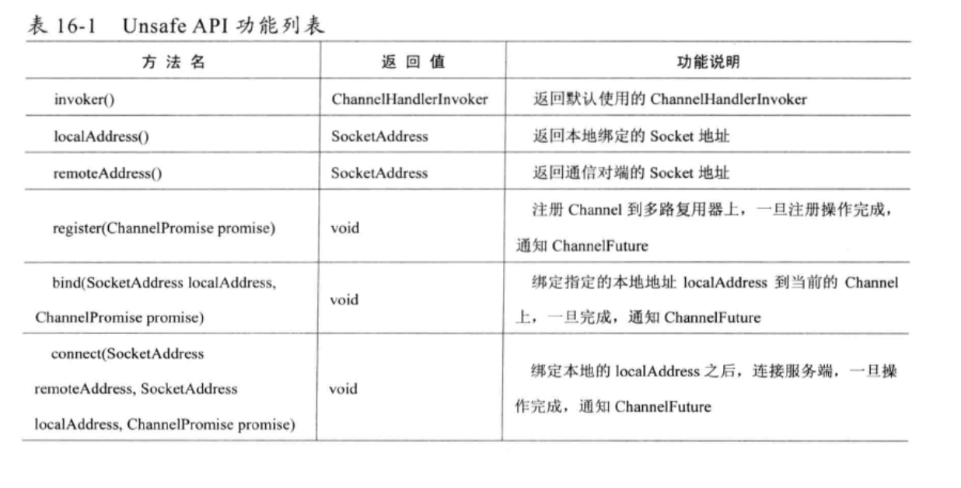

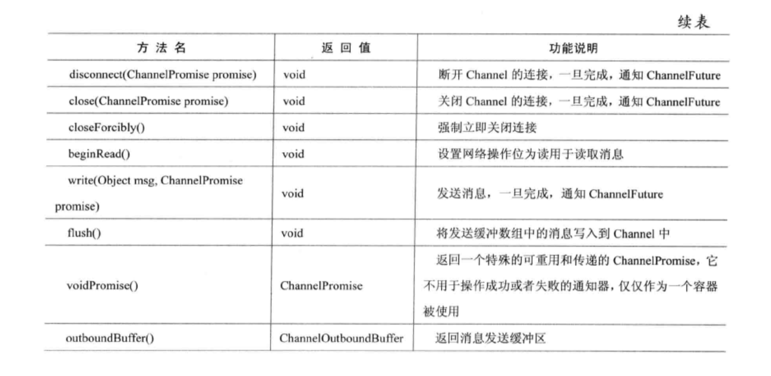

## 16.4 Unsafe源码分析

### 16.4.1 Unsage继承关系图

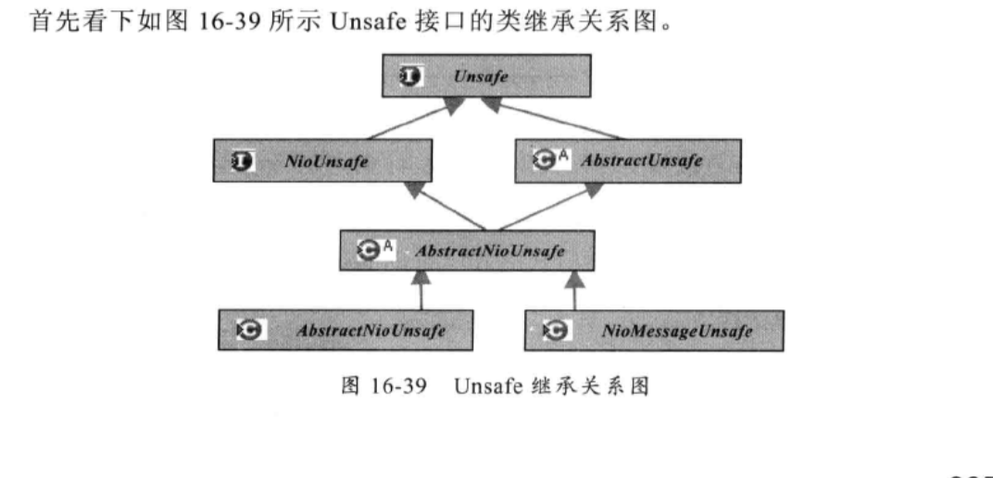

### 16.4.2 AbstractUnsafe

1. register

主要用于将当前Unsafe对应的Channel注册到EventLoop的多路复用器上，然后调用DefaultChannelPipeline的fireChannelRegistered方法。

|  |
| --- |
| public final void register(final ChannelPromise promise) {  if (eventLoop.inEventLoop()) {  register0(promise);  } else {  try {  eventLoop.execute(new Runnable() {  @Override  public void run() {  register0(promise);  }  });  } catch (Throwable t) {  *logger*.warn(  "Force-closing a channel whose registration task was not accepted by an event loop: {}",  AbstractChannel.this, t);  closeForcibly();  closeFuture.setClosed();  promise.setFailure(t);  }  } }  private void register0(ChannelPromise promise) {  try {  // check if the channel is still open as it could be closed in the mean time when the register  // call was outside of the eventLoop  // 判断Channel是否打开  if (!ensureOpen(promise)) {  return;  }  // 由AbstractNioUnsafe对应的AbstractNioChannel实现  doRegister();  registered = true;  promise.setSuccess();  pipeline.fireChannelRegistered();  // 判断当前的Channel是否已经被激活  if (isActive()) {  pipeline.fireChannelActive();  }  } catch (Throwable t) {  // Close the channel directly to avoid FD leak.  closeForcibly();  closeFuture.setClosed();  if (!promise.tryFailure(t)) {  *logger*.warn(  "Tried to fail the registration promise, but it is complete already. " +  "Swallowing the cause of the registration failure:", t);  }  } }  // 该方法前面已经介绍过了  protected void doRegister() throws Exception {  boolean selected = false;  for (;;) {  try {  selectionKey = javaChannel().register(eventLoop().selector, 0, this);  return;  } catch (CancelledKeyException e) {  if (!selected) {  // Force the Selector to select now as the "canceled" SelectionKey may still be  // cached and not removed because no Select.select(..) operation was called yet.  eventLoop().selectNow();  selected = true;  } else {  // We forced a select operation on the selector before but the SelectionKey is still cached  // for whatever reason. JDK bug ?  throw e;  }  }  } } |

2 bind方法

|  |
| --- |
| public final void bind(final SocketAddress localAddress, final ChannelPromise promise) {  if (!ensureOpen(promise)) {  return;  }   // See: https://github.com/netty/netty/issues/576  if (!PlatformDependent.*isWindows*() && !PlatformDependent.*isRoot*() &&  Boolean.*TRUE*.equals(config().getOption(ChannelOption.*SO_BROADCAST*)) &&  localAddress instanceof InetSocketAddress &&  !((InetSocketAddress) localAddress).getAddress().isAnyLocalAddress()) {  // Warn a user about the fact that a non-root user can't receive a  // broadcast packet on *nix if the socket is bound on non-wildcard address.  *logger*.warn(  "A non-root user can't receive a broadcast packet if the socket " +  "is not bound to a wildcard address; binding to a non-wildcard " +  "address (" + localAddress + ") anyway as requested.");  }   boolean wasActive = isActive();  try {  // 调用doBind方法  // 对于NioSocketChannel和NioServerSocketChannel有不同的实现  doBind(localAddress);  } catch (Throwable t) {  promise.setFailure(t);  // 关闭Channel  closeIfClosed();  return;  }  if (!wasActive && isActive()) {  invokeLater(new Runnable() {  @Override  public void run() {  pipeline.fireChannelActive();  }  });  }  promise.setSuccess(); } |

1. disconnect方法

用于客户端或者服务端主动关闭连接

|  |
| --- |
| public final void disconnect(final ChannelPromise promise) {  boolean wasActive = isActive();  try {  doDisconnect();  } catch (Throwable t) {  promise.setFailure(t);  closeIfClosed();  return;  }  if (wasActive && !isActive()) {  invokeLater(new Runnable() {  @Override  public void run() {  pipeline.fireChannelInactive();  }  });  }  promise.setSuccess();  closeIfClosed(); // doDisconnect() might have closed the channel } |

1. close方法

|  |
| --- |
| public final void close(final ChannelPromise promise) {  // 关闭之前，判断是否处于刷新状态，如果处于刷新状态说明还有消息尚未发送出去  // 需要等待到所有消息发送完成再关闭链路。  if (inFlush0) {  invokeLater(new Runnable() {  @Override  public void run() {  close(promise);  }  });  return;  }  // 判断关闭操作是否完成，如果已经完成，需要重复关闭链路。  if (closeFuture.isDone()) {  // Closed already.  promise.setSuccess();  return;  }   boolean wasActive = isActive();  ChannelOutboundBuffer outboundBuffer = this.outboundBuffer;  this.outboundBuffer = null; // Disallow adding any messages and flushes to outboundBuffer.   try {  // 执行关闭  doClose();  closeFuture.setClosed();  promise.setSuccess();  } catch (Throwable t) {  closeFuture.setClosed();  promise.setFailure(t);  }   // Fail all the queued messages  try {  outboundBuffer.failFlushed(*CLOSED_CHANNEL_EXCEPTION*);  outboundBuffer.close(*CLOSED_CHANNEL_EXCEPTION*);  } finally {   if (wasActive && !isActive()) {  invokeLater(new Runnable() {  @Override  public void run() {  pipeline.fireChannelInactive();  }  });  }  // 调用deregister方法，将Channel从多路复用器上取消注册。  deregister();  } }  protected void doDeregister() throws Exception {  eventLoop().cancel(selectionKey()); } |

1. write

将消息添加到唤醒发送数组中

|  |
| --- |
| public void write(Object msg, ChannelPromise promise) {  // Channel没有处于激活状态，说明TCP链路还没有真正建立成功  if (!isActive()) {  // Mark the write request as failure if the channel is inactive.  // Channel打开，但是TCP链路尚未建立成功：  // NOT_YET_CONNECTED_EXCEPTION  if (isOpen()) {  promise.tryFailure(*NOT_YET_CONNECTED_EXCEPTION*);  } else {  // Channel已经关闭：CLOSED_CHANNEL_EXCEPTION  promise.tryFailure(*CLOSED_CHANNEL_EXCEPTION*);  }  // release message now to prevent resource-leak  ReferenceCountUtil.*release*(msg);  } else {  outboundBuffer.addMessage(msg, promise);  } } |

1. flush

负责将发送缓冲区中待发送的消息全部写入到Channel中，

|  |
| --- |
| @Override public void flush() {  ChannelOutboundBuffer outboundBuffer = this.outboundBuffer;  if (outboundBuffer == null) {  return;  }   outboundBuffer.addFlush();  flush0(); }  protected void flush0() {  if (inFlush0) {  // Avoid re-entrance  return;  }   final ChannelOutboundBuffer outboundBuffer = this.outboundBuffer;  if (outboundBuffer == null || outboundBuffer.isEmpty()) {  return;  }   inFlush0 = true;   // Mark all pending write requests as failure if the channel is inactive.  if (!isActive()) {  try {  if (isOpen()) {  outboundBuffer.failFlushed(*NOT_YET_CONNECTED_EXCEPTION*);  } else {  outboundBuffer.failFlushed(*CLOSED_CHANNEL_EXCEPTION*);  }  } finally {  inFlush0 = false;  }  return;  }   try {  // 该方法是AbstractNioByteChannel中的方法，已经分析过了  doWrite(outboundBuffer);  } catch (Throwable t) {  outboundBuffer.failFlushed(t);  } finally {  inFlush0 = false;  } } |

### 16.4.3 AbstractNioUnsafe

AbstractNioUnsafe是AbstractUnsafe的NIO实现，主要实现了connect、finishConnect等方法

1.connect

|  |
| --- |
|  |

### 16.4.4 NioByteUnsafe

|  |
| --- |
| public void read() {  // 设置TCP的参数配置获取  final ChannelConfig config = config();  final ChannelPipeline pipeline = pipeline();  final ByteBufAllocator allocator = config.getAllocator();  final int maxMessagesPerRead = config.getMaxMessagesPerRead();  // 两个实现  // AdaptiveRecvByteBufAllocator：可动态调整缓冲区的大小  // FixedRecvByteBufAllocator:   RecvByteBufAllocator.Handle allocHandle = this.allocHandle;  if (allocHandle == null) {  this.allocHandle = allocHandle = config.getRecvByteBufAllocator().newHandle();  }  if (!config.isAutoRead()) {  removeReadOp();  }   ByteBuf byteBuf = null;  int messages = 0;  boolean close = false;  try {  // 计算获得下次预分配的换乘区容量byteBufCapcity  int byteBufCapacity = allocHandle.guess();  int totalReadAmount = 0;  do {  byteBuf = allocator.ioBuffer(byteBufCapacity);  // 返回本次可读取的最大长度  int writable = byteBuf.writableBytes();  // 异步读取消息  int localReadAmount = doReadBytes(byteBuf);  if (localReadAmount <= 0) {  // not was read release the buffer  byteBuf.release();  close = localReadAmount < 0;  break;  }  // 触发和完成ChannelRead事件调用之后  pipeline.fireChannelRead(byteBuf);  byteBuf = null;   if (totalReadAmount >= Integer.*MAX_VALUE* - localReadAmount) {  // Avoid overflow.  totalReadAmount = Integer.*MAX_VALUE*;  break;  }   totalReadAmount += localReadAmount;  if (localReadAmount < writable) {  // Read less than what the buffer can hold,  // which might mean we drained the recv buffer completely.  break;  }  } while (++ messages < maxMessagesPerRead);   pipeline.fireChannelReadComplete();  allocHandle.record(totalReadAmount);   if (close) {  closeOnRead(pipeline);  close = false;  }  } catch (Throwable t) {  handleReadException(pipeline, byteBuf, t, close);  }  } } |

# ChannelPipeline和ChannelHandler

## 17.1 ChannelPipeline 功能说明

ChannelPipeline是ChannelHandler的容器，它负责ChannelHandler管理和事件拦截调度。

### 17.1.1 ChannelPipeline的事件处理

1. SocketChannel.read方法读取ByteBuf，触发ChannelRead事件，由IO线程NioEventLoop调用ChannelPipeline的fireChannelRead(Object msg )方法，将消息ByteBuf传输到ChannelPipeline中。
2. 消息依次被HeadHandler、ChannelHandler1....TailHandler拦截和处理，在这个过程中，任何ChannelHandler都可以中断当前的流程，结束消息的传递
3. 调用ChannelHandlerContext的write方法发送消息，消息从TailHandler开始，途经ChannelHandlerN.....ChannelHandler1、HeadHandler，最终被添加到消息发送缓冲区等待刷新和发送，在此过程中也可以中断消息的传递。例如当编码失败，就需要中断

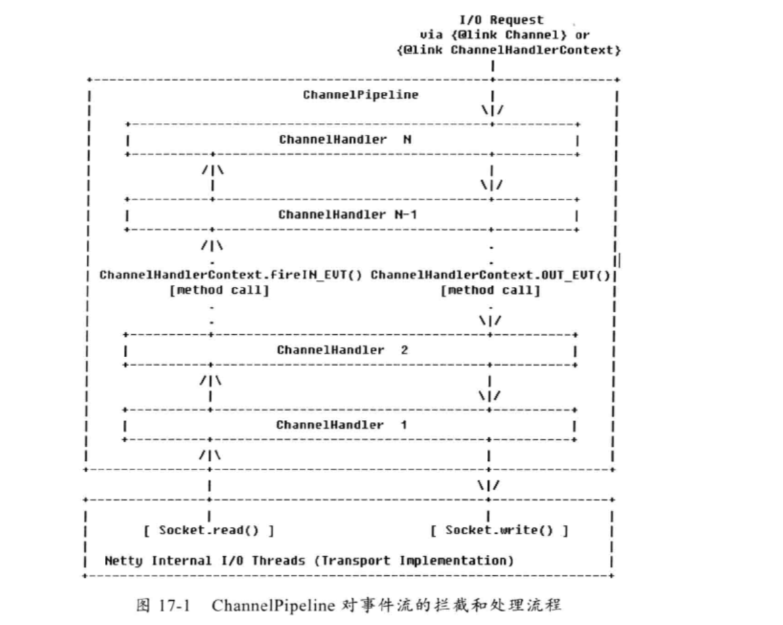

Netty中的事件分为inbound事件和outbound事件。inbound事件通常由IO线程触发，例如TCP链路建立事件、链路关闭事件、读事件、异常通知事件等。

触发inbound事件的方法如下：

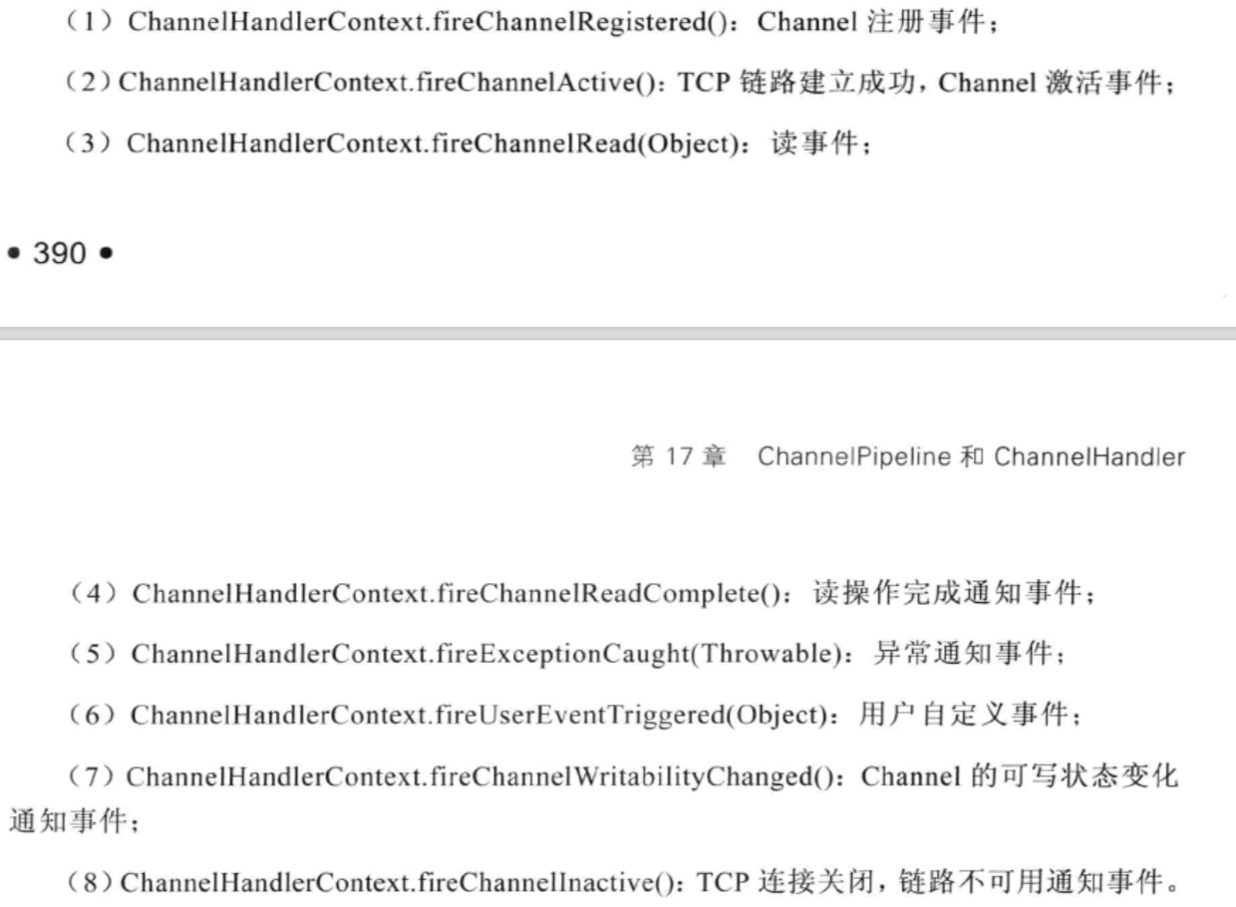

Outbound事件通常是由用户主动发起的网络IO操做，例如用户发起的连接操作、绑定操作、消息发送等操作，

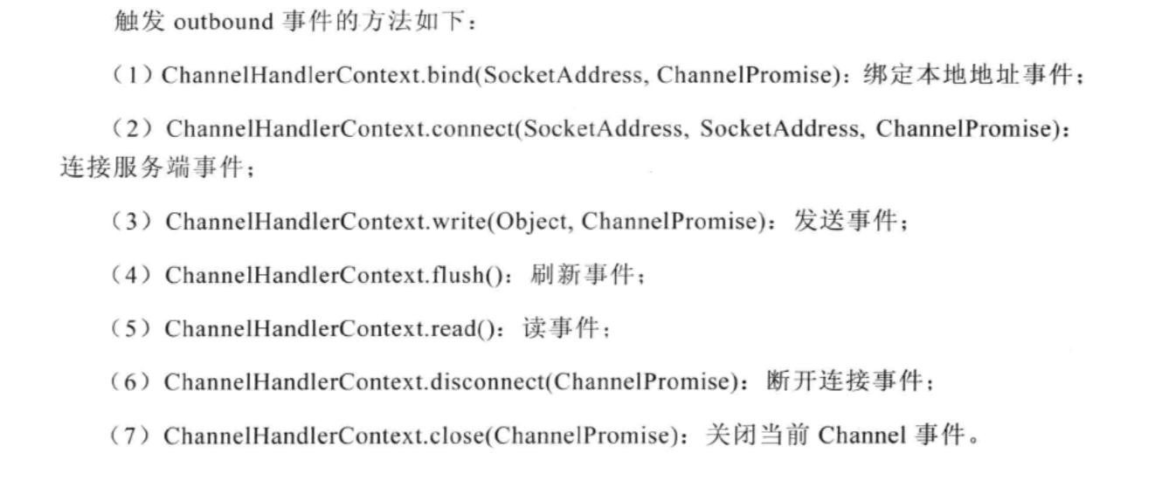

### 17.1.3 构建pipeline

### 17.1.4 ChannelPipeline的主要特性

ChannelPipeline支持动态的添加或者删除ChannelHandler

.

## 17.2 ChannelPipeline

### 17.2.1 ChannelPipeline 类继承关系

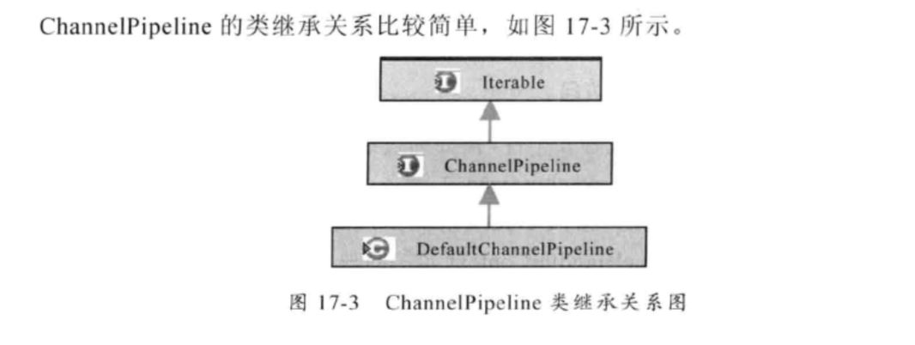

### 17.2.2 ChannelPipeline 对ChannelHandler的管理

ChannelPipeline是ChannelHandler的管理容器，负责ChannelHandler的查询、添加、替换和删除。

|  |
| --- |
| @Override public ChannelPipeline addBefore(String baseName, String name, ChannelHandler handler) {  return addBefore((ChannelHandlerInvoker) null, baseName, name, handler); }  @Override public ChannelPipeline addBefore(EventExecutorGroup group, String baseName, String name, ChannelHandler handler) {  return addBefore(findInvoker(group), baseName, name, handler); }  @Override public ChannelPipeline addBefore(  ChannelHandlerInvoker invoker, String baseName, final String name, ChannelHandler handler) {  synchronized (this) {  DefaultChannelHandlerContext ctx = getContextOrDie(baseName);   checkDuplicateName(name);   DefaultChannelHandlerContext newCtx =  new DefaultChannelHandlerContext(this, invoker, name, handler);   addBefore0(name, ctx, newCtx);  }  return this; } |

由于ChannelPipeline支持运行期动态修改，因此存在两种潜在的多线程并发访问场景

1. IO线程和用户业务线程的并发访问；
2. 用户多个线程之间的并发访问

|  |
| --- |
| public ChannelHandlerContext context(String name) {  if (name == null) {  throw new NullPointerException("name");  }  // 同步  synchronized (this) {  return name2ctx.get(name);  } } |

对新增的ChannelHandler名进行重复性校验，如果已经有同名的ChannelHandler存在，则不允许覆盖，抛出IllegalArgumenteException(“Duplicatee handler name:”+name)异常。检验通过之后，使用新增的ChannelHandler等参数构造一个新的DefaultChannelHandlerContext。

|  |
| --- |
| @Override public ChannelPipeline addLast(String name, ChannelHandler handler) {  return addLast((ChannelHandlerInvoker) null, name, handler); }  @Override public ChannelPipeline addLast(EventExecutorGroup group, String name, ChannelHandler handler) {  return addLast(findInvoker(group), name, handler); }  @Override public ChannelPipeline addLast(ChannelHandlerInvoker invoker, final String name, ChannelHandler handler) {  synchronized (this) {  // 校验是否添加过  checkDuplicateName(name);   DefaultChannelHandlerContext newCtx =  new DefaultChannelHandlerContext(this, invoker, name, handler);   addLast0(name, newCtx);  }   return this; }  private void addLast0(final String name, DefaultChannelHandlerContext newCtx) {  // 校验是否可以共享  *checkMultiplicity*(newCtx);    DefaultChannelHandlerContext prev = tail.prev;  newCtx.prev = prev;  newCtx.next = tail;  prev.next = newCtx;  tail.prev = newCtx;   name2ctx.put(name, newCtx);   callHandlerAdded(newCtx); }  private static void checkMultiplicity(ChannelHandlerContext ctx) {  ChannelHandler handler = ctx.handler();  if (handler instanceof ChannelHandlerAdapter) {  ChannelHandlerAdapter h = (ChannelHandlerAdapter) handler;  if (!h.isSharable() && h.added) {  throw new ChannelPipelineException(  h.getClass().getName() +  " is not a @Sharable handler, so can't be added or removed multiple times.");  }  h.added = true;  } } |

### 17.2.3 ChannelPipeline 的inbound事件

pipeline中以fireXXX命名的方法都是从IO线程流向用户业务Handler的inbound事件，

1. 调用HeadHandler对应的fireXXX方法
2. 执行事件相关的逻辑操作

public ChannelPipeline fireChannelActive() {  
 head.fireChannelActive();  
 // 判断当前的Channel配置是否自动读取。  
 if (channel.config().isAutoRead()) {  
 channel.read();  
 }  
  
 return this;  
}

### 17.2.4 ChannelPipeline 的outbound事件

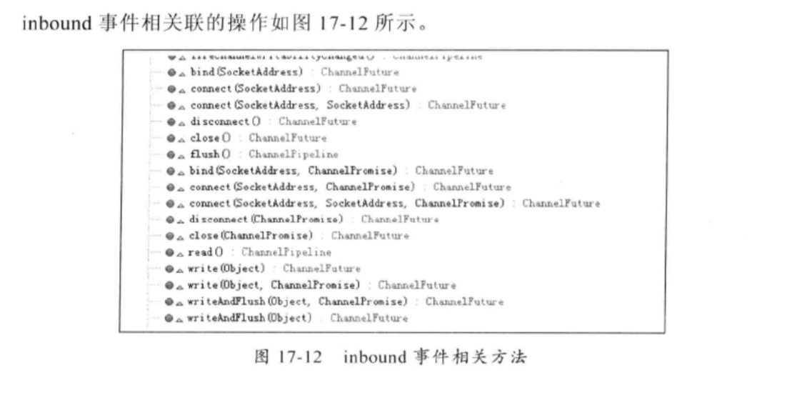

Pipeline负责将IO事件通过TailHandler进行调度和传播，最终调用Unsafe的IO方法进行IO操作

@Override  
public ChannelFuture connect(SocketAddress remoteAddress) {  
 return tail.connect(remoteAddress);  
}

最终会调用到HeadHandler的connect方法。

public void connect(  
 ChannelHandlerContext ctx,  
 SocketAddress remoteAddress, SocketAddress localAddress,  
 ChannelPromise promise) throws Exception {  
 unsafe.connect(remoteAddress, localAddress, promise);  
}

17.3 ChannelHandler功能说明

ChannelHandler类似于Servlet的Filter过滤器。负责对IO事件或者IO操作进行拦截和处理，它可以选择性拦截和处理自己感兴趣的时间，也可以透传和终止事件的传递。

ChannelHandler支持注解，目前支持的注解有两种：

1. Shareble：多个ChannelPipeline共用同一个ChannelHandler
2. Skip：被Skip注解的方法不会被调用，直接被忽略。

## 17.3 ChannelHandler功能说明

### 17.3.1 ChannelHandlerAdapter功能说明

大多数的ChannelHandler会选者性地拦截和处理某个某些事件，其他的事件会忽略，由下一个ChannelHandler进行拦截和处理。这就会导致一个问题：用户ChannelHandler必须要实现ChannelHandler的所有接扣，包括它不关心的那些事件处理接口，这回导致用户代码的冗余和臃肿。

Netty提供了ChannelHandlerAdapter几类，它的所欲接口实现都是事件透传。用户关心那些事件，覆盖ChannelHandlerAdapter对应的方法即可。

@Skip  
@Override  
public void read(ChannelHandlerContext ctx) throws Exception {  
 ctx.read();  
}  
  
*/**  
 * Calls {****@link*** *ChannelHandlerContext#write(Object)} to forward  
 * to the next {****@link*** *ChannelHandler} in the {****@link*** *ChannelPipeline}.  
 *  
 * Sub-classes may override this method to change behavior.  
 */*@Skip  
@Override  
public void write(ChannelHandlerContext ctx, Object msg, ChannelPromise promise) throws Exception {  
 ctx.write(msg, promise);  
}

### 17.3.2 ByteToMessageDecoder功能说明

将ByteBuf解码成业务POJO对象。

用户的解码器继承ByteToMessageDecoder，只需要实现void decode(ChannelHandler,Context ctx,ByteBuf in , List<Object> out)

### 17.3.3 MessageToMessageDecoder功能说明

将一个对象二次解码为其他对象。

从SocketChannel读取到的Tcp数据报是ByteBuffer，实际就是字节数组，将ByteBuffer中数据解码为Java对象，为一次解码，再将java对象解码为另一个POJO对象，为二次解码。

Http+xml协议栈为例，第一次解码往往是将字节数组解码成HttpRequest对象。

### 17.3.4 LengthFieldBaseFrameDecoder功能说明

半包解码器：LineBasedFrameDecoder和DelimiterBasedFrameDecoder、LengthFieldBasedFrameDecoder。

如何区分一个整包消息，

1. 固定长度，例如每120个字节代表一个整包消息，不足的前面补0.解码器在处理这类定长消息的时候比较简单，每次读到指定长度的字节后再进行解码。
2. 通过回车换行符区分消息，例如FTP协议。这列区分消息的方式多用于文本协议。
3. 通过分隔符区分整包消息
4. 通过执行长度来标识整包消息

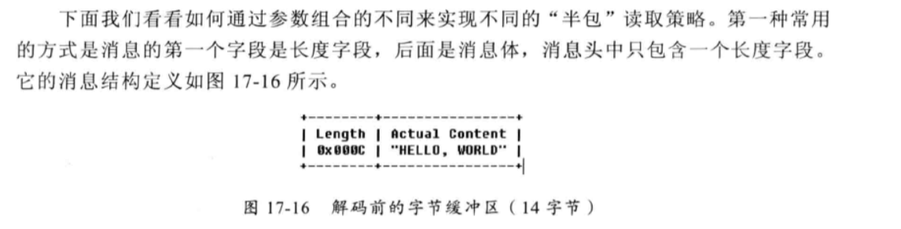

### 17.3.5 MessageToByteEncoder功能说明

负责将POJO对象编码成ByteBuf，用户的编码器继承MessageToByteEncoder。

### 17.3.6 MessageToMessageEncoder功能说明

将POJO编码成另一个对象。

### 17.3.7 LengthFieldPrepender功能说明

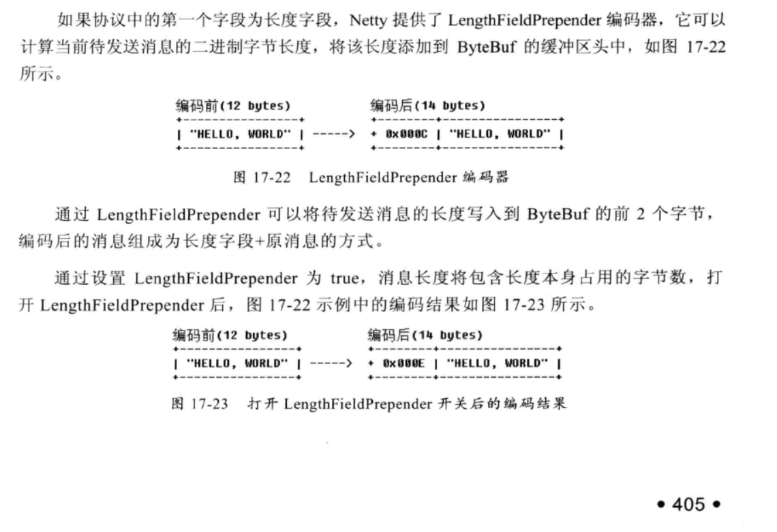

## 17.4 ChannelHandler源码分析

### 17.4.1 ChannelHandler的类继承关系图

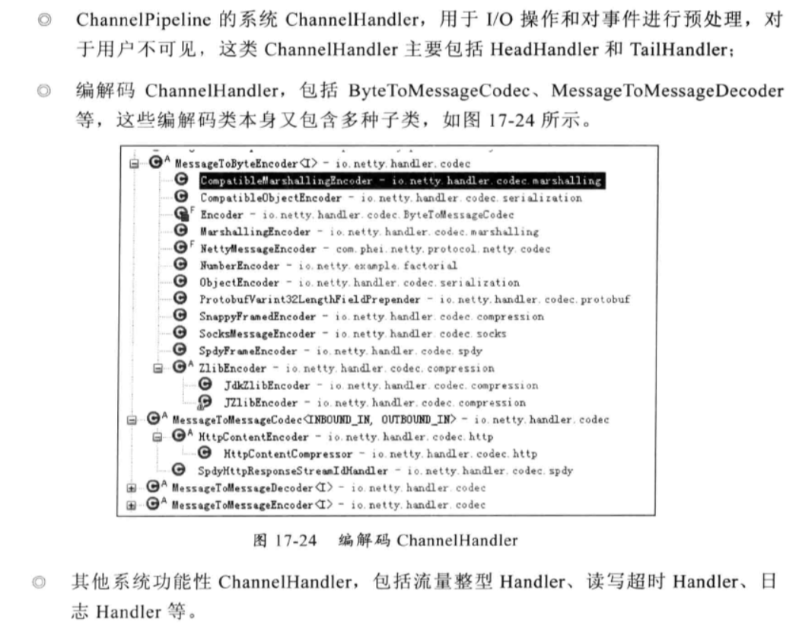

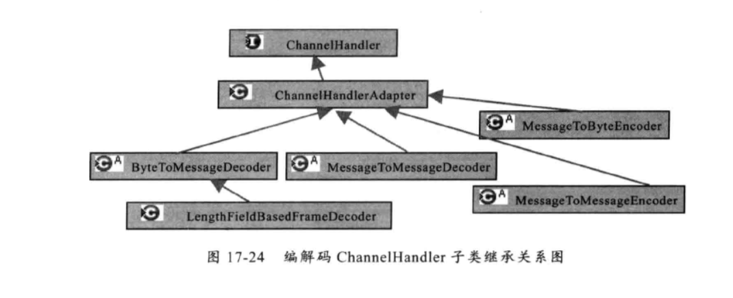

### 17.4.2 ByteToMessageeDecoder 源码分析

ByteToMessageDecoder解码器用于将ByteBuf解码成POJO对象，

|  |
| --- |
| public void channelRead(ChannelHandlerContext ctx, Object msg) throws Exception {  //   if (msg instanceof ByteBuf) {  RecyclableArrayList out = RecyclableArrayList.*newInstance*();  try {  ByteBuf data = (ByteBuf) msg;  first = cumulation == null;  if (first) {  // 缓存没有解码完成的半包消息  cumulation = data;  } else {  if (cumulation.writerIndex() > cumulation.maxCapacity() - data.readableBytes()) {  // 扩展cumulation容量  expandCumulation(ctx, data.readableBytes());  }  cumulation.writeBytes(data);  data.release();  }  // 进行解码  callDecode(ctx, cumulation, out);  } catch (DecoderException e) {  throw e;  } catch (Throwable t) {  throw new DecoderException(t);  } finally {  if (cumulation != null && !cumulation.isReadable()) {  cumulation.release();  cumulation = null;  }  int size = out.size();  decodeWasNull = size == 0;   for (int i = 0; i < size; i ++) {  ctx.fireChannelRead(out.get(i));  }  out.recycle();  }  } else {  ctx.fireChannelRead(msg);  } }  protected void callDecode(ChannelHandlerContext ctx, ByteBuf in, List<Object> out) {  try {  while (in.isReadable()) {  int outSize = out.size();  int oldInputLength = in.readableBytes();  decode(ctx, in, out);   // Check if this handler was removed before continuing the loop.  // If it was removed, it is not safe to continue to operate on the buffer.  //  // See https://github.com/netty/netty/issues/1664  if (ctx.isRemoved()) {  break;  }   if (outSize == out.size()) {  if (oldInputLength == in.readableBytes()) {  break;  } else {  continue;  }  }   if (oldInputLength == in.readableBytes()) {  throw new DecoderException(  StringUtil.*simpleClassName*(getClass()) +  ".decode() did not read anything but decoded a message.");  }  // 如果是单条消息解码器，第一次解码完成之后就退出循环  if (isSingleDecode()) {  break;  }  }  } catch (DecoderException e) {  throw e;  } catch (Throwable cause) {  throw new DecoderException(cause);  } } |

### 17.4.3 MessageToMessageDecoder源码分析

MessageToMessageDecoder负责将一个Pojo对象解码成另一个POJO对象。

@Override  
public void channelRead(ChannelHandlerContext ctx, Object msg) throws Exception {  
 RecyclableArrayList out = RecyclableArrayList.*newInstance*();  
 try {  
 if (acceptInboundMessage(msg)) {  
 @SuppressWarnings("unchecked")  
 I cast = (I) msg;  
 try {

// 具体的子类进行解码  
 decode(ctx, cast, out);  
 } finally {  
 ReferenceCountUtil.*release*(cast);  
 }  
 } else {  
 out.add(msg);  
 }  
 } catch (DecoderException e) {  
 throw e;  
 } catch (Exception e) {  
 throw new DecoderException(e);  
 } finally {  
 int size = out.size();  
 for (int i = 0; i < size; i ++) {  
 ctx.fireChannelRead(out.get(i));  
 }  
 out.recycle();  
 }  
}

### 17.4.4 LengthFieldBaseFrameDecoder源码分析

基于消息长度的半包解码器。

protected final void decode(ChannelHandlerContext ctx, ByteBuf in, List<Object> out) throws Exception {  
 Object decoded = decode(ctx, in);  
 if (decoded != null) {  
 out.add(decoded);  
 }  
}

|  |
| --- |
| protected Object decode(ChannelHandlerContext ctx, ByteBuf in) throws Exception {  // 丢弃的字节数不能大于当前缓冲区可读的字节数  if (discardingTooLongFrame) {  long bytesToDiscard = this.bytesToDiscard;  int localBytesToDiscard = (int) Math.*min*(bytesToDiscard, in.readableBytes());  // 跳过需要忽略的字节数  in.skipBytes(localBytesToDiscard);  bytesToDiscard -= localBytesToDiscard;  this.bytesToDiscard = bytesToDiscard;   failIfNecessary(false);  }   if (in.readableBytes() < lengthFieldEndOffset) {  return null;  }   int actualLengthFieldOffset = in.readerIndex() + lengthFieldOffset;  // 根据长度字段计算的字节长度进行判断。  long frameLength = getUnadjustedFrameLength(in, actualLengthFieldOffset, lengthFieldLength, byteOrder);   if (frameLength < 0) {  in.skipBytes(lengthFieldEndOffset);  throw new CorruptedFrameException(  "negative pre-adjustment length field: " + frameLength);  }  // 对当前缓冲区的可读字节数和长度偏移量进行对比，如果小于长度便宜量，则说明当前缓冲区的数据报不够，需要返回空，由IO线程继续读取后续的数据报  frameLength += lengthAdjustment + lengthFieldEndOffset;   if (frameLength < lengthFieldEndOffset) {  in.skipBytes(lengthFieldEndOffset);  throw new CorruptedFrameException(  "Adjusted frame length (" + frameLength + ") is less " +  "than lengthFieldEndOffset: " + lengthFieldEndOffset);  }  // 修正后的报文长度大于ByteBuf的最大容量，说明接收到的消息长度大于系统允许的最大长度上线  if (frameLength > maxFrameLength) {  long discard = frameLength - in.readableBytes();  tooLongFrameLength = frameLength;   if (discard < 0) {  // buffer contains more bytes then the frameLength so we can discard all now  in.skipBytes((int) frameLength);  } else {  // Enter the discard mode and discard everything received so far.  discardingTooLongFrame = true;  bytesToDiscard = discard;  in.skipBytes(in.readableBytes());  }  failIfNecessary(true);  return null;  }   // never overflows because it's less than maxFrameLength  int frameLengthInt = (int) frameLength;  if (in.readableBytes() < frameLengthInt) {  return null;  }   if (initialBytesToStrip > frameLengthInt) {  in.skipBytes(frameLengthInt);  throw new CorruptedFrameException(  "Adjusted frame length (" + frameLength + ") is less " +  "than initialBytesToStrip: " + initialBytesToStrip);  }  in.skipBytes(initialBytesToStrip);   // extract frame  int readerIndex = in.readerIndex();  int actualFrameLength = frameLengthInt - initialBytesToStrip;  ByteBuf frame = extractFrame(ctx, in, readerIndex, actualFrameLength);  in.readerIndex(readerIndex + actualFrameLength);  return frame; }  private void failIfNecessary(boolean firstDetectionOfTooLongFrame) {  if (bytesToDiscard == 0) {  // Reset to the initial state and tell the handlers that  // the frame was too large.  long tooLongFrameLength = this.tooLongFrameLength;  this.tooLongFrameLength = 0;  discardingTooLongFrame = false;  if (!failFast ||  failFast && firstDetectionOfTooLongFrame) {  fail(tooLongFrameLength);  }  } else {  // Keep discarding and notify handlers if necessary.  if (failFast && firstDetectionOfTooLongFrame) {  fail(tooLongFrameLength);  }  } }  protected long getUnadjustedFrameLength(ByteBuf buf, int offset, int length, ByteOrder order) {  buf = buf.order(order);  long frameLength;  switch (length) {  case 1:  frameLength = buf.getUnsignedByte(offset);  break;  case 2:  frameLength = buf.getUnsignedShort(offset);  break;  case 3:  frameLength = buf.getUnsignedMedium(offset);  break;  case 4:  frameLength = buf.getUnsignedInt(offset);  break;  case 8:  frameLength = buf.getLong(offset);  break;  default:  throw new DecoderException(  "unsupported lengthFieldLength: " + lengthFieldLength + " (expected: 1, 2, 3, 4, or 8)");  }  return frameLength; } |

### 17.4.5 MessageToByteEncoder源码分析

负责将用户的POJO对象编码成ByteBuf，以便通过网络进行传输。

### 17.4.6 MessageToMessageEncoder源码分析

### 17.4.7 LengthFieldPrepender源码分析

# 第18章EventLoop和EventLoopGroup

## 18.1 netty的线程模型

### 18.1.1 Reactor单线程模型

Nio线程的职责：

作为NIO服务端，接收客户端的TCP连接；

作为NIO客户端，向服务端发起TCP连接；

读取通信对端的请求或者应答消息；

向通信对端发送消息请求或者应答消息。

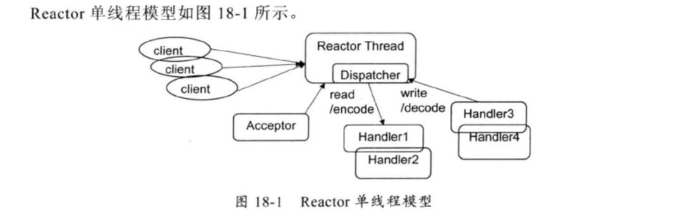

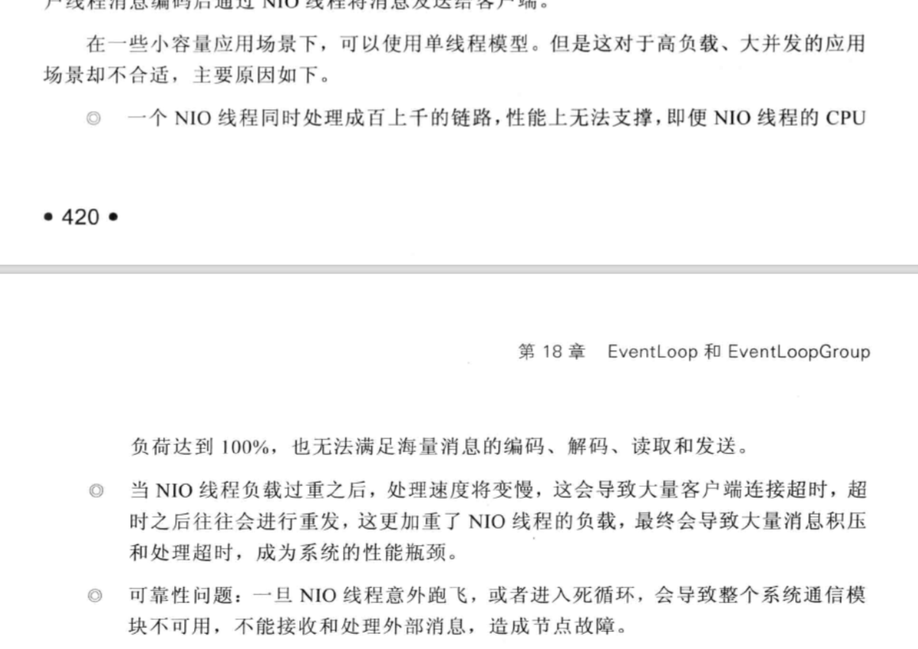

### 18.1.2 Reactor多线程模型

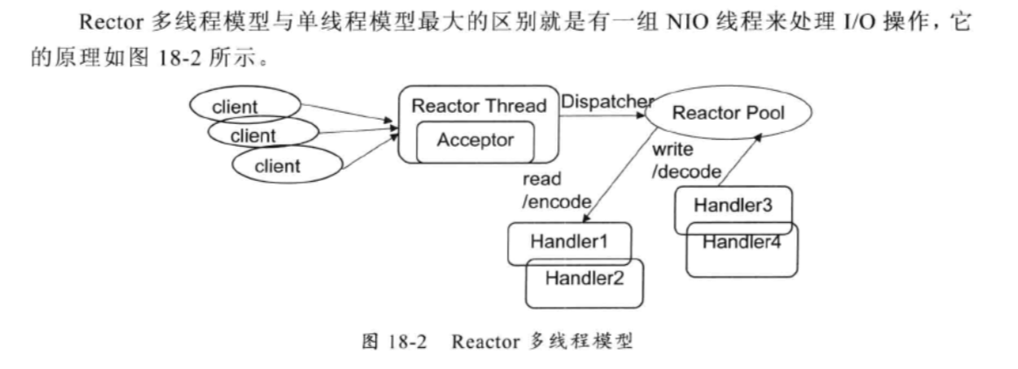

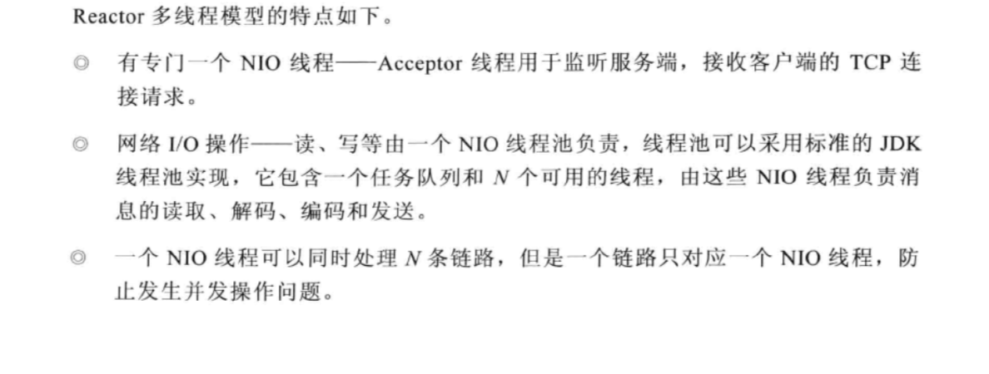

### 18.1.3 主从Reactor多线程模型

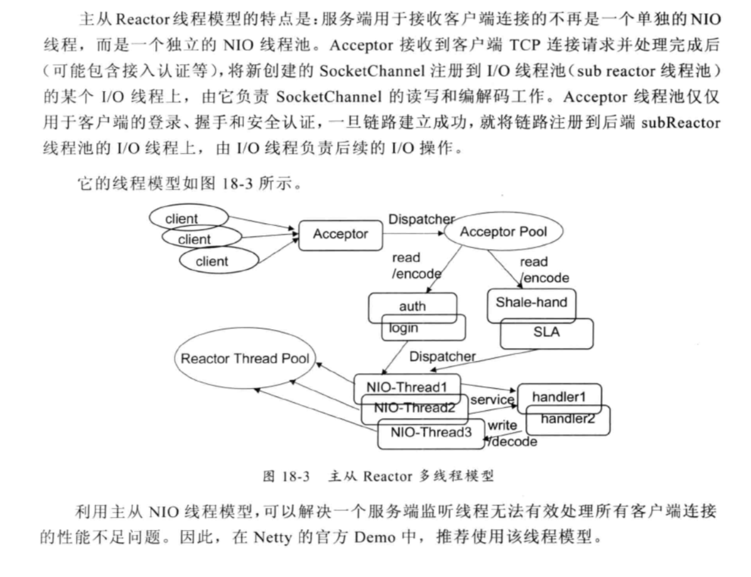

### 18.1.4 Netty的线程模型

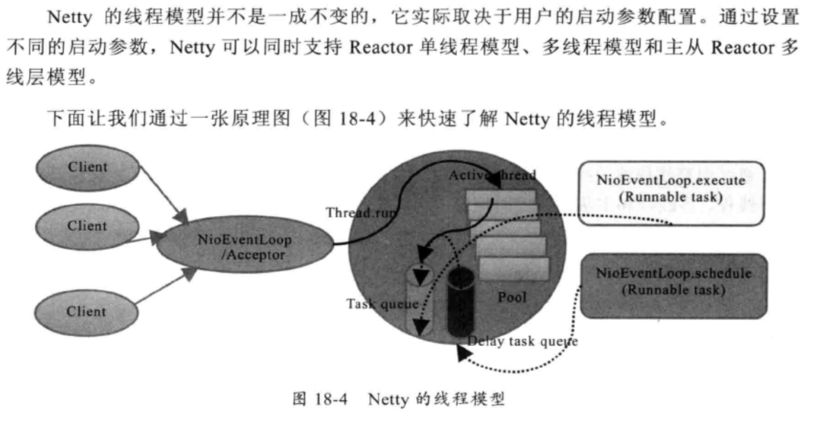

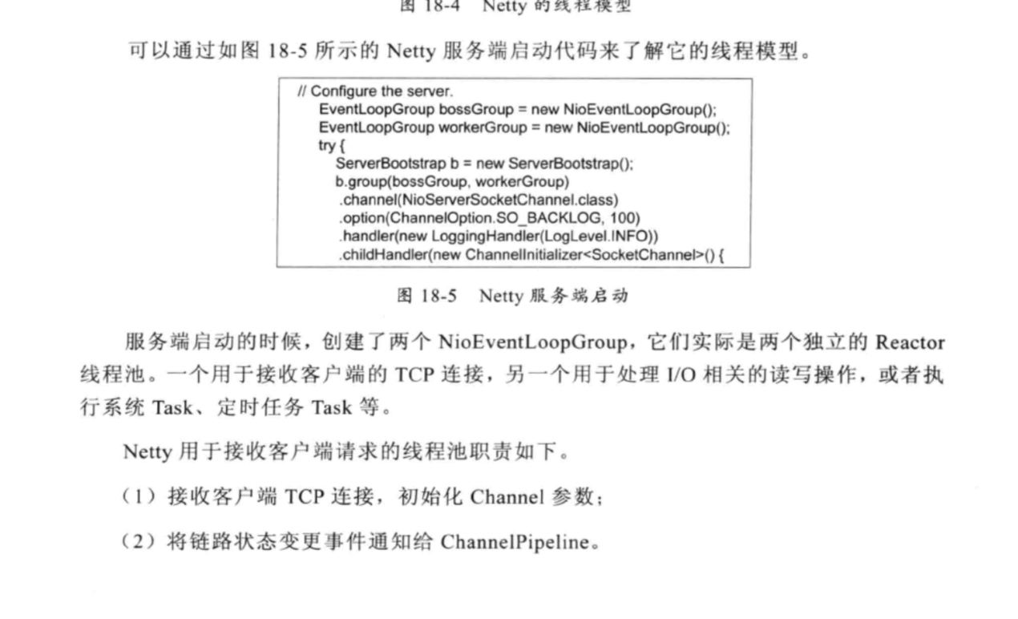

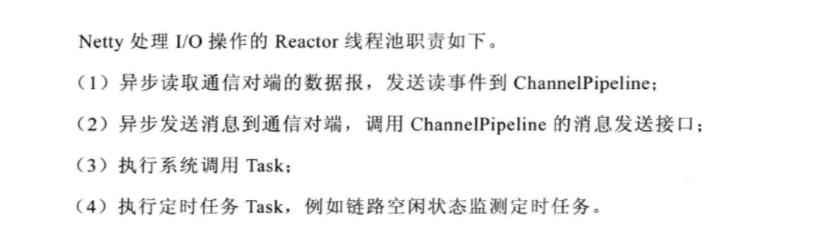

### 18.1.5 最佳实践

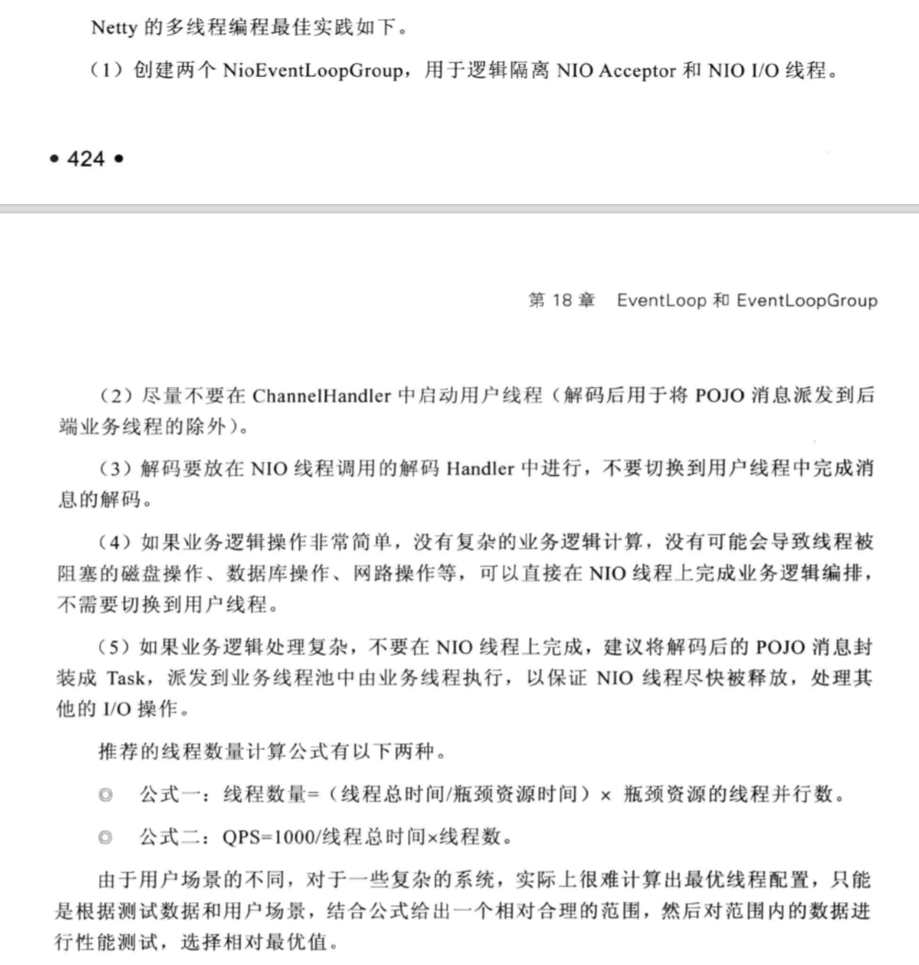

## 18.2 NioEventLoop源码分析

### 18.2.1 NioEventLoop设计原理

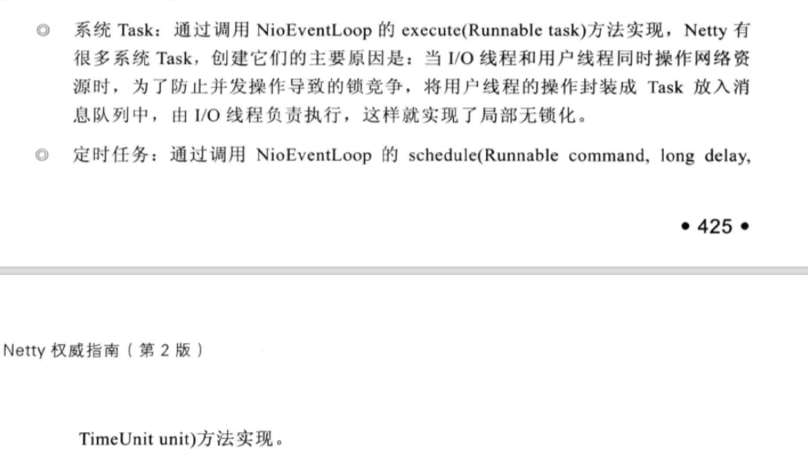

### 18.2.2 NioEventLoop继承关系类图

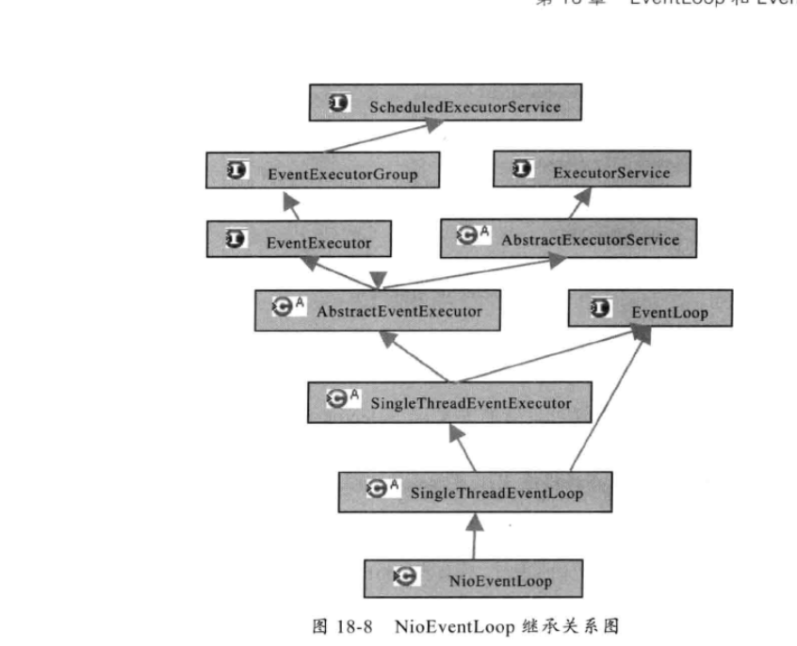

### 18.2.3 NioEventLoop

selector多路复用器的初始化

|  |
| --- |
| private Selector openSelector() {  final Selector selector;  try {  selector = provider.openSelector();  } catch (IOException e) {  throw new ChannelException("failed to open a new selector", e);  }   if (*DISABLE_KEYSET_OPTIMIZATION*) {  return selector;  }   try {  SelectedSelectionKeySet selectedKeySet = new SelectedSelectionKeySet();   Class<?> selectorImplClass =  Class.*forName*("sun.nio.ch.SelectorImpl", false, ClassLoader.*getSystemClassLoader*());   // Ensure the current selector implementation is what we can instrument.  if (!selectorImplClass.isAssignableFrom(selector.getClass())) {  return selector;  }   Field selectedKeysField = selectorImplClass.getDeclaredField("selectedKeys");  Field publicSelectedKeysField = selectorImplClass.getDeclaredField("publicSelectedKeys");   selectedKeysField.setAccessible(true);  publicSelectedKeysField.setAccessible(true);   selectedKeysField.set(selector, selectedKeySet);  publicSelectedKeysField.set(selector, selectedKeySet);   selectedKeys = selectedKeySet;  *logger*.trace("Instrumented an optimized java.util.Set into: {}", selector);  } catch (Throwable t) {  selectedKeys = null;  *logger*.trace("Failed to instrument an optimized java.util.Set into: {}", selector, t);  }   return selector; } |

run方法

|  |
| --- |
| protected void run() {  for (;;) {  oldWakenUp = wakenUp.getAndSet(false);  try {  if (hasTasks()) {  // 有任务，立即进行一次select操作  selectNow();  } else {  // 轮询，看看是否有准备就绪的Channel  select();   // 'wakenUp.compareAndSet(false, true)' is always evaluated  // before calling 'selector.wakeup()' to reduce the wake-up  // overhead. (Selector.wakeup() is an expensive operation.)  //  // However, there is a race condition in this approach.  // The race condition is triggered when 'wakenUp' is set to  // true too early.  //  // 'wakenUp' is set to true too early if:  // 1) Selector is waken up between 'wakenUp.set(false)' and  // 'selector.select(...)'. (BAD)  // 2) Selector is waken up between 'selector.select(...)' and  // 'if (wakenUp.get()) { ... }'. (OK)  //  // In the first case, 'wakenUp' is set to true and the  // following 'selector.select(...)' will wake up immediately.  // Until 'wakenUp' is set to false again in the next round,  // 'wakenUp.compareAndSet(false, true)' will fail, and therefore  // any attempt to wake up the Selector will fail, too, causing  // the following 'selector.select(...)' call to block  // unnecessarily.  //  // To fix this problem, we wake up the selector again if wakenUp  // is true immediately after selector.select(...).  // It is inefficient in that it wakes up the selector for both  // the first case (BAD - wake-up required) and the second case  // (OK - no wake-up required).   if (wakenUp.get()) {  selector.wakeup();  }  }   cancelledKeys = 0;   final long ioStartTime = System.*nanoTime*();  needsToSelectAgain = false;  if (selectedKeys != null) {  processSelectedKeysOptimized(selectedKeys.flip());  } else {  processSelectedKeysPlain(selector.selectedKeys());  }  final long ioTime = System.*nanoTime*() - ioStartTime;   final int ioRatio = this.ioRatio;  runAllTasks(ioTime * (100 - ioRatio) / ioRatio);   if (isShuttingDown()) {  closeAll();  if (confirmShutdown()) {  break;  }  }  } catch (Throwable t) {  *logger*.warn("Unexpected exception in the selector loop.", t);   // Prevent possible consecutive immediate failures that lead to  // excessive CPU consumption.  try {  Thread.*sleep*(1000);  } catch (InterruptedException e) {  // Ignore.  }  }  } }  void selectNow() throws IOException {  try {  selector.selectNow();  } finally {  // restore wakup state if needed  if (wakenUp.get()) {  selector.wakeup();  }  } }  private void select() throws IOException {  Selector selector = this.selector;  try {  int selectCnt = 0;  long currentTimeNanos = System.*nanoTime*();  long selectDeadLineNanos = currentTimeNanos + delayNanos(currentTimeNanos);  for (;;) {  long timeoutMillis = (selectDeadLineNanos - currentTimeNanos + 500000L) / 1000000L;  if (timeoutMillis <= 0) {  if (selectCnt == 0) {  selector.selectNow();  selectCnt = 1;  }  break;  }   int selectedKeys = selector.select(timeoutMillis);  selectCnt ++;   if (selectedKeys != 0 || oldWakenUp || wakenUp.get() || hasTasks()) {  // Selected something,  // waken up by user, or  // the task queue has a pending task.  break;  }   if (*SELECTOR_AUTO_REBUILD_THRESHOLD* > 0 &&  selectCnt >= *SELECTOR_AUTO_REBUILD_THRESHOLD*) {  // The selector returned prematurely many times in a row.  // Rebuild the selector to work around the problem.  *logger*.warn(  "Selector.select() returned prematurely {} times in a row; rebuilding selector.",  selectCnt);  // 检测到Selector处于死循环后，需要通过重建Selector的方式让系统恢复正常，  rebuildSelector();  selector = this.selector;   // Select again to populate selectedKeys.  selector.selectNow();  selectCnt = 1;  break;  }   currentTimeNanos = System.*nanoTime*();  }   if (selectCnt > *MIN_PREMATURE_SELECTOR_RETURNS*) {  if (*logger*.isDebugEnabled()) {  *logger*.debug("Selector.select() returned prematurely {} times in a row.", selectCnt - 1);  }  }  } catch (CancelledKeyException e) {  if (*logger*.isDebugEnabled()) {  *logger*.debug(CancelledKeyException.class.getSimpleName() + " raised by a Selector - JDK bug?", e);  }  // Harmless exception - log anyway  } }  public void rebuildSelector() {  if (!inEventLoop()) {  execute(new Runnable() {  @Override  public void run() {  rebuildSelector();  }  });  return;  }   final Selector oldSelector = selector;  final Selector newSelector;   if (oldSelector == null) {  return;  }   try {  newSelector = openSelector();  } catch (Exception e) {  *logger*.warn("Failed to create a new Selector.", e);  return;  }   // Register all channels to the new Selector.  int nChannels = 0;  for (;;) {  try {  for (SelectionKey key: oldSelector.keys()) {  Object a = key.attachment();  try {  if (key.channel().keyFor(newSelector) != null) {  continue;  }   int interestOps = key.interestOps();  key.cancel();  key.channel().register(newSelector, interestOps, a);  nChannels ++;  } catch (Exception e) {  *logger*.warn("Failed to re-register a Channel to the new Selector.", e);  if (a instanceof AbstractNioChannel) {  AbstractNioChannel ch = (AbstractNioChannel) a;  ch.unsafe().close(ch.unsafe().voidPromise());  } else {  @SuppressWarnings("unchecked")  NioTask<SelectableChannel> task = (NioTask<SelectableChannel>) a;  *invokeChannelUnregistered*(task, key, e);  }  }  }  } catch (ConcurrentModificationException e) {  // Probably due to concurrent modification of the key set.  continue;  }   break;  }   selector = newSelector;   try {  // time to close the old selector as everything else is registered to the new one  oldSelector.close();  } catch (Throwable t) {  if (*logger*.isWarnEnabled()) {  *logger*.warn("Failed to close the old Selector.", t);  }  }   *logger*.info("Migrated " + nChannels + " channel(s) to the new Selector."); } |

# Future和Promise

## 19.1 Future 功能

ChannelFuture功能介绍

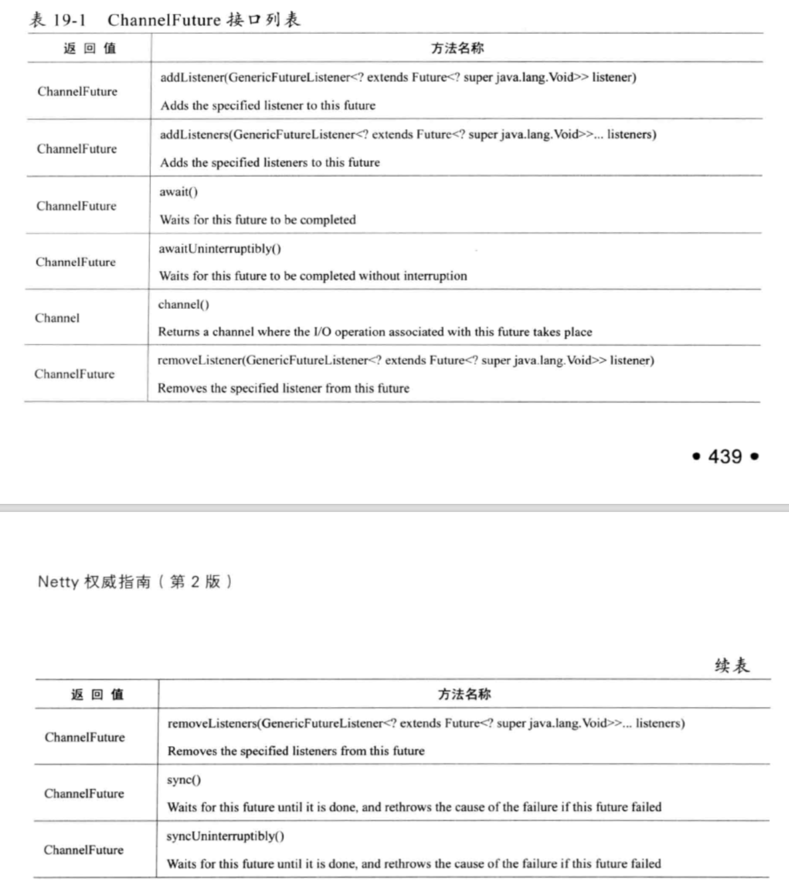

ChannelFuture有两种状态：uncompleted和completed。新的ChannelFuture被创建，此时它处于uncompleted状态-非失败、非成功、非取消。ChannelFuture将会被设置成completed，它的结果有如下三种可能。

操作成功；

操作失败；

操作被取消。

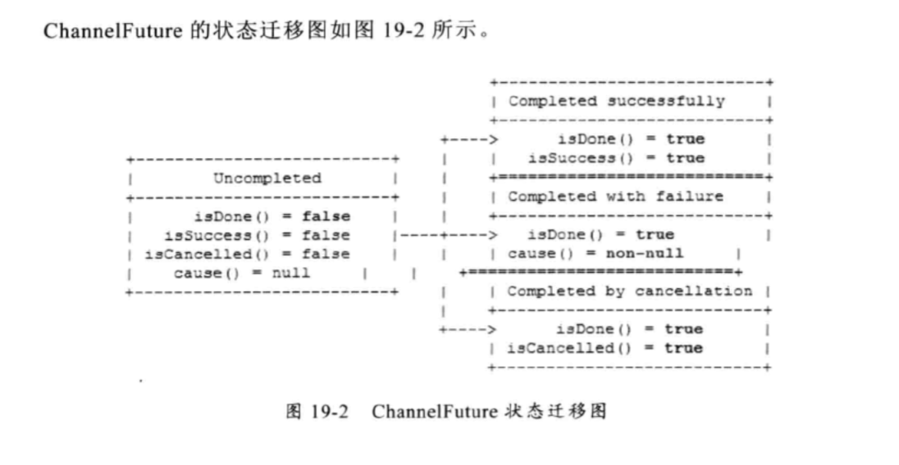

推荐通过GenericFutureListener代替ChannelFuture的get等方法：当我们进行一步IO操作时，完成的时间是无法预测的，如果不设置超时时间，它会导致调用线程长时间被阻塞，甚至挂死。而设置超时时间，时间又无法紧缺预测。利用一步通知机制回调GeernericFutrureListener是最佳的解决方案。

异步IO有两类超时：一个是TCP层面的IO超时。另一个是业务逻辑层面的工作超时。通常情况下业务逻辑超时时间应该大于IO超时时间。

## 19.2 ChannelFuture 源码分析

AbstractFuture实现Future接口，它不允许IO操作被取消。

|  |
| --- |
| public V get() throws InterruptedException, ExecutionException {  // 无限期阻塞  await();   Throwable cause = cause();  if (cause == null) {  return getNow();  }  throw new ExecutionException(cause); }  支持超时的方法  @Override public V get(long timeout, TimeUnit unit) throws InterruptedException, ExecutionException, TimeoutException {  if (await(timeout, unit)) {  Throwable cause = cause();  if (cause == null) {  return getNow();  }  throw new ExecutionException(cause);  }  throw new TimeoutException(); } |

## 19.3 Promise功能介绍

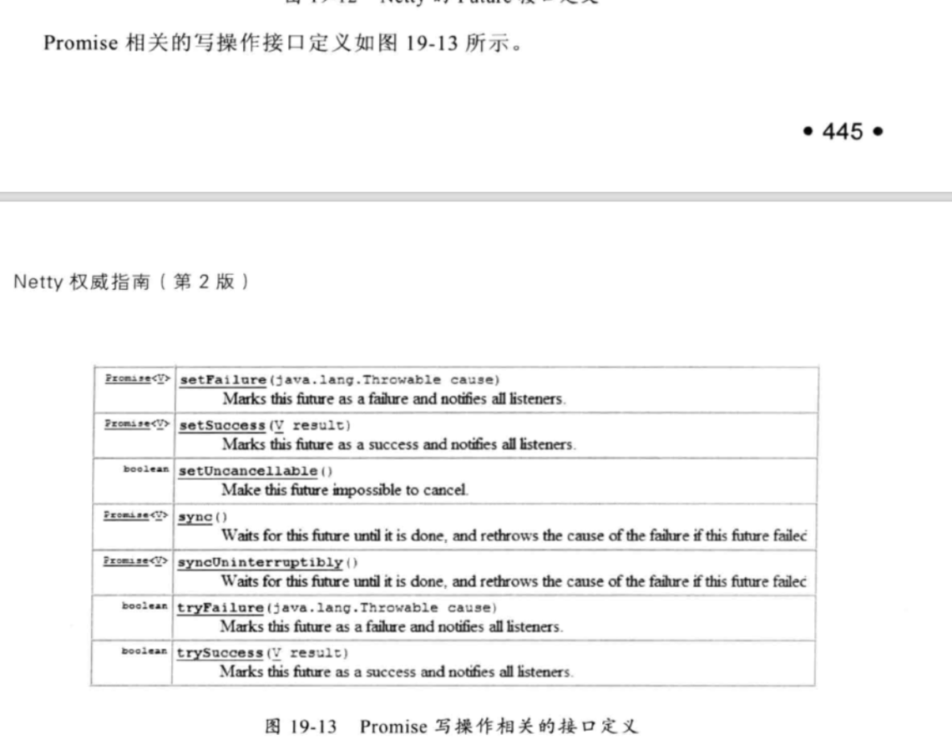

ChannelHandlerContext的write方法，会创建一个新的ChannelPromise

|  |
| --- |
| //  public ChannelFuture write(Object msg) {  return write(msg, newPromise()); }  public ChannelPromise newPromise() {  return new DefaultChannelPromise(channel(), executor()); } |

## 19.4 Promise源码分析

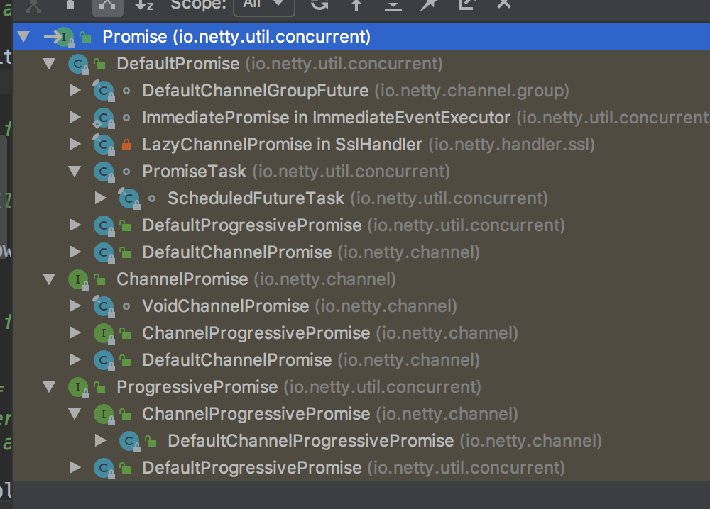

DefaultPromise

|  |
| --- |
| public Promise<V> setSuccess(V result) {  if (setSuccess0(result)) {  notifyListeners();  return this;  }  throw new IllegalStateException("complete already: " + this); }  private boolean setSuccess0(V result) {  if (isDone()) {  return false;  }   synchronized (this) {  // Allow only once.  if (isDone()) {  return false;  }  if (result == null) {  this.result = *SUCCESS*;  } else {  this.result = result;  }  if (hasWaiters()) {  notifyAll();  }  }  return true; } |